**Lesson 3: How are Tokens Burned?**

# Lazatech Courses

Welcome to the Lazatech Educate website. All of the available courses are mentioned here. You are free to enroll in any course you like. You are also free to select the lessons you desire to complete. You may learn at your own speed, and you can track your progress and earnings using the navigation bar above.  
  
Course 1: Getting to know LAZATECH EDUCATE AND ITS SOCIAL MEDIA COUNTERPART  
Complete this course if you want to get the most out of Lazatech Educate and our ecosystem, since it covers the project as a whole as well as the suite of utilities we are introducing to the XRPL.  
  
Lesson 1: An introduction to Lazatech Educate And its Social Media Counterpart  
 The Lazatech Educate ecosystem is based on the XRP blockchain. The Treasury ecosystem now consists of two coins with significantly distinct goals. As Lazatech grows and expands, additional tokens may be issued for a specific function. Our specialized store of value token (think of it as the 'gold' or 'Bitcoin' of our ecosystem) is denoted by the symbol $LZT, while our volatile utility-driven token is denoted by the sign $LAZA.  
  
**The Lazatech Social Media Website** “Laza '' is a Hebrew word which means “God has helped” and ''tech” is a short word for technology. This name shows the goal of the system which is to aid students in their online learning and provide a helping online community to answer their queries and acquire more knowledge. The platform intends to offer a plagiarism checker inside the application to ensure the credibility and uniqueness of the information posted in it. And most importantly, a user-friendly and engaged tech community aims to help each other on their college voyage. The platform's initial functions are blog, forum, polls, and event creation. These functions are under development, and the developers may add other functions that they see fit for the system, which can help the users to have a straightforward approach in learning computer programming tools and codes.   
 An awarding system based on ‘Likes’ obtained from other users and the questions posted will have an assigned token award for the person who can give an answer for it. These processes will be used to encourage students to help their fellow students inside the platform. The initial plan for this component is the highest person who had the most likes would receive a $LZT token from the xrp ledger which they can be used in their future projects to help them on their expenses. Coil web monetization integration would also be used in the Lazatech platform for the acquisition of funds for the awards. Coil provides an alternative to traditional paid advertising for online monetization. As consumers consume content, Coil employs the interledger protocol (ILP) to broadcast micropayments. The payment channels of the XRPL are a suitable method for settling these micropayments quickly and cheaply.

**$LZT** Supply – 100 million tokens plan to create, the token is planned to be blackholed (impossible to create more).

Use case - The purpose of $LZT is to hold the value of our ecosystem and serve as a sturdy token on which to develop. Holding $LZT allows our holders access to the whole ecosystem without subjecting their primary investment to extreme volatility. Users are rewarded with $LZT tokens for answering academic-related questions on Lazatech's social media platforms . $LZT is also distributed to users of Lazatech Educate, our 'Learn to Earn' platform if they correctly answered the quizzes on every courses.  
 **$LAZA**  
 Supply- Currently 25 million tokens planned to create, the token is planned to be not blackholed (it is possible to create more tokens)

Use Case – **$**LAZA is the volatile and powerful utility token within our ecosystem. It allows Lazatech to offer riskier and rewarding investment opportunities for those who wish to be involved. Holders of **$LZT** are rewarded with free **$**LAZA every month, which allows them essentially free access to our future projects.   
  
**Lesson 1: An introduction to Treasury XRPL Quiz**

Top of Form

1. **What is the purpose of $LZT?**
   *  Utility
   *  A store of value
   *  Gambling
   *  Meme coin

Correct

1. **What is the purpose of $LAZA?**
   *  Utility
   *  A store of value
   *  Gambling
   *  Meme coin

Correct

1. **What is the planned total circulation of $LZT**
   *  1000
   *  100 Million
   *  Every holder is issued 1 token

Correct  
Lesson 2: Why has Lazatech made the XRPL it’s home?  
Lazatech was introduced to the XRPL for a variety of crucial reasons. Unlike other popular blockchains such as ETH and BSC, the XRPL is largely obscure to a vast majority of crypto investors; many are unaware that it even exists. In contrast, the XRPL offers some of the quickest and cheapest transactions, in addition to the power and reliability of Ripple, which supports it. We decided to create the Lazatech Ecosystem on the XRPL due to the high level of community engagement, transaction efficiency, and enormous future potential and exposure.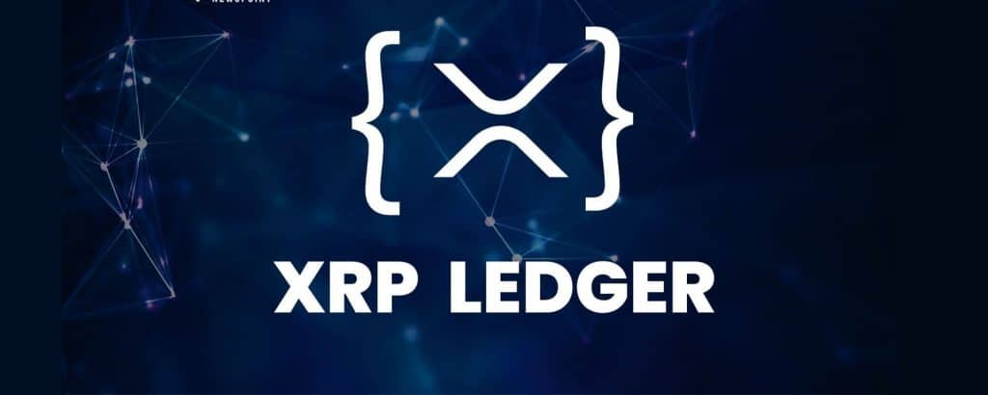  
 The XRPL (and its native asset $XRP) has enabled Lazatech to grow rapidly while keeping user and developer expenses low. The XRPL's built-in DEX means that our tokens may be exchanged instantaneously, and various simple applications/programs provide a large number of individuals with instant, efficient, and simple methods to interact with their favorite tokens. Ripple fosters and facilitates a variety of advances throughout the ledger, thus the area is always evolving, expanding, and adapting!  
  
**Lesson 2: Why has Lazatech made the XRPL it’s home? Quiz**

**Top of Form**

1. **What is the native (base) currency of the XRPL?**
   * ** $XRPL**
   * ** $LZT**
   * ** $LAZA**
   * ** $XRP**

**Correct**

1. **Which of these blockchains are the cheapest/fastest?**
   * ** ETH**
   * ** BTC**
   * ** XRPL**
   * ** BNC**

**Correct**

1. **Why did Lazatech choose to make the XRPL it’s home**
   * ** Because of the low costs of transactions, speed, and efficiency**
   * ** Because Jed McCaleb called us up and was very insistent**
   * ** Because other blockchains aren't accepting any new project launches**

**Correct**

Lesson 3: Lazatech Social Media“Laza '' is a Hebrew word which means “God has helped” and ''tech” is a short word for technology. This name shows the goal of the system which is to aid students in their online learning and provide a helping online community to answer their queries and acquire more knowledge. The platform intends to offer a plagiarism checker inside the Lazatech website application to ensure the credibility and uniqueness of the information posted in it. And most importantly, a user-friendly and engaged tech community aims to help each other on their college voyage. The platform's initial functions are blog, forum, polls, and event creation. These functions are under development, and the developers may add other functions that they see fit for the system, which can help the users to have a straightforward approach in learning computer programming tools and codes.

An awarding system based on ‘Likes’ obtained from other users and the questions posted will have an assigned token award for the person who can give an answer for it. These processes will be used to encourage students to help their fellow students inside the platform. The initial plan for this component is the highest person who had the most likes would receive a $LZT token from the xrp ledger which they can be used in their future projects to help them on their expenses. Coil web monetization integration would also be used in the Lazatech platform for the acquisition of funds for the awards. Coil provides an alternative to traditional paid advertising for online monetization. As consumers consume content, Coil employs the interledger protocol (ILP) to broadcast micropayments. The payment channels of the XRPL are a suitable method for settling these micropayments quickly and cheaply.

**Lesson 3: Lazatech Social Media Website Quiz**

What does LAZA means? Top of Form

1. What
   *  Help
   *  God has helped
   *  money

Correct

1. **True of False: Does Lazatech Soc Med offers token rewards to its users?**
   *  True
   *  False

Correct**5/5 $TRSRY**  
  
Lesson 4: Lazatech – Educate "Lazatech Educate" is a web based application that aims to provide its users the knowledge about the xrp ledger and "Lazatech Social Media Website Application", a capstone project by Gabriel Edrian Alvaro, Marian Guerra, and Mariel Guerra. Initially, the proposed website application is an online course that comprises with lessons the social media application and its crypto currency integration. It would give them the necessary knowledge on how to work with the capstone project website and xrp ledger crypto trading platform

This project will consists of lessons and quizzes after them. Once a user answered a question and it was correct, they will received a crypto token to their XRP ledger address.

**Lesson 5: Lazatech Educate Quiz**

Top of Form

1. True or False: Lazatech Educate will give you the knowledge of the social media counterpart of it, the education platform itself, and the xrpl ledger technology.
   *  True
   *  False

Correct

1. Lazatech Educate ensure make its users knowledgeable before entering its social media counterpart and the XRPL ledger blockchain.
   *  True
   *  False

Correct

## Course 2: Know how to Burn

This Know how to Burn course provides an introduction to blockchain-based burning, what it is, its attributes, and its benefits.

  Please note that the courses in this course are Learn to BURN lessons. In other words, completing the quizzes for each lesson in this course will contribute to a decrease in the supply of $TRSRY, but you will not earn $TRSRY for this lesson.

### Lesson 1: Token Supply and its Effect on Price

Please note that this is the Learn to BURN course. In other words, by completing the exam you will reduce the supply of $LZT, but you will not get any for this lesson.

We've all seen it: a newbie to a cryptocurrency society or community asks, "What is a cheap coin (less than $1) that will become as popular as Bitcoin?" … Usually, this is followed by an engaging introduction to the domain of token supply and market capitalization. This lecture will discuss why the supply of a token is crucial.

Consider iron ore and platinum as "tokens" for two actual commodities: iron ore and platinum. Both of these metals are extracted actively. Iron ore is currently priced at roughly US$144 per ton, but platinum is valued at approximately US$32.7 million per ton. Why is iron so affordable yet it is basically used everywhere on the planet for a variety of purposes? Platinum is mostly utilized in the jewelry industry, but it also has electrical and medical applications; why is it so expensive?

*What is the greatest amount of resources available?*

70 000 Tons of Platinum are anticipated to exist on the planet. The world's iron ore reserves are believed to be 800 billion tons; there are 11,400,000,000,000,000 times more Iron Ore than Platinum. **Let's determine the completely diluted market capitalization of each asset.**

Platinum – 70 000 x 32 700 000 = US$2 289 000 000 000

Iron Ore – 800 000 000 000 x 144 = US$115 200 000 000 000

The market worth of iron ore is almost fifty times that of platinum, although it costs 227 000 times less per ton.

This should help you understand that the price of a token or coin is influenced by a number of variables, with supply being the most crucial. In general, tokens with a larger quantity have lower prices, whereas tokens with a lesser supply have higher values. This is precisely why a token's market capitalization is a superior performance measure and permits the most precise comparisons.  
   
 The preceding analogy is not intended to be exact; it is only a broad illustration of supply.

**Lesson 1: Token Supply and its Effect on Price Quiz**

1. **True or False: You should purchase the lowest coins possible, as their prices can quickly approach those of Bitcoin.**
   * https://lh6.googleusercontent.com/0YzHBWSQmGWHXNyXEDCntPpeVtk75UGPAnXct3Dlr0kdvuLypT_9H7DheZW6leoJtdNX4vV8-PiI9QPyR76Y3v6jf1K34JARziVd1JYWQcfPzpzT5i7CcYfptPFcCOU2_zEB5zfDAFy_ykrMtgpobA True
   * https://lh4.googleusercontent.com/W6wVT3nHyyg5ZEWg46aTY81v37AjefhvlNMMP3_Tl5WRMyqOv1jCu7UALZrxHVJCy9gf5UgwzGECRotTNgnp1QUjBWCAb56MecFWcRUC329qMvwUGX4zsHlMXEqDXVQCbVr-F5D4r9RSag2zqtVoww False

Correct

Right Answer: False

1. **Token A has a supply of 100,000 units and a market capitalization of $200,000, whereas Token B has a supply of 500,000 units and a market capitalization of $1,000,000.**

Token A’s price is ______ Token B’s price.

* https://lh6.googleusercontent.com/0YzHBWSQmGWHXNyXEDCntPpeVtk75UGPAnXct3Dlr0kdvuLypT_9H7DheZW6leoJtdNX4vV8-PiI9QPyR76Y3v6jf1K34JARziVd1JYWQcfPzpzT5i7CcYfptPFcCOU2_zEB5zfDAFy_ykrMtgpobA Greater
* https://lh4.googleusercontent.com/W6wVT3nHyyg5ZEWg46aTY81v37AjefhvlNMMP3_Tl5WRMyqOv1jCu7UALZrxHVJCy9gf5UgwzGECRotTNgnp1QUjBWCAb56MecFWcRUC329qMvwUGX4zsHlMXEqDXVQCbVr-F5D4r9RSag2zqtVoww Less than
* https://lh6.googleusercontent.com/0YzHBWSQmGWHXNyXEDCntPpeVtk75UGPAnXct3Dlr0kdvuLypT_9H7DheZW6leoJtdNX4vV8-PiI9QPyR76Y3v6jf1K34JARziVd1JYWQcfPzpzT5i7CcYfptPFcCOU2_zEB5zfDAFy_ykrMtgpobA Equal

Incorrect

Right Answer: **Equal**

### Lesson 2: What is Burning

*Length: 10 minutes*

Burning is a cryptocurrency term for the depletion of a coin's or token's supply. When tokens are burnt, they are irretrievable and permanently lost. They are then transferred to an inaccessible wallet and are afterwards presumed destroyed. As stated earlier, supply is a crucial factor in determining the value of an item. When demand and supply are equal, an item with a lesser supply will be more expensive because those who wish to obtain it will be required to pay more.

Burning can be accomplished in a number of ways and for various reasons, but it is always intended to result in a price increase. Not only is the quantity reduced, but precise and focused marketing might motivate new investors to hold on to the token/coin if they watch the development team doing burns.

Vitalik, Binance, and Stellar are accountable for a few of the most notable incidents of burns. The SHIB creators provided Vitalik Buterin fifty percent of the Shiba Inu supply, of which he burned ninety percent and gave away the remaining ten percent. Binance has undertaken quarterly burning of BNB since 2017 and will continue to do so until 50% of the supply has been spent. The Stellar Development Foundation consumed more than fifty percent of Stellar's supply (55 Billion XLM).

As with any investment in the bitcoin industry, proceed with caution when investing in a project promising a burn, particularly with smaller, lesser-known enterprises. There are several examples of projects that transferred their tokens to a different wallet and then purported to "burn" them. In the meanwhile, the team has complete access to the tokens, so driving up the price and earning publicity.

**Lesson 2: What is Burning Quiz**

1. **True or False: in order to complete a burn, a token must be transmitted to an inaccessible address.**
   * https://lh4.googleusercontent.com/W6wVT3nHyyg5ZEWg46aTY81v37AjefhvlNMMP3_Tl5WRMyqOv1jCu7UALZrxHVJCy9gf5UgwzGECRotTNgnp1QUjBWCAb56MecFWcRUC329qMvwUGX4zsHlMXEqDXVQCbVr-F5D4r9RSag2zqtVoww True
   * https://lh6.googleusercontent.com/0YzHBWSQmGWHXNyXEDCntPpeVtk75UGPAnXct3Dlr0kdvuLypT_9H7DheZW6leoJtdNX4vV8-PiI9QPyR76Y3v6jf1K34JARziVd1JYWQcfPzpzT5i7CcYfptPFcCOU2_zEB5zfDAFy_ykrMtgpobA False

Correct

Answer: **True**

1. **Typically, burns are done to ____ a token's value?**
   * https://lh4.googleusercontent.com/W6wVT3nHyyg5ZEWg46aTY81v37AjefhvlNMMP3_Tl5WRMyqOv1jCu7UALZrxHVJCy9gf5UgwzGECRotTNgnp1QUjBWCAb56MecFWcRUC329qMvwUGX4zsHlMXEqDXVQCbVr-F5D4r9RSag2zqtVoww Increase
   * https://lh6.googleusercontent.com/0YzHBWSQmGWHXNyXEDCntPpeVtk75UGPAnXct3Dlr0kdvuLypT_9H7DheZW6leoJtdNX4vV8-PiI9QPyR76Y3v6jf1K34JARziVd1JYWQcfPzpzT5i7CcYfptPFcCOU2_zEB5zfDAFy_ykrMtgpobA Decrease
   * https://lh6.googleusercontent.com/0YzHBWSQmGWHXNyXEDCntPpeVtk75UGPAnXct3Dlr0kdvuLypT_9H7DheZW6leoJtdNX4vV8-PiI9QPyR76Y3v6jf1K34JARziVd1JYWQcfPzpzT5i7CcYfptPFcCOU2_zEB5zfDAFy_ykrMtgpobA Stabilise

Correct

Answer: **Increase**

1. **DYOR means?**
   * https://lh6.googleusercontent.com/0YzHBWSQmGWHXNyXEDCntPpeVtk75UGPAnXct3Dlr0kdvuLypT_9H7DheZW6leoJtdNX4vV8-PiI9QPyR76Y3v6jf1K34JARziVd1JYWQcfPzpzT5i7CcYfptPFcCOU2_zEB5zfDAFy_ykrMtgpobA DYOR token
   * https://lh6.googleusercontent.com/0YzHBWSQmGWHXNyXEDCntPpeVtk75UGPAnXct3Dlr0kdvuLypT_9H7DheZW6leoJtdNX4vV8-PiI9QPyR76Y3v6jf1K34JARziVd1JYWQcfPzpzT5i7CcYfptPFcCOU2_zEB5zfDAFy_ykrMtgpobA Don’t yank on rhinos
   * https://lh6.googleusercontent.com/0YzHBWSQmGWHXNyXEDCntPpeVtk75UGPAnXct3Dlr0kdvuLypT_9H7DheZW6leoJtdNX4vV8-PiI9QPyR76Y3v6jf1K34JARziVd1JYWQcfPzpzT5i7CcYfptPFcCOU2_zEB5zfDAFy_ykrMtgpobA Do your own regards
   * https://lh4.googleusercontent.com/W6wVT3nHyyg5ZEWg46aTY81v37AjefhvlNMMP3_Tl5WRMyqOv1jCu7UALZrxHVJCy9gf5UgwzGECRotTNgnp1QUjBWCAb56MecFWcRUC329qMvwUGX4zsHlMXEqDXVQCbVr-F5D4r9RSag2zqtVoww Do your own research

Correct

Answer: **Do your own research**

**Lesson 3: How are Tokens Burned?**

*Length: 10 minutes*

As explained in the last lecture, burning tokens involves transferring them to an unreachable address. This course will cover how to implement this on any blockchain, including XRPL.  
  
**ETH, BSC etc.**

On the vast majority of blockchains, destroying a token is a simple process. The easiest technique is to use Google or Twitter to search for a publicly advertised burn location. For example, the most frequent burn address on the Ethereum blockchain is 0x0000000000000000000000000000000000000000000000000000dEaD. Create your own address without retaining any of the keys or phrases, then send your tokens to it. There are further websites that enable the drafting of contracts that ensure the safety and legality of the burn; https://burn.fish/ is an example and offers an excellent description of the site's concept and code.

**XRPL**

In some ways, the XRPL makes burning extremely easy, yet in others, amateurs may experience difficulty. The 'trustline' is the fundamental difference between most blockchains and the XRPL; an address cannot get a token if it does not have a trustline associated with it. If they did not have a trustline established to your token prior to being blackholed (losing account access), they would not be able to receive it at the public burn addresses. However, each token on the XRPL has an issuer address, which is the address used to distribute tokens throughout the ledger. If this issuer address is blackholed (see prior lectures for an explanation of why this is done), you have all the tools necessary to burn tokens.

Now that we've established that tokens may be burnt by sending them back to their issuer, let's test this in XUMM...

It does not permit it! XUMM protects users from transferring tokens to a blackholed address, which is a great precaution in 99.9 percent of situations, but not when tokens are to be burned. There are two ways to overcome this restriction: sending a new program, such as XRP Toolkit, to the issuer, or, for XUMM purists, utilizing an xApp known as a 'token trasher'. The token trasher has the constraint that you must discard the ENTIRE number of tokens you wish to destroy; you cannot pick a partial quantity.

You now have a comprehensive grasp of token burning. It is generally not recommended to burn your own tokens unless you fully understand the consequences and hazards. By burning tokens, you lose access to them, and as Do Kwon, the founder of LUNA, stated, "You're essentially burning money."

**Lesson 3: How are Tokens Burned? Quiz**

1. **What are the risks associated with sending an ETH token to a random ETH address (with no transactions or activity) in order to burn it?**
   * https://lh3.googleusercontent.com/cX0DvsbciaSgCp9Mnb8Wq-83MAQ1sXYmuQE8EDXkNjjBpI9s4lzTbRmBJGaynnFiSRsyYSZ74JkhWDogOnrOepfzcdzKz6Co3yJTeHKMKddCRN486gzIpkwOz3ewIHLcOBcH98XsbfM250Fnk4cm0w The address might not have the necessary trustline configured, or it might be unreachable, and you've simply wasted your tokens.
   * https://lh6.googleusercontent.com/zA_wbT0o3Ku3Xt-KW5ksElEYuv6nx5nqQcNfULnU8mHJmzRiewMlDDwJx4ypEZ9oM6LmNLyPcSo1CkJi7s0LugvX0OTNypbqIwev2ItYRj3_Ij-ebV6tUyQzVeP3O19cfwYC01QGokx33K27kLXw9g The address may be corrupted
   * https://lh6.googleusercontent.com/zA_wbT0o3Ku3Xt-KW5ksElEYuv6nx5nqQcNfULnU8mHJmzRiewMlDDwJx4ypEZ9oM6LmNLyPcSo1CkJi7s0LugvX0OTNypbqIwev2ItYRj3_Ij-ebV6tUyQzVeP3O19cfwYC01QGokx33K27kLXw9g The address may not have been accessed or used, but its owner may now have access to your tokens.

Incorrect

Right Answer: **The address may have not been accessed or used yet but may have an owner who now has access to your tokens**

1. **True or false: XUMM is the only means to interact with and access the XRPL?**
   * https://lh6.googleusercontent.com/zA_wbT0o3Ku3Xt-KW5ksElEYuv6nx5nqQcNfULnU8mHJmzRiewMlDDwJx4ypEZ9oM6LmNLyPcSo1CkJi7s0LugvX0OTNypbqIwev2ItYRj3_Ij-ebV6tUyQzVeP3O19cfwYC01QGokx33K27kLXw9g True
   * https://lh3.googleusercontent.com/cX0DvsbciaSgCp9Mnb8Wq-83MAQ1sXYmuQE8EDXkNjjBpI9s4lzTbRmBJGaynnFiSRsyYSZ74JkhWDogOnrOepfzcdzKz6Co3yJTeHKMKddCRN486gzIpkwOz3ewIHLcOBcH98XsbfM250Fnk4cm0w False

Correct

Right Answer: **False**

**Lesson 4: Different Types of Burns**

*Length: 10 minutes*

There are numerous methods for burning tokens, the majority of which depend on the particulars of each project and the objectives of the burn. Other tokens/coins rely on burning as a fundamental utility mechanism. Here are some of the most common types of burns:

**Undistributed Burn** – Destruction of tokens/coins that have never been sold or circulated. This decreases the TOTAL supply of the project, but has no effect on the circulating supply. This indicates that the same quantity of tokens will be made available on the market, with no anticipated price change. These burns are excellent for advertising, but they guarantee a future depletion of resources.

**Buy-back and Burn** – An advantageous scenario for investors. The projects acquire their tokens/coins from the market, which increases both volume and price. After all purchases are made, the entire amount is burned. This reduces the total and circulating supply, which should theoretically lead to a higher price.

**Developer Wallet Burn** – Similar to the undistributed burn, with the exception that the developer's wallet provides the tokens. This is an additional common marketing strategy that can be used to demonstrate a team's commitment to the project. It has no impact on the Circulating supply but reduces the Total supply.

**Tax/Contract/Fee Burn** – Prevalent to ETH and BSC token initiatives, and utilized by multiple currencies, including XRP, as a fee structure. The peak year for tax/contract burning initiatives like Safemoon, wherein the purchase or sale of a token results in its destruction, was 2021. These forms of tokens have spread across the globe and are still in use. XRP incurs negligible fees for all blockchain transactions, together with buy, sell, sign, transmit, etc. Instead of being transmitted to Ripple, this fee is burned and removed from circulation. This is true for numerous blockchains; feel free to investigate further!

**Learn to Burn** – Lazatech Educate's cutting-edge approach to burning is a world first in the field of crypto education! LZT incentives are instead sent to a blackholed address using the same technique as our Learn to Earn software. This means that each time you complete a lesson, you help reduce the total amount of LZT!

Undoubtedly, there are a number of additional obscure and lesser-known techniques, but these are the most prevalent and widely used in the cryptocurrency industry.

**Lesson 4: Different Types of Burns Quiz**

1. **True or False: "Learn to Burn" decreases the Total Supply of $TRSRY but has no impact on the circulating supply.**
   * https://lh3.googleusercontent.com/cX0DvsbciaSgCp9Mnb8Wq-83MAQ1sXYmuQE8EDXkNjjBpI9s4lzTbRmBJGaynnFiSRsyYSZ74JkhWDogOnrOepfzcdzKz6Co3yJTeHKMKddCRN486gzIpkwOz3ewIHLcOBcH98XsbfM250Fnk4cm0w True
   * https://lh6.googleusercontent.com/zA_wbT0o3Ku3Xt-KW5ksElEYuv6nx5nqQcNfULnU8mHJmzRiewMlDDwJx4ypEZ9oM6LmNLyPcSo1CkJi7s0LugvX0OTNypbqIwev2ItYRj3_Ij-ebV6tUyQzVeP3O19cfwYC01QGokx33K27kLXw9g False

Correct

Right Answer: **True**

1. **What is the most efficient Burn technique that an XRPL token development team can employ to reduce the CIRCULATING supply?**
   * https://lh6.googleusercontent.com/zA_wbT0o3Ku3Xt-KW5ksElEYuv6nx5nqQcNfULnU8mHJmzRiewMlDDwJx4ypEZ9oM6LmNLyPcSo1CkJi7s0LugvX0OTNypbqIwev2ItYRj3_Ij-ebV6tUyQzVeP3O19cfwYC01QGokx33K27kLXw9g Buy-back and Burn
   * https://lh6.googleusercontent.com/zA_wbT0o3Ku3Xt-KW5ksElEYuv6nx5nqQcNfULnU8mHJmzRiewMlDDwJx4ypEZ9oM6LmNLyPcSo1CkJi7s0LugvX0OTNypbqIwev2ItYRj3_Ij-ebV6tUyQzVeP3O19cfwYC01QGokx33K27kLXw9g Learn to Burn
   * https://lh6.googleusercontent.com/zA_wbT0o3Ku3Xt-KW5ksElEYuv6nx5nqQcNfULnU8mHJmzRiewMlDDwJx4ypEZ9oM6LmNLyPcSo1CkJi7s0LugvX0OTNypbqIwev2ItYRj3_Ij-ebV6tUyQzVeP3O19cfwYC01QGokx33K27kLXw9g Developer wallet burn
   * https://lh3.googleusercontent.com/cX0DvsbciaSgCp9Mnb8Wq-83MAQ1sXYmuQE8EDXkNjjBpI9s4lzTbRmBJGaynnFiSRsyYSZ74JkhWDogOnrOepfzcdzKz6Co3yJTeHKMKddCRN486gzIpkwOz3ewIHLcOBcH98XsbfM250Fnk4cm0w Fee burn

Incorrect

Right Answer: **Buy-back and Burn**

**Lesson 5: Crypto Quiz**

Length: 10 minutes

Thank you for understanding how to burn $LZT tokens as a Lazatech Community member. We hope that you have gained new knowledge from our academy and cannot wait to offer you additional high-quality courses. The final component of our Burnathon course is a test of your prior knowledge and research skills.

Best wishes, and thank you once more!

**Lesson 5: Crypto Quiz**

1. **What kind of DEX is incorporated into the XRPL?**
   * https://lh6.googleusercontent.com/zA_wbT0o3Ku3Xt-KW5ksElEYuv6nx5nqQcNfULnU8mHJmzRiewMlDDwJx4ypEZ9oM6LmNLyPcSo1CkJi7s0LugvX0OTNypbqIwev2ItYRj3_Ij-ebV6tUyQzVeP3O19cfwYC01QGokx33K27kLXw9g Automatic Market Maker DEX
   * https://lh3.googleusercontent.com/cX0DvsbciaSgCp9Mnb8Wq-83MAQ1sXYmuQE8EDXkNjjBpI9s4lzTbRmBJGaynnFiSRsyYSZ74JkhWDogOnrOepfzcdzKz6Co3yJTeHKMKddCRN486gzIpkwOz3ewIHLcOBcH98XsbfM250Fnk4cm0w Orderbook DEX
   * https://lh6.googleusercontent.com/zA_wbT0o3Ku3Xt-KW5ksElEYuv6nx5nqQcNfULnU8mHJmzRiewMlDDwJx4ypEZ9oM6LmNLyPcSo1CkJi7s0LugvX0OTNypbqIwev2ItYRj3_Ij-ebV6tUyQzVeP3O19cfwYC01QGokx33K27kLXw9g DEX Aggregator

Correct**9/9 $TRSRY**

Right Answer: **Orderbook DEX**

1. **True or False: volume indicates the price increase of an asset over a 24-hour period.**
   * https://lh6.googleusercontent.com/zA_wbT0o3Ku3Xt-KW5ksElEYuv6nx5nqQcNfULnU8mHJmzRiewMlDDwJx4ypEZ9oM6LmNLyPcSo1CkJi7s0LugvX0OTNypbqIwev2ItYRj3_Ij-ebV6tUyQzVeP3O19cfwYC01QGokx33K27kLXw9g True
   * https://lh3.googleusercontent.com/cX0DvsbciaSgCp9Mnb8Wq-83MAQ1sXYmuQE8EDXkNjjBpI9s4lzTbRmBJGaynnFiSRsyYSZ74JkhWDogOnrOepfzcdzKz6Co3yJTeHKMKddCRN486gzIpkwOz3ewIHLcOBcH98XsbfM250Fnk4cm0w False

Correct**9/9 $TRSRY**

Right Answer: **False**

1. **What purpose does a cryptocurrency wallet serve?**
   * https://lh3.googleusercontent.com/cX0DvsbciaSgCp9Mnb8Wq-83MAQ1sXYmuQE8EDXkNjjBpI9s4lzTbRmBJGaynnFiSRsyYSZ74JkhWDogOnrOepfzcdzKz6Co3yJTeHKMKddCRN486gzIpkwOz3ewIHLcOBcH98XsbfM250Fnk4cm0w It holds your coins tokens nfts
   * https://lh6.googleusercontent.com/zA_wbT0o3Ku3Xt-KW5ksElEYuv6nx5nqQcNfULnU8mHJmzRiewMlDDwJx4ypEZ9oM6LmNLyPcSo1CkJi7s0LugvX0OTNypbqIwev2ItYRj3_Ij-ebV6tUyQzVeP3O19cfwYC01QGokx33K27kLXw9g Allows you to send cryptocurrencies to others
   * https://lh6.googleusercontent.com/zA_wbT0o3Ku3Xt-KW5ksElEYuv6nx5nqQcNfULnU8mHJmzRiewMlDDwJx4ypEZ9oM6LmNLyPcSo1CkJi7s0LugvX0OTNypbqIwev2ItYRj3_Ij-ebV6tUyQzVeP3O19cfwYC01QGokx33K27kLXw9g Allows you to take cryptocurrency off the blockchain and store safely within your wallet away from hackers
   * https://lh6.googleusercontent.com/zA_wbT0o3Ku3Xt-KW5ksElEYuv6nx5nqQcNfULnU8mHJmzRiewMlDDwJx4ypEZ9oM6LmNLyPcSo1CkJi7s0LugvX0OTNypbqIwev2ItYRj3_Ij-ebV6tUyQzVeP3O19cfwYC01QGokx33K27kLXw9g Doesn’t hold any cryptocurreny, simply holds your private and public keys allowing you to sign transactions on the blockchain

Incorrect

[Right Answer: **Doesn’t hold any cryptocurreny, simply holds your private and public keys allowing you to sign transactions on the blockchain**](https://www.trsryxrpl.com/quiz/lesson-4-different-types-of-burns/)

1. **True or False: ASIC and GPU miners can earn over 100 XRP per day.**
   * https://lh6.googleusercontent.com/zA_wbT0o3Ku3Xt-KW5ksElEYuv6nx5nqQcNfULnU8mHJmzRiewMlDDwJx4ypEZ9oM6LmNLyPcSo1CkJi7s0LugvX0OTNypbqIwev2ItYRj3_Ij-ebV6tUyQzVeP3O19cfwYC01QGokx33K27kLXw9g True
   * https://lh3.googleusercontent.com/cX0DvsbciaSgCp9Mnb8Wq-83MAQ1sXYmuQE8EDXkNjjBpI9s4lzTbRmBJGaynnFiSRsyYSZ74JkhWDogOnrOepfzcdzKz6Co3yJTeHKMKddCRN486gzIpkwOz3ewIHLcOBcH98XsbfM250Fnk4cm0w False

Correct

Right Answer: **False**

1. **What is Bitcoin's maximum supply?**
   * https://lh3.googleusercontent.com/cX0DvsbciaSgCp9Mnb8Wq-83MAQ1sXYmuQE8EDXkNjjBpI9s4lzTbRmBJGaynnFiSRsyYSZ74JkhWDogOnrOepfzcdzKz6Co3yJTeHKMKddCRN486gzIpkwOz3ewIHLcOBcH98XsbfM250Fnk4cm0w 21 000 000 BTC
   * https://lh6.googleusercontent.com/zA_wbT0o3Ku3Xt-KW5ksElEYuv6nx5nqQcNfULnU8mHJmzRiewMlDDwJx4ypEZ9oM6LmNLyPcSo1CkJi7s0LugvX0OTNypbqIwev2ItYRj3_Ij-ebV6tUyQzVeP3O19cfwYC01QGokx33K27kLXw9g 21 000 000 USDT
   * https://lh6.googleusercontent.com/zA_wbT0o3Ku3Xt-KW5ksElEYuv6nx5nqQcNfULnU8mHJmzRiewMlDDwJx4ypEZ9oM6LmNLyPcSo1CkJi7s0LugvX0OTNypbqIwev2ItYRj3_Ij-ebV6tUyQzVeP3O19cfwYC01QGokx33K27kLXw9g 21 000 000 mBTC

Correct

Right Answer: **21 000 000 BTC**

1. **What is the difference between XRP and the Ripple cryptocurrency?**
   * https://lh6.googleusercontent.com/zA_wbT0o3Ku3Xt-KW5ksElEYuv6nx5nqQcNfULnU8mHJmzRiewMlDDwJx4ypEZ9oM6LmNLyPcSo1CkJi7s0LugvX0OTNypbqIwev2ItYRj3_Ij-ebV6tUyQzVeP3O19cfwYC01QGokx33K27kLXw9g They are the same thing
   * https://lh6.googleusercontent.com/zA_wbT0o3Ku3Xt-KW5ksElEYuv6nx5nqQcNfULnU8mHJmzRiewMlDDwJx4ypEZ9oM6LmNLyPcSo1CkJi7s0LugvX0OTNypbqIwev2ItYRj3_Ij-ebV6tUyQzVeP3O19cfwYC01QGokx33K27kLXw9g Ripple is owned by the company XRP
   * https://lh3.googleusercontent.com/cX0DvsbciaSgCp9Mnb8Wq-83MAQ1sXYmuQE8EDXkNjjBpI9s4lzTbRmBJGaynnFiSRsyYSZ74JkhWDogOnrOepfzcdzKz6Co3yJTeHKMKddCRN486gzIpkwOz3ewIHLcOBcH98XsbfM250Fnk4cm0w Ripple is the company that created the XRPL and XRP is a digital asset

Correct

Right Answer: **Ripple is the company that created the XRPL and XRP is a digital asset**

1. **How is the market cap of a cryptocurrency determined?**
   * https://lh6.googleusercontent.com/zA_wbT0o3Ku3Xt-KW5ksElEYuv6nx5nqQcNfULnU8mHJmzRiewMlDDwJx4ypEZ9oM6LmNLyPcSo1CkJi7s0LugvX0OTNypbqIwev2ItYRj3_Ij-ebV6tUyQzVeP3O19cfwYC01QGokx33K27kLXw9g Every dollar invested into the project is counted and added together
   * https://lh6.googleusercontent.com/zA_wbT0o3Ku3Xt-KW5ksElEYuv6nx5nqQcNfULnU8mHJmzRiewMlDDwJx4ypEZ9oM6LmNLyPcSo1CkJi7s0LugvX0OTNypbqIwev2ItYRj3_Ij-ebV6tUyQzVeP3O19cfwYC01QGokx33K27kLXw9g Circulating supply multiplied by maximum supply
   * https://lh3.googleusercontent.com/cX0DvsbciaSgCp9Mnb8Wq-83MAQ1sXYmuQE8EDXkNjjBpI9s4lzTbRmBJGaynnFiSRsyYSZ74JkhWDogOnrOepfzcdzKz6Co3yJTeHKMKddCRN486gzIpkwOz3ewIHLcOBcH98XsbfM250Fnk4cm0w Current price multiplied by circulating supply
   * https://lh6.googleusercontent.com/zA_wbT0o3Ku3Xt-KW5ksElEYuv6nx5nqQcNfULnU8mHJmzRiewMlDDwJx4ypEZ9oM6LmNLyPcSo1CkJi7s0LugvX0OTNypbqIwev2ItYRj3_Ij-ebV6tUyQzVeP3O19cfwYC01QGokx33K27kLXw9g Current price multiplied by maximum supply

Correct

Right Answer: **Current price multiplied by circulating supply**

1. **Using your preferred research method, approximately how much XRP has been burned?**
   * https://lh6.googleusercontent.com/zA_wbT0o3Ku3Xt-KW5ksElEYuv6nx5nqQcNfULnU8mHJmzRiewMlDDwJx4ypEZ9oM6LmNLyPcSo1CkJi7s0LugvX0OTNypbqIwev2ItYRj3_Ij-ebV6tUyQzVeP3O19cfwYC01QGokx33K27kLXw9g 48 million XRP
   * https://lh6.googleusercontent.com/zA_wbT0o3Ku3Xt-KW5ksElEYuv6nx5nqQcNfULnU8mHJmzRiewMlDDwJx4ypEZ9oM6LmNLyPcSo1CkJi7s0LugvX0OTNypbqIwev2ItYRj3_Ij-ebV6tUyQzVeP3O19cfwYC01QGokx33K27kLXw9g 10.5 million XRP
   * https://lh6.googleusercontent.com/zA_wbT0o3Ku3Xt-KW5ksElEYuv6nx5nqQcNfULnU8mHJmzRiewMlDDwJx4ypEZ9oM6LmNLyPcSo1CkJi7s0LugvX0OTNypbqIwev2ItYRj3_Ij-ebV6tUyQzVeP3O19cfwYC01QGokx33K27kLXw9g 52 million XRP
   * https://lh3.googleusercontent.com/cX0DvsbciaSgCp9Mnb8Wq-83MAQ1sXYmuQE8EDXkNjjBpI9s4lzTbRmBJGaynnFiSRsyYSZ74JkhWDogOnrOepfzcdzKz6Co3yJTeHKMKddCRN486gzIpkwOz3ewIHLcOBcH98XsbfM250Fnk4cm0w 22.7 million XRP

Incorrect

Right Answer: **10.5 million XRP**

Course 3: Protect Yourself – The importance of DYOR

Numerous individuals engage in DYOR. However, there is no need for concern if you are new to the game but willing to invest in certain XRPL companies that appear promising. Before putting your money where your mouth is, this course will walk you through a 10-point checklist to ensure you've covered all your bases. Otherwise, you will continue to put your money where their mouth is, and it will most likely end up in their pocket, not yours.

**Lesson 1: Introduction**

DYOR is an acronym that stands for "Conduct your own research" The world of cryptocurrencies is an exciting place where numerous individuals earn millions of dollars. However, many individuals invest money they cannot afford to lose in the hope of receiving a golden paycheck that never materializes.

Numerous people compare the cryptosphere to the digital Wild West on account of its abundance of wealth and high risks.

This course examines the steps that should be taken before deciding to FOMO into the next great thing.

The ten-point assurance checklist

Never has this been truer than in cryptography, where nothing is ever certain. If you intend to invest some of your hard-earned money, completing this course and the accompanying 10-point checklist will increase your chances of backing a project with longevity.

This is more of an introduction than a lecture, so let's begin with the quiz below.

**Lesson 1: Introduction Quiz**

1. **What is the acronym DYOR?**
   * https://lh6.googleusercontent.com/zA_wbT0o3Ku3Xt-KW5ksElEYuv6nx5nqQcNfULnU8mHJmzRiewMlDDwJx4ypEZ9oM6LmNLyPcSo1CkJi7s0LugvX0OTNypbqIwev2ItYRj3_Ij-ebV6tUyQzVeP3O19cfwYC01QGokx33K27kLXw9g Don't yank on rhinos
   * https://lh6.googleusercontent.com/zA_wbT0o3Ku3Xt-KW5ksElEYuv6nx5nqQcNfULnU8mHJmzRiewMlDDwJx4ypEZ9oM6LmNLyPcSo1CkJi7s0LugvX0OTNypbqIwev2ItYRj3_Ij-ebV6tUyQzVeP3O19cfwYC01QGokx33K27kLXw9g Do your own recycling
   * https://lh3.googleusercontent.com/cX0DvsbciaSgCp9Mnb8Wq-83MAQ1sXYmuQE8EDXkNjjBpI9s4lzTbRmBJGaynnFiSRsyYSZ74JkhWDogOnrOepfzcdzKz6Co3yJTeHKMKddCRN486gzIpkwOz3ewIHLcOBcH98XsbfM250Fnk4cm0w Do your own research

Correct

Right Answer: **Do your own research**

1. **Making quick cash with cryptocurrency is**
   * https://lh6.googleusercontent.com/zA_wbT0o3Ku3Xt-KW5ksElEYuv6nx5nqQcNfULnU8mHJmzRiewMlDDwJx4ypEZ9oM6LmNLyPcSo1CkJi7s0LugvX0OTNypbqIwev2ItYRj3_Ij-ebV6tUyQzVeP3O19cfwYC01QGokx33K27kLXw9g Not impossible
   * https://lh3.googleusercontent.com/cX0DvsbciaSgCp9Mnb8Wq-83MAQ1sXYmuQE8EDXkNjjBpI9s4lzTbRmBJGaynnFiSRsyYSZ74JkhWDogOnrOepfzcdzKz6Co3yJTeHKMKddCRN486gzIpkwOz3ewIHLcOBcH98XsbfM250Fnk4cm0w Risky, you need to do your own research
   * https://lh6.googleusercontent.com/zA_wbT0o3Ku3Xt-KW5ksElEYuv6nx5nqQcNfULnU8mHJmzRiewMlDDwJx4ypEZ9oM6LmNLyPcSo1CkJi7s0LugvX0OTNypbqIwev2ItYRj3_Ij-ebV6tUyQzVeP3O19cfwYC01QGokx33K27kLXw9g Not for those who are investing money they can't afford to lose
   * https://lh6.googleusercontent.com/zA_wbT0o3Ku3Xt-KW5ksElEYuv6nx5nqQcNfULnU8mHJmzRiewMlDDwJx4ypEZ9oM6LmNLyPcSo1CkJi7s0LugvX0OTNypbqIwev2ItYRj3_Ij-ebV6tUyQzVeP3O19cfwYC01QGokx33K27kLXw9g All of the above

Incorrect

Right Answer: **All of the above**

**Lesson 2: Twitter – Portal into Crypto**

*Length: 10 minutes*

This is the first point of contact for all new initiatives seeking to build their community.

Twitter's availability and popularity are in no way indicative of its legitimacy. Numerous negative actors use Twitter to increase interaction and encourage hasty decisions. Anyone can create their own Twitter account.

What is the number of followers on the account? The larger their audience, the greater their exposure. You may also examine their followers, which will give you an idea of how much attention they have garnered. However, be cautious because followers can be purchased; therefore, while a large number of followers is encouraging, the interaction of those followers is far more revealing.

Followers and Retweets are available for sale.

– Are the DMs accessible? Not implying they will respond, but knowing you can contact them if necessary is helpful. Why not offer them some words of encouragement? They would appreciate it.

– Do not merely peruse their tweets; their replies typically provide a more compelling narrative. Determine whether holders are hostile; this will help to paint a picture of the nature of the project and how it interacts with its stakeholders.

– The "checkmark in blue" Twitter gives its blue checkmark to prominent organizations and individuals with a large number of followers. As blockchain adoption increases, this will be an excellent indicator to look for, despite the fact that almost no blockchain projects currently have them. (However, this is not a reason to reject the current proposal) – Did you know you can "Tip" someone a small amount of XRP, then check your wallet to see where the tip went and their wallet to see where the tip went? In the next XRPL Forensics Module, we will delve deeper into this topic.

Followers may be bots, and tweets may receive a disproportionate number of likes and retweets compared to their number of followers.

How long has Twitter been operational? Does it date back to the project's inception? Old Twitter accounts that have been reactivated are red flags because they may have been renamed by malicious projects.

Be skeptical of Twitter polls. These are readily accessible. They do not necessarily reflect the sentiment of the project's supporters accurately.

**Lesson 2: Twitter – Portal into Crypto Quiz**

1. **True or False: If they have a Twitter account, I can trust them because they have registered as a business.**
   * https://lh6.googleusercontent.com/zA_wbT0o3Ku3Xt-KW5ksElEYuv6nx5nqQcNfULnU8mHJmzRiewMlDDwJx4ypEZ9oM6LmNLyPcSo1CkJi7s0LugvX0OTNypbqIwev2ItYRj3_Ij-ebV6tUyQzVeP3O19cfwYC01QGokx33K27kLXw9g True
   * https://lh3.googleusercontent.com/cX0DvsbciaSgCp9Mnb8Wq-83MAQ1sXYmuQE8EDXkNjjBpI9s4lzTbRmBJGaynnFiSRsyYSZ74JkhWDogOnrOepfzcdzKz6Co3yJTeHKMKddCRN486gzIpkwOz3ewIHLcOBcH98XsbfM250Fnk4cm0w False

Correct

Right Answer: **False**

1. **True or False: Twitter surveys cannot be purchased.**
   * https://lh6.googleusercontent.com/zA_wbT0o3Ku3Xt-KW5ksElEYuv6nx5nqQcNfULnU8mHJmzRiewMlDDwJx4ypEZ9oM6LmNLyPcSo1CkJi7s0LugvX0OTNypbqIwev2ItYRj3_Ij-ebV6tUyQzVeP3O19cfwYC01QGokx33K27kLXw9g True
   * https://lh3.googleusercontent.com/cX0DvsbciaSgCp9Mnb8Wq-83MAQ1sXYmuQE8EDXkNjjBpI9s4lzTbRmBJGaynnFiSRsyYSZ74JkhWDogOnrOepfzcdzKz6Co3yJTeHKMKddCRN486gzIpkwOz3ewIHLcOBcH98XsbfM250Fnk4cm0w False

Correct

Right Answer: **False**

**Lesson 3: Secondary Socials – Diving Deeper**

*Length: 10 minutes*

If a project has a Telegram group or a Discord server, this indicates an increased effort to communicate with the community, which is a positive sign. Other networks, such as Facebook and Reddit, are valuable sources, but their utilization within cryptocurrency is becoming less common.



Take the time to join any or all of the available groups, as they will provide you with useful information. Active conversation within these networks indicates that the initiative is alive and well. Nothing should raise more red flags than the most recent post questioning the project's continued existence.

The participation of a powerful individual in a project is becoming increasingly encouraging. Be cautious, however, as they may employ extremely active "hired hands," and be prepared to inquire about their involvement in the project. Therefore, their absence is a warning sign.

Some projects have fewer Twitter followers than Telegram followers, which is a major red flag given the widespread availability of Telegram bots. Twitter should have more followers than Telegram.

– Scroll up a bit in the feeds and look for the same people posting and retweeting; you want to see interaction from a variety of followers to get a sense of the project's overall participation. – If Telegram has disabled chat typing, this is a MASSIVE red flag.

– When researching a project, contact the administrator to see if they respond; any self-respecting project should make themselves available for valid reasons.

**Lesson 3: Secondary Socials – Diving Deeper Quiz**

1. **True or False: It is acceptable to contact the project developers.**
   * https://lh3.googleusercontent.com/cX0DvsbciaSgCp9Mnb8Wq-83MAQ1sXYmuQE8EDXkNjjBpI9s4lzTbRmBJGaynnFiSRsyYSZ74JkhWDogOnrOepfzcdzKz6Co3yJTeHKMKddCRN486gzIpkwOz3ewIHLcOBcH98XsbfM250Fnk4cm0w Certainly, you are an investor prospect after all.

https://lh6.googleusercontent.com/zA_wbT0o3Ku3Xt-KW5ksElEYuv6nx5nqQcNfULnU8mHJmzRiewMlDDwJx4ypEZ9oM6LmNLyPcSo1CkJi7s0LugvX0OTNypbqIwev2ItYRj3_Ij-ebV6tUyQzVeP3O19cfwYC01QGokx33K27kLXw9g How dare you? They are extremely busy managing the project.

Correct

Right Answer: **Absolutely, you are a potential investor after all**

1. **Telegram has turned off chat...**
   * https://lh6.googleusercontent.com/zA_wbT0o3Ku3Xt-KW5ksElEYuv6nx5nqQcNfULnU8mHJmzRiewMlDDwJx4ypEZ9oM6LmNLyPcSo1CkJi7s0LugvX0OTNypbqIwev2ItYRj3_Ij-ebV6tUyQzVeP3O19cfwYC01QGokx33K27kLXw9g Don't worry, it means they are too busy to open it up to their holders/investors
   * https://lh3.googleusercontent.com/cX0DvsbciaSgCp9Mnb8Wq-83MAQ1sXYmuQE8EDXkNjjBpI9s4lzTbRmBJGaynnFiSRsyYSZ74JkhWDogOnrOepfzcdzKz6Co3yJTeHKMKddCRN486gzIpkwOz3ewIHLcOBcH98XsbfM250Fnk4cm0w Unless this is an info only group and they have another for community engagement, then this is a red flag.

Correct

Right Answer: **Unless this is an info only group and they have another for community engagement, then this is a red flag**

**Lesson 4: Whitepaper – Diving Deeper**

*Length: 10 minutes*

A whitepaper is a crucial document for any project's launch. It is identical to a Business Plan you would expect to see from a startup company in the "real world," but has been tailored for the cryptocurrency industry.

It should include essentials such as: – Background/history – Project objective – Use case or functionality proposed

– Tokenomics (see below)

- Team-specific data (doxxing) (see next lesson)

– Roadmap

Despite the fact that a well-written and professionally produced whitepaper should go a long way toward establishing credibility, keep in mind that, for the time being, it is likely only a promise of future events. It is not a contract, but rather an expression of intent to provide the specified items.

**Lesson 4: Whitepaper – Diving Deeper Quiz**

1. **Whitepapers are contractual documents, correct?**
   * https://lh6.googleusercontent.com/zA_wbT0o3Ku3Xt-KW5ksElEYuv6nx5nqQcNfULnU8mHJmzRiewMlDDwJx4ypEZ9oM6LmNLyPcSo1CkJi7s0LugvX0OTNypbqIwev2ItYRj3_Ij-ebV6tUyQzVeP3O19cfwYC01QGokx33K27kLXw9g True: If they fail to deliver, I will receive my money back.
   * https://lh3.googleusercontent.com/cX0DvsbciaSgCp9Mnb8Wq-83MAQ1sXYmuQE8EDXkNjjBpI9s4lzTbRmBJGaynnFiSRsyYSZ74JkhWDogOnrOepfzcdzKz6Co3yJTeHKMKddCRN486gzIpkwOz3ewIHLcOBcH98XsbfM250Fnk4cm0w False: It is a commitment by the project to carry out its stated objectives.

Correct

Right Answer: **False: It is a commitment by the project to carry out its stated objectives.**

1. **True or False: A whitepaper is always an ideal scenario?**
   * https://lh6.googleusercontent.com/zA_wbT0o3Ku3Xt-KW5ksElEYuv6nx5nqQcNfULnU8mHJmzRiewMlDDwJx4ypEZ9oM6LmNLyPcSo1CkJi7s0LugvX0OTNypbqIwev2ItYRj3_Ij-ebV6tUyQzVeP3O19cfwYC01QGokx33K27kLXw9g True: You have to dream big
   * https://lh3.googleusercontent.com/cX0DvsbciaSgCp9Mnb8Wq-83MAQ1sXYmuQE8EDXkNjjBpI9s4lzTbRmBJGaynnFiSRsyYSZ74JkhWDogOnrOepfzcdzKz6Co3yJTeHKMKddCRN486gzIpkwOz3ewIHLcOBcH98XsbfM250Fnk4cm0w False: Projects should establish goals that are attainable within the allotted time frame.

Correct

Right Answer: **Projects should establish goals that are attainable within the allotted time frame.**

**Lesson 5 – Website - Online Presence**

Anyone is able to create a website, but registering a domain name for initiatives that aim to rug makes them susceptible to being identified. While it is possible to search for basic information about a website and its owner, the information is often censored due to the site's privacy policies. It is not to imply, however, that if authorities were to become involved, they could not demand their information, so this move bolsters confidence that they may remain.

Do not mistake a Linktree or similar Twitter link for a website. Linktree (various options are available) offers a hyperlinked page that allows you to create trustlines, purchase or exchange their tokens, and more, but this is NOT a website.

Checking the security of a website: A website that handles sensitive information or data should employ Secure Sockets Layer protection (SSL).

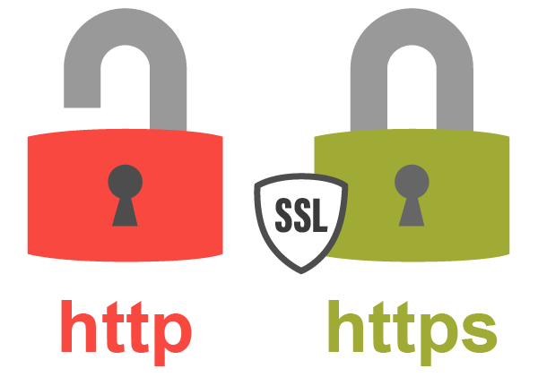  
Please click here for more information on determining whether a website is secure.

Do not be alarmed: the web addresses of many crypto initiatives may not be recognizable.

The prevalence of io.cypto and other domain names of a similar nature is growing, but this should not cause alarm.

DO NOT EVER:

Share information that is not accessible to the general public on websites, forms, and registrations. In order to link your wallet to a website or service, it may be necessary to disclose your XRP wallet's address. Your secret keys are private for a reason; giving them away would be the same as opening your wallet and saying "help yourself" or leaving the doors to your home or vehicle unlocked.

**Lesson 5 – Website - Online Presence Quiz**

1. **True or False: For a REAL project, a crypto web address is required.**
   * https://lh6.googleusercontent.com/zA_wbT0o3Ku3Xt-KW5ksElEYuv6nx5nqQcNfULnU8mHJmzRiewMlDDwJx4ypEZ9oM6LmNLyPcSo1CkJi7s0LugvX0OTNypbqIwev2ItYRj3_Ij-ebV6tUyQzVeP3O19cfwYC01QGokx33K27kLXw9g True
   * https://lh3.googleusercontent.com/cX0DvsbciaSgCp9Mnb8Wq-83MAQ1sXYmuQE8EDXkNjjBpI9s4lzTbRmBJGaynnFiSRsyYSZ74JkhWDogOnrOepfzcdzKz6Co3yJTeHKMKddCRN486gzIpkwOz3ewIHLcOBcH98XsbfM250Fnk4cm0w False

Correct

Right Answer: **False**

1. **True or False: It is acceptable to use my secret key on a website.**
   * https://lh6.googleusercontent.com/zA_wbT0o3Ku3Xt-KW5ksElEYuv6nx5nqQcNfULnU8mHJmzRiewMlDDwJx4ypEZ9oM6LmNLyPcSo1CkJi7s0LugvX0OTNypbqIwev2ItYRj3_Ij-ebV6tUyQzVeP3O19cfwYC01QGokx33K27kLXw9g True: If they require it to sign you up, it is acceptable.
   * https://lh3.googleusercontent.com/cX0DvsbciaSgCp9Mnb8Wq-83MAQ1sXYmuQE8EDXkNjjBpI9s4lzTbRmBJGaynnFiSRsyYSZ74JkhWDogOnrOepfzcdzKz6Co3yJTeHKMKddCRN486gzIpkwOz3ewIHLcOBcH98XsbfM250Fnk4cm0w False: NEVER NEVER NEVER provide information that is not publicly available

Correct

Right Answer: **NEVER NEVER NEVER provide information that is not publicly available**

**Lesson 6 – Doxxing – A face to a name**

Doxxing is when a project's team introduces themselves to the public. Knowing that there are genuine people behind a genuine initiative and that they are willing to put their identities (and reputations) on the line fosters trust in the project and is typically a vote of confidence.

Doxx is the abbreviation for Document-Of-X, or dox. Where 'x' represents any individual, organization, or thing that may be Doxable.

  
Anonymous is inadequate. When investing in a project, you are investing in people.

Caution is advised: a website claiming Lauren as the program's creator, Dave as the director of marketing, Devon as the visual artist, and Mario as the chief financial officer is meaningless.

What are you anticipating from a Team Doxx?

You need full names, locations, and as much information as possible regarding their roles.

If the project includes a link to their personal Twitter profiles (if they have one), it is a step in the right direction, but it would be much more effective if they also included a link to their professional LinkedIn profiles. However, it would be preferable if they could supply a GlobalID username or link. This will provide you with access to reliable, fully-verified information and go a long way toward establishing their identity.

KYC, or Know Your Customer, is a measure utilized by a variety of Cex's, Dex's, and platforms that facilitate the issuance of new projects/tokens. The absence of Know Your Customer (KYC) should serve as a red flag, as it would make reporting criminal activity to authorities significantly more difficult.

**Lesson 6 – Doxxing – A face to a name Quiz**

1. **If project teams are not doxxed...**
   * https://lh6.googleusercontent.com/zA_wbT0o3Ku3Xt-KW5ksElEYuv6nx5nqQcNfULnU8mHJmzRiewMlDDwJx4ypEZ9oM6LmNLyPcSo1CkJi7s0LugvX0OTNypbqIwev2ItYRj3_Ij-ebV6tUyQzVeP3O19cfwYC01QGokx33K27kLXw9g It implies that you should not invest.
   * https://lh3.googleusercontent.com/cX0DvsbciaSgCp9Mnb8Wq-83MAQ1sXYmuQE8EDXkNjjBpI9s4lzTbRmBJGaynnFiSRsyYSZ74JkhWDogOnrOepfzcdzKz6Co3yJTeHKMKddCRN486gzIpkwOz3ewIHLcOBcH98XsbfM250Fnk4cm0w It indicates that you must proceed with extreme caution because you know nothing about the people behind the project.

Correct

Right Answer: **It indicates that you must proceed with extreme caution because you know nothing about the people behind the project.**

1. **If you have KYC and/or GlobalID, you can contact them if necessary.**
   * https://lh6.googleusercontent.com/zA_wbT0o3Ku3Xt-KW5ksElEYuv6nx5nqQcNfULnU8mHJmzRiewMlDDwJx4ypEZ9oM6LmNLyPcSo1CkJi7s0LugvX0OTNypbqIwev2ItYRj3_Ij-ebV6tUyQzVeP3O19cfwYC01QGokx33K27kLXw9g True: all their information is available
   * https://lh3.googleusercontent.com/cX0DvsbciaSgCp9Mnb8Wq-83MAQ1sXYmuQE8EDXkNjjBpI9s4lzTbRmBJGaynnFiSRsyYSZ74JkhWDogOnrOepfzcdzKz6Co3yJTeHKMKddCRN486gzIpkwOz3ewIHLcOBcH98XsbfM250Fnk4cm0w False: However, this makes them easier to identify should authorities become involved.

Correct

Right Answer: **However, this makes them easier to identify should authorities become involved.**

**Lesson 7: Lives/AMA’s – Real People**

*Length: 10 minutes*

There are certain project team members and people that prefer to work in the background.

Eventually, though, a project must be readied for public display. The basic least would be participation in a Twitter spaces discussion, but it would be preferable if they had also engaged in YouTube livestreams or AMAs (ask me anything), which provide public visibility and inspire faith in the idea.

As you begin to follow more individuals in this area, you may frequently engage in Spaces discussions sponsored by a wide variety of initiatives or Twitter celebrities. These are generally There are members of the project team who prefer to work in the background.

However, a project must eventually be prepared for public display. The bare minimum would be participation in a Twitter spaces discussion, but it would be preferable if they had also participated in YouTube livestreams or AMAs (ask me anything), which provide public visibility and instill confidence in the concept.

As you follow more people in this field, you may frequently participate in Spaces discussions sponsored by numerous initiatives or Twitter celebrities. These are commonly



Do not be afraid to inquire when a project intends to host live chats, AMAs, or make their videos publicly accessible.

If they refuse, you must inquire as to why...

There should be no reason for a project to not be accessible to its potential investors/holders; ultimately, they are accountable to you.

Don't be just a listener. If you have something on your mind, it is likely that others do as well. Be the one to ask the challenging questions.

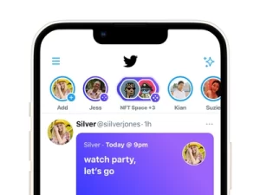

**Lesson 7: Lives/AMA’s – Real People Quiz**

1. **What are AMAs?**
   * https://lh6.googleusercontent.com/zA_wbT0o3Ku3Xt-KW5ksElEYuv6nx5nqQcNfULnU8mHJmzRiewMlDDwJx4ypEZ9oM6LmNLyPcSo1CkJi7s0LugvX0OTNypbqIwev2ItYRj3_Ij-ebV6tUyQzVeP3O19cfwYC01QGokx33K27kLXw9g Automatic Money Accreditation
   * https://lh3.googleusercontent.com/cX0DvsbciaSgCp9Mnb8Wq-83MAQ1sXYmuQE8EDXkNjjBpI9s4lzTbRmBJGaynnFiSRsyYSZ74JkhWDogOnrOepfzcdzKz6Co3yJTeHKMKddCRN486gzIpkwOz3ewIHLcOBcH98XsbfM250Fnk4cm0w Ask Me Anything
   * https://lh6.googleusercontent.com/zA_wbT0o3Ku3Xt-KW5ksElEYuv6nx5nqQcNfULnU8mHJmzRiewMlDDwJx4ypEZ9oM6LmNLyPcSo1CkJi7s0LugvX0OTNypbqIwev2ItYRj3_Ij-ebV6tUyQzVeP3O19cfwYC01QGokx33K27kLXw9g Ask Me Anonymously

Correct

Right Answer: **Ask Me Anything**

1. **True or False: A project that does not conduct AMA's cannot be relied upon.**
   * https://lh3.googleusercontent.com/cX0DvsbciaSgCp9Mnb8Wq-83MAQ1sXYmuQE8EDXkNjjBpI9s4lzTbRmBJGaynnFiSRsyYSZ74JkhWDogOnrOepfzcdzKz6Co3yJTeHKMKddCRN486gzIpkwOz3ewIHLcOBcH98XsbfM250Fnk4cm0w True: If they are unwilling to put themselves out there, they cannot be trusted under any circumstances.
   * https://lh6.googleusercontent.com/zA_wbT0o3Ku3Xt-KW5ksElEYuv6nx5nqQcNfULnU8mHJmzRiewMlDDwJx4ypEZ9oM6LmNLyPcSo1CkJi7s0LugvX0OTNypbqIwev2ItYRj3_Ij-ebV6tUyQzVeP3O19cfwYC01QGokx33K27kLXw9g False: There could be a number of reasons why they cannot, including language barriers.

Incorrect

Right Answer: **False: If they are unwilling to put themselves out there, they cannot be trusted under any circumstances.**

**Lesson 8: Blackholing – Limiting Inflation**

Before investing in a project, you should become intimately acquainted with the project and its objectives (whitepaper). The second step is to determine whether the account that issued the token is a blackhole.

**What does it mean to be blackholed?**

If a project chooses to blackhole its issuing address after issuing tokens, it will never be able to issue additional tokens. As an investor in this token, protection against inflation caused by the issuance of new tokens, which would decrease the value of your holdings, should be advantageous. In the case of NFT projects that use a token as a promissory note against an NFT, you are aware that a blackholed account will ensure a degree of rarity (and, consequently, value) for the NFTs. In some instances, however, the use case will mean that blackholing will reduce the utility of the project. If the token is used as a means of rewards, for instance, its utility will cease once all tokens have been issued.



**Let’s take Lazatech as an example:**

After 100 million native tokens were issued, the $LZT issuance address was blackholed. The logic is that as the project grows, the value of these tokens will increase as their supply is limited and their demand increases.

You are responsible for determining whether the reasons for not blackholing are valid, and genuine projects should not be offended by your questions about blackholing unless they have something to hide.

For more information on how to verify whether a token is blackholed or not, please refer to our upcoming forensics course. Until then, you can find this information in their whitepaper or on their social media accounts.

**Lesson 8: Blackholing – Limiting Inflation Quiz**

1. **What is the definition of blockholing?**
   * https://lh6.googleusercontent.com/zA_wbT0o3Ku3Xt-KW5ksElEYuv6nx5nqQcNfULnU8mHJmzRiewMlDDwJx4ypEZ9oM6LmNLyPcSo1CkJi7s0LugvX0OTNypbqIwev2ItYRj3_Ij-ebV6tUyQzVeP3O19cfwYC01QGokx33K27kLXw9g It implies that if you keep your crypto away from sunlight, it's safe.
   * https://lh3.googleusercontent.com/cX0DvsbciaSgCp9Mnb8Wq-83MAQ1sXYmuQE8EDXkNjjBpI9s4lzTbRmBJGaynnFiSRsyYSZ74JkhWDogOnrOepfzcdzKz6Co3yJTeHKMKddCRN486gzIpkwOz3ewIHLcOBcH98XsbfM250Fnk4cm0w It means that a project cannot issue additional tokens to increase circulation.

Correct

Right Answer: **It means that a project cannot issue additional tokens to increase circulation.**

1. **Is a project less reliable because it has not been blackholed?**
   * https://lh6.googleusercontent.com/zA_wbT0o3Ku3Xt-KW5ksElEYuv6nx5nqQcNfULnU8mHJmzRiewMlDDwJx4ypEZ9oM6LmNLyPcSo1CkJi7s0LugvX0OTNypbqIwev2ItYRj3_Ij-ebV6tUyQzVeP3O19cfwYC01QGokx33K27kLXw9g Absolutely. No blackhole = red flag
   * https://lh3.googleusercontent.com/cX0DvsbciaSgCp9Mnb8Wq-83MAQ1sXYmuQE8EDXkNjjBpI9s4lzTbRmBJGaynnFiSRsyYSZ74JkhWDogOnrOepfzcdzKz6Co3yJTeHKMKddCRN486gzIpkwOz3ewIHLcOBcH98XsbfM250Fnk4cm0w It's not that simple; you must consider the project's utility before rendering a verdict.

Correct**5/5 $TRSRY**

Right Answer: **It's not that simple; you must consider the project's utility before rendering a verdict.**

**Lesson 9: Who’s Holding What – Power In Numbers**

This is a crucial component of DYOR. Before investing in a project, you should always verify how and by whom the token supply is held.

Ordinarily, a large number of tokens will be stored in one or multiple wallets. This is commonplace. Depending on how the project organizes its "Project Wallets," one may contain tokens intended for air drops or rewards, while the other may contain team payments/project/listings budget. There may also be any number of project officers with personal wallets containing substantial sums. This should not be a concern, but the larger the amount the project is withholding, the more you should investigate why.

In general, a wallet containing more than 25 percent should be detailed somewhere, and if it isn't, you should be suspicious.

**“The classic rug pull”**

This occurs when a small portion of the total supply of tokens is sold in pre-sale or distributed via air drops, the project is then pumped, and those running the project dump their massive holdings when the token price reaches a reasonable valuation, leaving the holders with nothing.

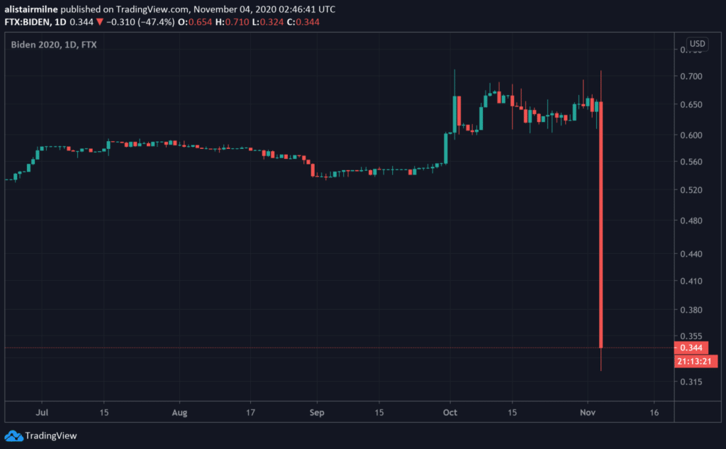

You may also fall victim to a slower rug, in which project developers slowly sell off their holdings to make the change less noticeable in the charts. Always keep an eye on the top 10 wallets holding the project's token, and be aware of what other community members are saying.

In the project's whitepaper, the majority of this information should be detailed under the heading Tokenomics. Some platforms, including xpmarket.io and xrplcoins.com, will display the Richlist (top holding wallets) for any project you are considering investing in. If this is not possible, and if you have any questions, you should ask them via one of their social media platforms. Remember that as an investor you have the right to inquire about any aspect of the project, and that it is their responsibility to provide you with clarity, so don't be shy.

**Lesson 9: Who’s Holding What – Power In Numbers Quiz**

1. **What is a rugpull?**
   * https://lh3.googleusercontent.com/cX0DvsbciaSgCp9Mnb8Wq-83MAQ1sXYmuQE8EDXkNjjBpI9s4lzTbRmBJGaynnFiSRsyYSZ74JkhWDogOnrOepfzcdzKz6Co3yJTeHKMKddCRN486gzIpkwOz3ewIHLcOBcH98XsbfM250Fnk4cm0wIt is a well-known scam in which an individual or group launches a project, promotes it to attract investors, and then sells their holdings in order to profit.
   * https://lh6.googleusercontent.com/zA_wbT0o3Ku3Xt-KW5ksElEYuv6nx5nqQcNfULnU8mHJmzRiewMlDDwJx4ypEZ9oM6LmNLyPcSo1CkJi7s0LugvX0OTNypbqIwev2ItYRj3_Ij-ebV6tUyQzVeP3O19cfwYC01QGokx33K27kLXw9g In a rugpull, investors are asked to search their couches and rugs for spare cash that can be used to purchase additional tokens.

Correct

Right Answer**: It is a well-known scam in which an individual or group launches a project, promotes it to attract investors, and then sells their holdings in order to profit.**

1. **What are the red flags to watch out for in projects that may result in rug pulling?**
   * https://lh6.googleusercontent.com/zA_wbT0o3Ku3Xt-KW5ksElEYuv6nx5nqQcNfULnU8mHJmzRiewMlDDwJx4ypEZ9oM6LmNLyPcSo1CkJi7s0LugvX0OTNypbqIwev2ItYRj3_Ij-ebV6tUyQzVeP3O19cfwYC01QGokx33K27kLXw9g A small number of wallets hold the majority of the token supply.
   * https://lh6.googleusercontent.com/zA_wbT0o3Ku3Xt-KW5ksElEYuv6nx5nqQcNfULnU8mHJmzRiewMlDDwJx4ypEZ9oM6LmNLyPcSo1CkJi7s0LugvX0OTNypbqIwev2ItYRj3_Ij-ebV6tUyQzVeP3O19cfwYC01QGokx33K27kLXw9g A project that launches with a token pre-sale and promises of enormous returns on investment.
   * https://lh6.googleusercontent.com/zA_wbT0o3Ku3Xt-KW5ksElEYuv6nx5nqQcNfULnU8mHJmzRiewMlDDwJx4ypEZ9oM6LmNLyPcSo1CkJi7s0LugvX0OTNypbqIwev2ItYRj3_Ij-ebV6tUyQzVeP3O19cfwYC01QGokx33K27kLXw9g Developers of the project who remain anonymous and cannot be contacted if you have any questions
   * https://lh3.googleusercontent.com/cX0DvsbciaSgCp9Mnb8Wq-83MAQ1sXYmuQE8EDXkNjjBpI9s4lzTbRmBJGaynnFiSRsyYSZ74JkhWDogOnrOepfzcdzKz6Co3yJTeHKMKddCRN486gzIpkwOz3ewIHLcOBcH98XsbfM250Fnk4cm0w ALL OF THE ABOVE

Correct

Right Answer: **ALL OF THE ABOVE**

**Lesson 10: Don’t “buy big green candles” – as the saying goes**

This is classic FOMO (Fear of Missing Out).

You hear about a project, you join their social media platforms only to see people going crazy with excitement, and you think to yourself, "I need to join this project before I miss out." Everyone has been there. STOP. Too many investors are burned by buying when the price is soaring, only to discover they bought at the peak. You are then committed to the project with the hope that it will reach another All-Time-High (ATH) soon; otherwise, you must choose between selling at a loss or holding for the long term.

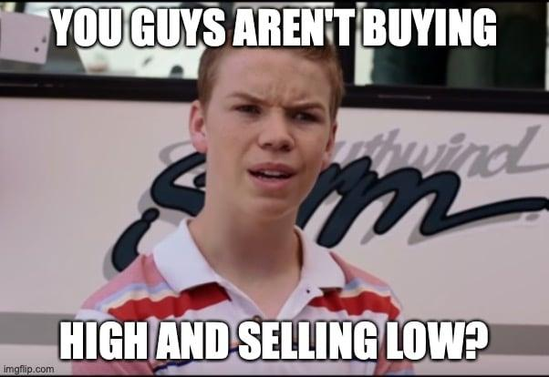

Instead, if you can identify genuine projects that are experiencing a decline and buy when the candles are red, your chances of earning a profit in the short term increase dramatically. There is no reason to believe that the price will not decline further. This is when chart analysis becomes a truly invaluable tool (See our module on Chart Analysis), as it enables you to interpret the price action and attempt to predict how the price will fluctuate over the next few hours/days/weeks.

**Lesson 10: Don’t “buy big green candles” – as the saying goes Quiz**

1. **True or False: Buying when everyone else is buying can only be advantageous.**
   * https://lh6.googleusercontent.com/zA_wbT0o3Ku3Xt-KW5ksElEYuv6nx5nqQcNfULnU8mHJmzRiewMlDDwJx4ypEZ9oM6LmNLyPcSo1CkJi7s0LugvX0OTNypbqIwev2ItYRj3_Ij-ebV6tUyQzVeP3O19cfwYC01QGokx33K27kLXw9g True: Do what others seem to be doing.
   * https://lh3.googleusercontent.com/cX0DvsbciaSgCp9Mnb8Wq-83MAQ1sXYmuQE8EDXkNjjBpI9s4lzTbRmBJGaynnFiSRsyYSZ74JkhWDogOnrOepfzcdzKz6Co3yJTeHKMKddCRN486gzIpkwOz3ewIHLcOBcH98XsbfM250Fnk4cm0w False, check the graph and avoid purchasing when the project is surging, as this is frequently followed by a correction or even a dump.

Correct

Right Answer: **False, check the graph and avoid purchasing when the project is surging, as this is frequently followed by a correction or even a dump.**

1. **What is FOMO?**
   * https://lh6.googleusercontent.com/zA_wbT0o3Ku3Xt-KW5ksElEYuv6nx5nqQcNfULnU8mHJmzRiewMlDDwJx4ypEZ9oM6LmNLyPcSo1CkJi7s0LugvX0OTNypbqIwev2ItYRj3_Ij-ebV6tUyQzVeP3O19cfwYC01QGokx33K27kLXw9g Fear Of Moving On
   * https://lh3.googleusercontent.com/cX0DvsbciaSgCp9Mnb8Wq-83MAQ1sXYmuQE8EDXkNjjBpI9s4lzTbRmBJGaynnFiSRsyYSZ74JkhWDogOnrOepfzcdzKz6Co3yJTeHKMKddCRN486gzIpkwOz3ewIHLcOBcH98XsbfM250Fnk4cm0w Fear Of Missing Out

Correct

Right Answer: **Fear Of Missing Out**

**Lesson 11: Buy the F E A R – timing your entry**

When contemplating an investment, it is always prudent to pause, take a step back, and assess the market from a broader perspective.

This can be accomplished by reading all of your preferred news sources, watching YouTube roundups from reputable and trustworthy YouTubers, and gauging the general sentiment on social media and in your chat groups.

Fear and Greed Index is an additional popular tool. This is updated frequently and generates a current Fear & Greed rating based on a variety of factors including trends, volatility, general sentiment, and more.

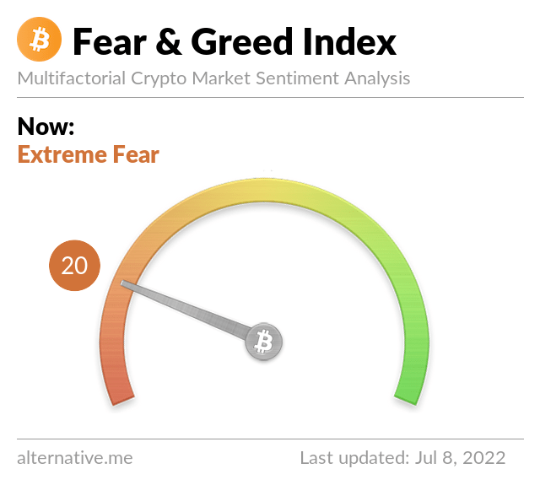

This value ranges from 0 to 100, where 0 indicates Extreme Fear and 100 indicates Extreme Greed. This will help you determine when it may be prudent to consider additional investments:

**As a general rule:**

This value ranges from 0 to 100, with 0 representing Extreme Fear and 100 representing Extreme Greed. This can help you determine if it's a good time to consider additional investments:

**Lesson 11: Buy the F E A R – timing your entry Quiz**

Congratulations! You have passed this quiz achieving 100%

1. **What does the Fear & Greed index measure?**
   * https://lh3.googleusercontent.com/V7zQGTlS1G4iHJyZdMxaAstrT8cDZiS7DY-XGa3MLSiTwfRsAmTo8AOB99uwdo5gvOFOLqHICTsMLaKVUVbXNoOaPQbCsfQbPcm_HEX3iuFCOzW6OlFEczfV9LNFpsd8RPopGOrh6aD72ljQgq9akQ It reflects the overall market sentiment of investors.
   * It indicates the amount of cryptocurrency currently available for purchase on the market.

Correct

Right Answer: It reflects the overall market sentiment of investors.

1. **True or False: Before deciding to invest, all I need to do is examine the Fear & Greed index.**
   * https://lh6.googleusercontent.com/yPUYhxcDHtZ-Z0B1D0PhBangmlSWz-NvQcx1a7huL5fYbG3sD7t-dqaZxAB518UJ6Cn0kcgALXTgHr9m7dkkh_D6Rdp_xtMWLH0WPgmMMHcQpra9TNh9kiHWDK0CtvFRGdC-v0qLaQyr4grFfKyoFQ True
   * https://lh3.googleusercontent.com/V7zQGTlS1G4iHJyZdMxaAstrT8cDZiS7DY-XGa3MLSiTwfRsAmTo8AOB99uwdo5gvOFOLqHICTsMLaKVUVbXNoOaPQbCsfQbPcm_HEX3iuFCOzW6OlFEczfV9LNFpsd8RPopGOrh6aD72ljQgq9akQ False

Correct

Right Answer: **False**

Course 4: Market Skills & Trading      In this thorough course, we examine every element of trading on XRPL. From market fundamentals to blockchain principles, as well as learning to analyze charts, trendlines, and more.  
  
This module offers a good beginner’s guide to the crypto market.  
 **Course 4.1: Market Basics**

  This module offers a good beginner’s guide to the crypto market.

**Lesson 1: Volume**

Congratulations! You have passed this lesson's quiz achieving 100%

*Length: 10 minutes*

  The total number of shares of a token traded during a given time period is referred to as trading volume. Trading volume is a technical indicator because it represents a token’s or a market’s overall activity. Trading volume is frequently used by investors to confirm the existence or continuation of a trend or trend reversal.  
 Trading volume can assist an investor in determining the strength of a project’s momentum and confirming a trend. Prices tend to move in the same direction as trading volume increases. That is, if a token’s price continues to rise in an uptrend, its volume should rise as well, and vice versa.  
Due to low activity, trading volume can also indicate when an investor should take profits and sell a token. If there is no correlation between trading volume and a token’s price, it indicates a weakness in the current trend and the possibility of a reversal.  
  
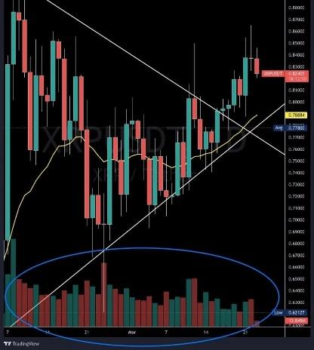

In the example above, the volume bars are shown at the bottom. When the price closes lower than the opening price the bar will be red, and when the price closes higher than the opening price the bar will be green.

**Lesson 1: Volume Quiz**

Congratulations! You have passed this quiz achieving 100%[**NEXT LESSON**](https://www.trsryxrpl.com/lesson/lesson-2-market-caps-and-dilution/)

1. **Prices tend to move in the _____ direction as trading volume increases?**
   * https://lh6.googleusercontent.com/nqnbeE1cUSJOY2gbCYYNOU-K4aZtEGdquQln2u199gUv6LzvY0AdprUvO7r5iU_ckMGl_IJfmDOMe6H5ITs78GjRGvxAui_QmZUFwZYxZWtUW9AAytP4IijvJAweIOI6dYyb8tKFvh4YzwBD5Q Wrong
   * https://lh6.googleusercontent.com/nqnbeE1cUSJOY2gbCYYNOU-K4aZtEGdquQln2u199gUv6LzvY0AdprUvO7r5iU_ckMGl_IJfmDOMe6H5ITs78GjRGvxAui_QmZUFwZYxZWtUW9AAytP4IijvJAweIOI6dYyb8tKFvh4YzwBD5Q Different
   * https://lh4.googleusercontent.com/cWje2kaNyzsGDAWCrIbeL1XjYZPAMWBaum5iZn1IlsPk2gNZ1gbNIln6efaCHcj_pQKVhwBRl8HWOzbm3AcvyK3lZtxVUKffo5RYsITixsDjVljGNS-xPdhlhEtQMR3wbB-hbg9Gf2lLBB468g Same
   * https://lh6.googleusercontent.com/nqnbeE1cUSJOY2gbCYYNOU-K4aZtEGdquQln2u199gUv6LzvY0AdprUvO7r5iU_ckMGl_IJfmDOMe6H5ITs78GjRGvxAui_QmZUFwZYxZWtUW9AAytP4IijvJAweIOI6dYyb8tKFvh4YzwBD5Q None of the above

Correct**4/4 $TRSRY**

1. **True or false: A red volume bar represents the price closing higher than the opening price during the time period?**
   * https://lh6.googleusercontent.com/nqnbeE1cUSJOY2gbCYYNOU-K4aZtEGdquQln2u199gUv6LzvY0AdprUvO7r5iU_ckMGl_IJfmDOMe6H5ITs78GjRGvxAui_QmZUFwZYxZWtUW9AAytP4IijvJAweIOI6dYyb8tKFvh4YzwBD5Q True
   * https://lh4.googleusercontent.com/cWje2kaNyzsGDAWCrIbeL1XjYZPAMWBaum5iZn1IlsPk2gNZ1gbNIln6efaCHcj_pQKVhwBRl8HWOzbm3AcvyK3lZtxVUKffo5RYsITixsDjVljGNS-xPdhlhEtQMR3wbB-hbg9Gf2lLBB468g False

Correct**4/4 $TRSRY**

**Lesson 2: Market Caps and Dilution**

Congratulations! You have passed this lesson's quiz achieving 100%

*Length: 10 minutes*

  Market capitalization is the total network value of a cryptocurrency at any given time, or the sum of all coins currently in circulation multiplied by the coin’s current price.

**Total crypto market capitalization  
=  
circulating supply of coins  
X  
price per coin**

  The market cap of a cryptocurrency is frequently used to rank its popularity and size — a cryptocurrency with a higher market cap is often regarded as more popular, as there are more crypto holders willing to hold the coin at the current price, contributing to a higher network value.  
A fully diluted market cap, on the other hand, calculates the market cap after all coins have been issued. It is the sum of the coin’s maximum supply multiplied by its current price.  
 For example, there are currently 18.782 million Bitcoin in circulation, while the total number of Bitcoin that will ever be minted is 21 million.  
 The issue with the fully diluted market cap is that, while it shows a higher market cap, it ignores any potential decrease in token price with the eventual increase in circulating supply.  
Fully diluted market cap assumes that the market cap will rise in direct proportion to the current circulating supply at any given time in the future. That, however, may not be the case. In theory, as the supply of the token increases, the price of the token should fall due to oversupply, resulting in token inflation. As a result, when investors consider a fully diluted market cap, they should keep in mind that the metric does not account for the impact of inflation on fully diluted market cap.

**Lesson 2: Market Caps and Dilution Quiz**

Congratulations! You have passed this quiz achieving 100%[**NEXT LESSON**](https://www.trsryxrpl.com/lesson/lesson-3-supply-vs-demand/)

1. **True or false: the market cap of a coin is the circulating supply of the coin divided by the price per coin?**
   * https://lh6.googleusercontent.com/nqnbeE1cUSJOY2gbCYYNOU-K4aZtEGdquQln2u199gUv6LzvY0AdprUvO7r5iU_ckMGl_IJfmDOMe6H5ITs78GjRGvxAui_QmZUFwZYxZWtUW9AAytP4IijvJAweIOI6dYyb8tKFvh4YzwBD5Q True
   * https://lh4.googleusercontent.com/cWje2kaNyzsGDAWCrIbeL1XjYZPAMWBaum5iZn1IlsPk2gNZ1gbNIln6efaCHcj_pQKVhwBRl8HWOzbm3AcvyK3lZtxVUKffo5RYsITixsDjVljGNS-xPdhlhEtQMR3wbB-hbg9Gf2lLBB468g False

Correct**4/4 $TRSRY**

1. **True or false: a fully diluted market cap is the sum of the coin’s maximum supply multiplied by its current price?**
   * https://lh4.googleusercontent.com/cWje2kaNyzsGDAWCrIbeL1XjYZPAMWBaum5iZn1IlsPk2gNZ1gbNIln6efaCHcj_pQKVhwBRl8HWOzbm3AcvyK3lZtxVUKffo5RYsITixsDjVljGNS-xPdhlhEtQMR3wbB-hbg9Gf2lLBB468g True
   * https://lh6.googleusercontent.com/nqnbeE1cUSJOY2gbCYYNOU-K4aZtEGdquQln2u199gUv6LzvY0AdprUvO7r5iU_ckMGl_IJfmDOMe6H5ITs78GjRGvxAui_QmZUFwZYxZWtUW9AAytP4IijvJAweIOI6dYyb8tKFvh4YzwBD5Q False

Correct**4/4 $TRSRY**

**Lesson 3: Supply vs Demand**

Congratulations! You have passed this lesson's quiz achieving 50%

*Length: 10 minutes*

  Supply and Demand is an important factor to consider, not just within the cryptocurrency space, but in everyday life. Understanding this relationship will further your understanding of market structure.

  Below is a basic explanation of the Supply Vs Demand laws, these laws work together to balance out the prices for every product on Earth and dictate the market price of cryptocurrency and all other free markets.

* Supply is the amount of the good that is being sold onto the market. At higher prices, it is desired for the supply to the market to be continuously increased as it is more profitable to sellers. At lower prices, it is less desirable to increase the sale supply as profits are reduced.
* Demand is the quantity of the good that consumers wish to buy at different prices. At higher prices, less will be demanded. As the prices are reduced the demand for the good will increase drastically.

Buyers are the demand, which is also considered the support, while the sellers are the supply, which are the resistance. Support is the point at which demand exceeds supply, causing the price to rise/increase. The level of resistance will be the point at which supply exceeds demand, causing the price to fall/decrease. In trading, supply and demand zones are typically liquidity pools. When an asset exhibits a sharp rise or decline, large institutional players or whales may miss the entry or exit due to the size of the orders. When this happens, they leave pending buy and sell orders at the bottom of the liquidity zones, hoping that the price will return to fill the remaining orders. A high price rise zone is the demand zone (support), and a sharp price decline zone is the supply zone (resistance).

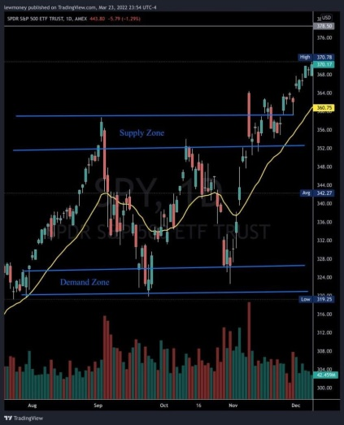

**Lesson 3: Supply Vs Demand Quiz**

Congratulations! You have passed this quiz achieving 50%[**NEXT LESSON**](https://www.trsryxrpl.com/lesson/lesson-4-token-inflation/)

1. **In most cases when a coin reaches a supply zone, it tends to _____?**
   * https://lh6.googleusercontent.com/nqnbeE1cUSJOY2gbCYYNOU-K4aZtEGdquQln2u199gUv6LzvY0AdprUvO7r5iU_ckMGl_IJfmDOMe6H5ITs78GjRGvxAui_QmZUFwZYxZWtUW9AAytP4IijvJAweIOI6dYyb8tKFvh4YzwBD5Q Breakthrough it with no issues
   * https://lh4.googleusercontent.com/cWje2kaNyzsGDAWCrIbeL1XjYZPAMWBaum5iZn1IlsPk2gNZ1gbNIln6efaCHcj_pQKVhwBRl8HWOzbm3AcvyK3lZtxVUKffo5RYsITixsDjVljGNS-xPdhlhEtQMR3wbB-hbg9Gf2lLBB468g Sharply fall or decline
   * https://lh6.googleusercontent.com/nqnbeE1cUSJOY2gbCYYNOU-K4aZtEGdquQln2u199gUv6LzvY0AdprUvO7r5iU_ckMGl_IJfmDOMe6H5ITs78GjRGvxAui_QmZUFwZYxZWtUW9AAytP4IijvJAweIOI6dYyb8tKFvh4YzwBD5Q Jump over it like it’s a puddle

Correct**4/4 $TRSRY**

1. **Looking at the chart below, which would be a good time to buy into a coin?**

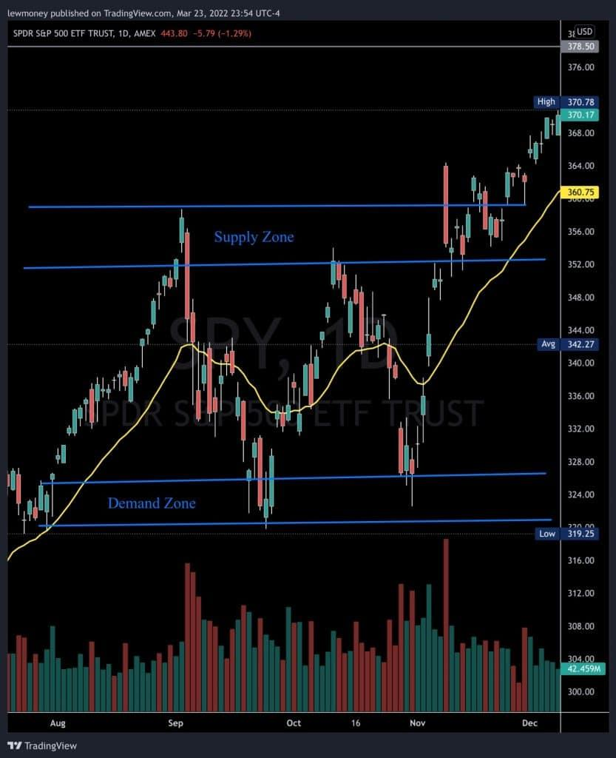

* https://lh4.googleusercontent.com/cWje2kaNyzsGDAWCrIbeL1XjYZPAMWBaum5iZn1IlsPk2gNZ1gbNIln6efaCHcj_pQKVhwBRl8HWOzbm3AcvyK3lZtxVUKffo5RYsITixsDjVljGNS-xPdhlhEtQMR3wbB-hbg9Gf2lLBB468g When it is about to hit the supply zone
* https://lh6.googleusercontent.com/nqnbeE1cUSJOY2gbCYYNOU-K4aZtEGdquQln2u199gUv6LzvY0AdprUvO7r5iU_ckMGl_IJfmDOMe6H5ITs78GjRGvxAui_QmZUFwZYxZWtUW9AAytP4IijvJAweIOI6dYyb8tKFvh4YzwBD5Q When it reached the demand zone

Incorrect**0/4 $TRSRY**

Right Answer: **When it reached the demand zone**

**Lesson 4: Token Inflation**

Congratulations! You have passed this lesson's quiz achieving 50%

*Length: 10 minutes*

In the cryptocurrency market, inflationary tokens differ from inflationary fiat assets.  
An inflationary token will be printed indefinitely, with no cap on the number of tokens that can ever be created. There are variations on the inflationary token model, with some tokens limiting token creation to once a year and others operating on a fixed schedule in perpetuity. This model is most similar to fiat currencies, but because it is dictated by code and a decentralized community rather than a centralized entity, it is more efficient and transparent.  
Over time, the supply of inflationary tokens exceeds the demand. As a result of the supply and demand imbalances, the tokens begin to lose value.  
With the passage of time, the number of deflationary tokens decreases. Their supply is controlled by withdrawing tokens from circulation. There are two methods for removing it:

* Purchase and burn – It entails removing tokens from the system and rendering them unusable. The creator or minting company of deflationary tokens buys back a significant amount of tokens from the general public. They send the tokens to a non-existent address. This permanently removes them from supply. The tokens can no longer be accessed. As a result, the value of tokens rises as demand increases.
* Transactional burn – It entails a certain amount of transaction fees being burned. A fee is charged every time a transaction occurs on the blockchain network. For a high trading volume, the fee is high. Because a portion of the fee is removed, the token becomes deflationary.

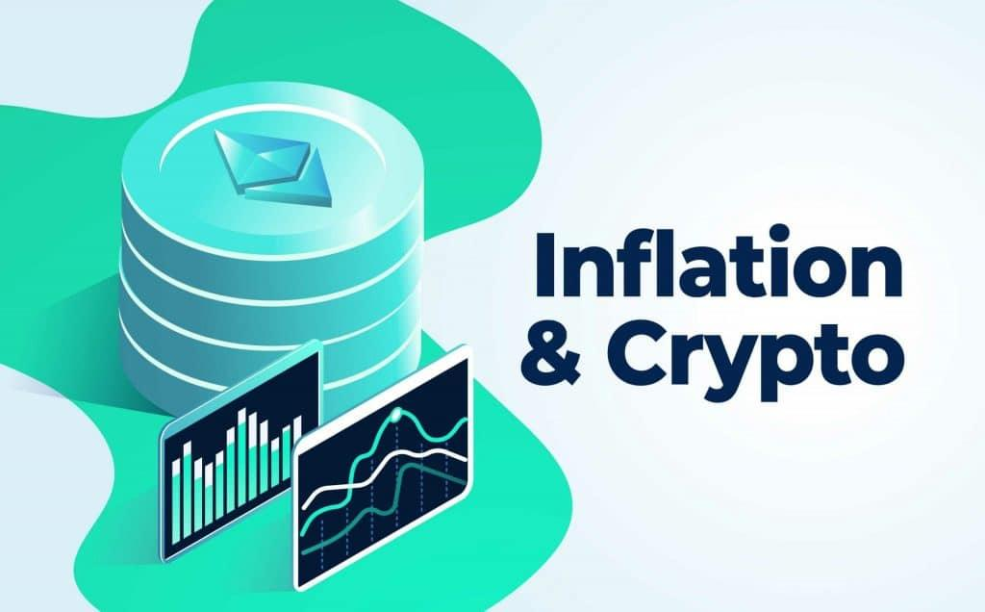

**Lesson 4: Token Inflation Quiz**

Congratulations! You have passed this quiz achieving 50%[**NEXT LESSON**](https://www.trsryxrpl.com/lesson/lesson-5-put-into-practice-coin-price-difference/)

1. **True or false: when the supply of tokens exceeds the demand, tokens will start to lose value?**
   * https://lh4.googleusercontent.com/cWje2kaNyzsGDAWCrIbeL1XjYZPAMWBaum5iZn1IlsPk2gNZ1gbNIln6efaCHcj_pQKVhwBRl8HWOzbm3AcvyK3lZtxVUKffo5RYsITixsDjVljGNS-xPdhlhEtQMR3wbB-hbg9Gf2lLBB468g True
   * https://lh6.googleusercontent.com/nqnbeE1cUSJOY2gbCYYNOU-K4aZtEGdquQln2u199gUv6LzvY0AdprUvO7r5iU_ckMGl_IJfmDOMe6H5ITs78GjRGvxAui_QmZUFwZYxZWtUW9AAytP4IijvJAweIOI6dYyb8tKFvh4YzwBD5Q False

Correct**4/4 $TRSRY**

1. **true or false: when tokens are removed from the supply, demand will decrease?**
   * https://lh4.googleusercontent.com/cWje2kaNyzsGDAWCrIbeL1XjYZPAMWBaum5iZn1IlsPk2gNZ1gbNIln6efaCHcj_pQKVhwBRl8HWOzbm3AcvyK3lZtxVUKffo5RYsITixsDjVljGNS-xPdhlhEtQMR3wbB-hbg9Gf2lLBB468g True
   * https://lh6.googleusercontent.com/nqnbeE1cUSJOY2gbCYYNOU-K4aZtEGdquQln2u199gUv6LzvY0AdprUvO7r5iU_ckMGl_IJfmDOMe6H5ITs78GjRGvxAui_QmZUFwZYxZWtUW9AAytP4IijvJAweIOI6dYyb8tKFvh4YzwBD5Q False

Incorrect**0/4 $TRSRY**

Right Answer: **False**

**Lesson 5: Put into practice: Coin Price Difference**

Congratulations! You have passed this lesson's quiz achieving 100%

*Length: 10 minutes*

In this lesson we are going to look at BTC Vs Shiba Inu.

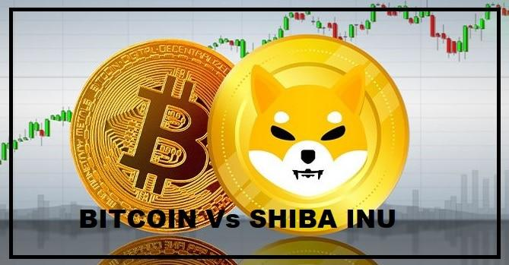

 Bitcoin is currently trading above $40,000 in March 2022, with a market capitalization of $835 billion.  
 SHIB, on the other hand, is currently trading at about $0.0000246. It has a market capitalization of approximately $13.5 billion.

Obviously, BTC is more expensive. Market capitalization, on the other hand, is a better way to understand a cryptocurrency. Though BTC is also far ahead of SHIB in this regard, it demonstrates that the two tokens are not as dissimilar in size as their face-value prices suggest.

 SHIB has more room to grow based solely on market capitalization. Its market cap of $13.5 billion pales in comparison to BTC’s $835 billion. If investors begin to shift their funds into SHIB, prices may rise even further. However, due to the widespread use of SHIB, this change is extremely unlikely.

 In terms of future uses and adoption, BTC is far more likely to be used. Corporations and institutions are already utilizing it. It also supports a much larger number of transactions than SHIB. Bitcoin may be a better long-term investment than SHIB.

**Lesson 5: Put into practice: Coin Price Difference Quiz**

Congratulations! You have passed this quiz achieving 100% [**NEXT LESSON**](https://www.trsryxrpl.com/lesson/lesson-6-effects-on-trading/)

1. **Which coin has a market cap of around $835 billion?**
   * https://lh4.googleusercontent.com/cWje2kaNyzsGDAWCrIbeL1XjYZPAMWBaum5iZn1IlsPk2gNZ1gbNIln6efaCHcj_pQKVhwBRl8HWOzbm3AcvyK3lZtxVUKffo5RYsITixsDjVljGNS-xPdhlhEtQMR3wbB-hbg9Gf2lLBB468g Bitcoin (BTC)
   * https://lh6.googleusercontent.com/nqnbeE1cUSJOY2gbCYYNOU-K4aZtEGdquQln2u199gUv6LzvY0AdprUvO7r5iU_ckMGl_IJfmDOMe6H5ITs78GjRGvxAui_QmZUFwZYxZWtUW9AAytP4IijvJAweIOI6dYyb8tKFvh4YzwBD5Q Shiba Inu (SHIB)

Correct**4/4 $TRSRY**

**Lesson 6: Effects On Trading**

Congratulations! You have passed this lesson's quiz achieving 100%

*Length: 10 minutes*

Inflation and cryptocurrency: These two were supposed to be inseparable — when inflation got hot, crypto was supposed to get even hotter. As a result, your money’s purchasing power may be protected. Despite this, as inflation has risen at the fastest rate in decades, crypto has been so volatile that the relationship has been called into question.

We’ve learned in recent months that big swings in crypto mean it lacks the consistency required to outpace inflation. For example, Bitcoin’s value dropped significantly in 2021, just as consumer prices began to rise — and it dropped again at the end of 2021, which has continued into 2022.  
The acceptance or rejection of cryptocurrency by world governments is another factor that sends cryptocurrency prices skyrocketing or plummeting.

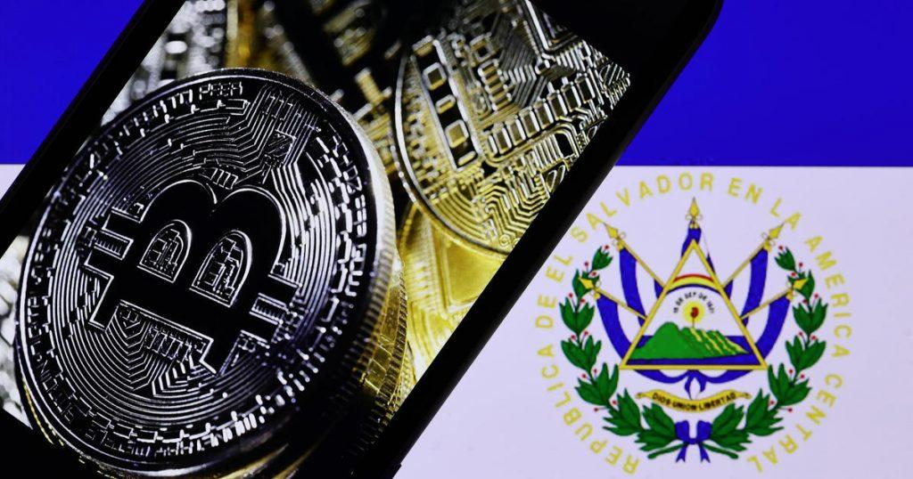*Image courtesy of Getty Images*

For example, when El Salvador decided to become the first country to accept Bitcoin as legal tender, its value increased by 6%.  
Similarly, the Securities and Exchange Commission (SEC) of the United States government classifies cryptocurrencies as securities. As a result, the SEC is attempting to approve cryptocurrency-based exchange-traded funds (EFTs).  
Also, banks in many countries are closed on weekends. When banks close, the volume of cryptocurrency trading decreases.  
Positive news in the media confirming investor safety is another factor that influences cryptocurrency prices. As a result of increased media attention, the general public gains a better understanding of cryptocurrencies and Bitcoin.

From June 2020 to June 2021, the value of cryptocurrency increased by 880 percent after India’s Supreme Court lifted the ban on cryptocurrency.  
Recently, corporate bodies and institutions have expressed confidence in the value of cryptocurrencies, causing their prices to rise. Companies, for example, are converting their cash treasuries into cryptocurrency.

The cost and time required to create a type of cryptocurrency, as well as the purpose, determine its value. The amount of cryptocurrency that the system allows to exist can also have an impact on the price.

**Lesson 6: Effects On Trading Quiz**

Congratulations! You have passed this quiz achieving 100%[**NEXT LESSON**](https://www.trsryxrpl.com/modules/charts-chart-analysis/?course_id=4097)

1. **What was the first country to accept Bitcoin as legal tender?**
   * https://lh6.googleusercontent.com/nqnbeE1cUSJOY2gbCYYNOU-K4aZtEGdquQln2u199gUv6LzvY0AdprUvO7r5iU_ckMGl_IJfmDOMe6H5ITs78GjRGvxAui_QmZUFwZYxZWtUW9AAytP4IijvJAweIOI6dYyb8tKFvh4YzwBD5Q Italy
   * https://lh6.googleusercontent.com/nqnbeE1cUSJOY2gbCYYNOU-K4aZtEGdquQln2u199gUv6LzvY0AdprUvO7r5iU_ckMGl_IJfmDOMe6H5ITs78GjRGvxAui_QmZUFwZYxZWtUW9AAytP4IijvJAweIOI6dYyb8tKFvh4YzwBD5Q USA
   * https://lh4.googleusercontent.com/cWje2kaNyzsGDAWCrIbeL1XjYZPAMWBaum5iZn1IlsPk2gNZ1gbNIln6efaCHcj_pQKVhwBRl8HWOzbm3AcvyK3lZtxVUKffo5RYsITixsDjVljGNS-xPdhlhEtQMR3wbB-hbg9Gf2lLBB468g El Salvador
   * https://lh6.googleusercontent.com/nqnbeE1cUSJOY2gbCYYNOU-K4aZtEGdquQln2u199gUv6LzvY0AdprUvO7r5iU_ckMGl_IJfmDOMe6H5ITs78GjRGvxAui_QmZUFwZYxZWtUW9AAytP4IijvJAweIOI6dYyb8tKFvh4YzwBD5Q China

Correct**4/4 $TRSRY**

1. **True or false: inflation causes cryptocurrency to be less volatile?**
   * https://lh6.googleusercontent.com/nqnbeE1cUSJOY2gbCYYNOU-K4aZtEGdquQln2u199gUv6LzvY0AdprUvO7r5iU_ckMGl_IJfmDOMe6H5ITs78GjRGvxAui_QmZUFwZYxZWtUW9AAytP4IijvJAweIOI6dYyb8tKFvh4YzwBD5Q True
   * https://lh4.googleusercontent.com/cWje2kaNyzsGDAWCrIbeL1XjYZPAMWBaum5iZn1IlsPk2gNZ1gbNIln6efaCHcj_pQKVhwBRl8HWOzbm3AcvyK3lZtxVUKffo5RYsITixsDjVljGNS-xPdhlhEtQMR3wbB-hbg9Gf2lLBB468g False

Correct**4/4 $TRSRY**

**Course 4.2: Charts & Chart Analysis**

[Dive into this module to gain a better understanding of how charts work including interpreting candles, using timeframes and indicators and identifying areas of support and resistance.  
 **Lesson 1 – Candlesticks**](https://www.trsryxrpl.com/quiz/lesson-6-effects-on-trading/)

[Congratulations! You have passed this lesson's quiz achieving 100%](https://www.trsryxrpl.com/quiz/lesson-6-effects-on-trading/)

[*Length: 10 minutes*](https://www.trsryxrpl.com/quiz/lesson-6-effects-on-trading/)

[How to read a candlestick](https://www.trsryxrpl.com/quiz/lesson-6-effects-on-trading/)

[Candlestick charts are generally the most preferred chart amongst traders, they excel in providing a great deal of information about the price action while being really simple to understand. They allow traders to view a prices high and low, as well as its open and close within a short glance. Understanding candlesticks will form the backbone of your trading journey!](https://www.trsryxrpl.com/quiz/lesson-6-effects-on-trading/)

* [The body of the candle is the open and close range of the time frame selected (a 5 min timeframe means each candle represents a 5 minute period). The green candle opens at a price and moves up, and closes at a higher price. The red candle does the opposite, starts at a price and moves down, closing lower.](https://www.trsryxrpl.com/quiz/lesson-6-effects-on-trading/)
* [The wicks are thin lines on the top and bottoms of the candles, they show the high and low range of a candle, of the time frame selected.](https://www.trsryxrpl.com/quiz/lesson-6-effects-on-trading/)
* [The close price of a candle is also the last price traded during the period of the candle formation.](https://www.trsryxrpl.com/quiz/lesson-6-effects-on-trading/)

[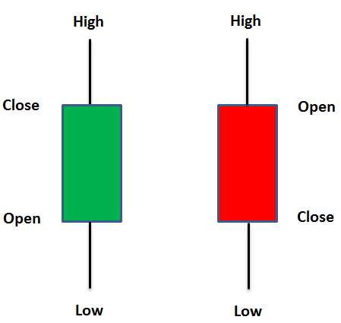](https://www.trsryxrpl.com/quiz/lesson-6-effects-on-trading/)

[**Lesson 1 – Candlesticks Quiz**](https://www.trsryxrpl.com/quiz/lesson-6-effects-on-trading/)

[Congratulations! You have passed this quiz achieving 100%](https://www.trsryxrpl.com/quiz/lesson-6-effects-on-trading/)[**NEXT LESSON**](https://www.trsryxrpl.com/lesson/lesson-2-chart-types/)

1. [**From what you learned about a red candle, can you conclude the current price from the latest candle below?**](https://www.trsryxrpl.com/quiz/lesson-6-effects-on-trading/)

[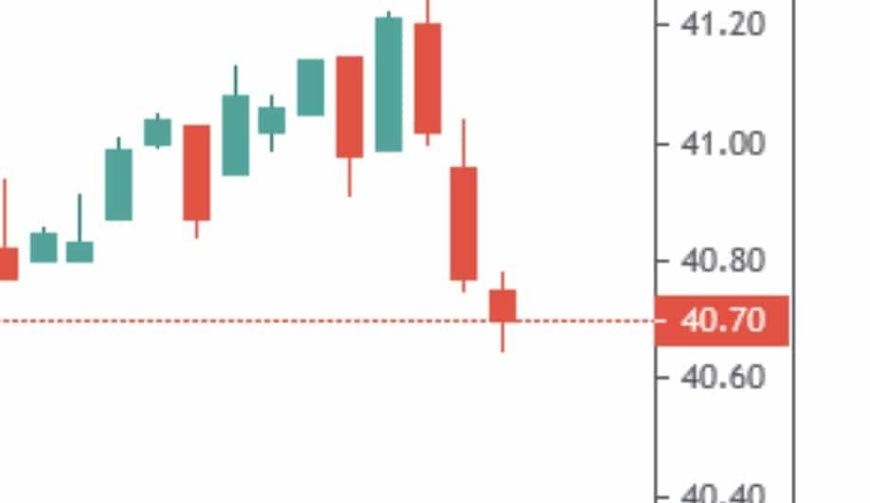](https://www.trsryxrpl.com/quiz/lesson-6-effects-on-trading/)

* [https://lh6.googleusercontent.com/nqnbeE1cUSJOY2gbCYYNOU-K4aZtEGdquQln2u199gUv6LzvY0AdprUvO7r5iU_ckMGl_IJfmDOMe6H5ITs78GjRGvxAui_QmZUFwZYxZWtUW9AAytP4IijvJAweIOI6dYyb8tKFvh4YzwBD5Q $40.80](https://www.trsryxrpl.com/quiz/lesson-6-effects-on-trading/)
* [https://lh6.googleusercontent.com/nqnbeE1cUSJOY2gbCYYNOU-K4aZtEGdquQln2u199gUv6LzvY0AdprUvO7r5iU_ckMGl_IJfmDOMe6H5ITs78GjRGvxAui_QmZUFwZYxZWtUW9AAytP4IijvJAweIOI6dYyb8tKFvh4YzwBD5Q $41.00](https://www.trsryxrpl.com/quiz/lesson-6-effects-on-trading/)
* [https://lh4.googleusercontent.com/cWje2kaNyzsGDAWCrIbeL1XjYZPAMWBaum5iZn1IlsPk2gNZ1gbNIln6efaCHcj_pQKVhwBRl8HWOzbm3AcvyK3lZtxVUKffo5RYsITixsDjVljGNS-xPdhlhEtQMR3wbB-hbg9Gf2lLBB468g $40.70](https://www.trsryxrpl.com/quiz/lesson-6-effects-on-trading/)
* [https://lh6.googleusercontent.com/nqnbeE1cUSJOY2gbCYYNOU-K4aZtEGdquQln2u199gUv6LzvY0AdprUvO7r5iU_ckMGl_IJfmDOMe6H5ITs78GjRGvxAui_QmZUFwZYxZWtUW9AAytP4IijvJAweIOI6dYyb8tKFvh4YzwBD5Q None of the above](https://www.trsryxrpl.com/quiz/lesson-6-effects-on-trading/)

[Correct**4/4 $TRSRY**](https://www.trsryxrpl.com/quiz/lesson-6-effects-on-trading/)

1. [**Looking at the green candle below and what you learned about highs and lows: True or false: the candle opened and dropped down to roughly $860.00 before moving back up to current price.**](https://www.trsryxrpl.com/quiz/lesson-6-effects-on-trading/)

[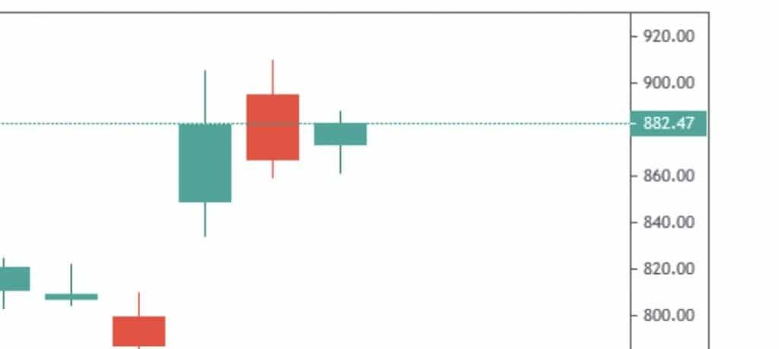](https://www.trsryxrpl.com/quiz/lesson-6-effects-on-trading/)

* [https://lh4.googleusercontent.com/cWje2kaNyzsGDAWCrIbeL1XjYZPAMWBaum5iZn1IlsPk2gNZ1gbNIln6efaCHcj_pQKVhwBRl8HWOzbm3AcvyK3lZtxVUKffo5RYsITixsDjVljGNS-xPdhlhEtQMR3wbB-hbg9Gf2lLBB468g True](https://www.trsryxrpl.com/quiz/lesson-6-effects-on-trading/)
* [https://lh6.googleusercontent.com/nqnbeE1cUSJOY2gbCYYNOU-K4aZtEGdquQln2u199gUv6LzvY0AdprUvO7r5iU_ckMGl_IJfmDOMe6H5ITs78GjRGvxAui_QmZUFwZYxZWtUW9AAytP4IijvJAweIOI6dYyb8tKFvh4YzwBD5Q False](https://www.trsryxrpl.com/quiz/lesson-6-effects-on-trading/)

[Correct**4/4 $TRSRY**](https://www.trsryxrpl.com/quiz/lesson-6-effects-on-trading/)

1. [**From what you learned about a green candle, can you conclude the current price from the latest candle below?**](https://www.trsryxrpl.com/quiz/lesson-6-effects-on-trading/)

[](https://www.trsryxrpl.com/quiz/lesson-6-effects-on-trading/)

* [https://lh4.googleusercontent.com/cWje2kaNyzsGDAWCrIbeL1XjYZPAMWBaum5iZn1IlsPk2gNZ1gbNIln6efaCHcj_pQKVhwBRl8HWOzbm3AcvyK3lZtxVUKffo5RYsITixsDjVljGNS-xPdhlhEtQMR3wbB-hbg9Gf2lLBB468g $882.47](https://www.trsryxrpl.com/quiz/lesson-6-effects-on-trading/)
* [https://lh6.googleusercontent.com/nqnbeE1cUSJOY2gbCYYNOU-K4aZtEGdquQln2u199gUv6LzvY0AdprUvO7r5iU_ckMGl_IJfmDOMe6H5ITs78GjRGvxAui_QmZUFwZYxZWtUW9AAytP4IijvJAweIOI6dYyb8tKFvh4YzwBD5Q $900.00](https://www.trsryxrpl.com/quiz/lesson-6-effects-on-trading/)
* [https://lh6.googleusercontent.com/nqnbeE1cUSJOY2gbCYYNOU-K4aZtEGdquQln2u199gUv6LzvY0AdprUvO7r5iU_ckMGl_IJfmDOMe6H5ITs78GjRGvxAui_QmZUFwZYxZWtUW9AAytP4IijvJAweIOI6dYyb8tKFvh4YzwBD5Q $860.00](https://www.trsryxrpl.com/quiz/lesson-6-effects-on-trading/)
* [https://lh6.googleusercontent.com/nqnbeE1cUSJOY2gbCYYNOU-K4aZtEGdquQln2u199gUv6LzvY0AdprUvO7r5iU_ckMGl_IJfmDOMe6H5ITs78GjRGvxAui_QmZUFwZYxZWtUW9AAytP4IijvJAweIOI6dYyb8tKFvh4YzwBD5Q None of the above](https://www.trsryxrpl.com/quiz/lesson-6-effects-on-trading/)

[Correct**4/4 $TRSRY**](https://www.trsryxrpl.com/quiz/lesson-6-effects-on-trading/)

[**Lesson 2 – Chart Types**](https://www.trsryxrpl.com/quiz/lesson-6-effects-on-trading/)

[Congratulations! You have passed this lesson's quiz achieving 100%](https://www.trsryxrpl.com/quiz/lesson-6-effects-on-trading/)

[*Length: 10 minutes*](https://www.trsryxrpl.com/quiz/lesson-6-effects-on-trading/)

[There are 3 distinct charts available which will give you a slightly different view](https://www.trsryxrpl.com/quiz/lesson-6-effects-on-trading/)

* [Line chart (left)  
  Beginner  
  Easier to draw support and resistance lines](https://www.trsryxrpl.com/quiz/lesson-6-effects-on-trading/)
* [Bar chart (middle)  
  Intermediate  
  Easier to identify trends](https://www.trsryxrpl.com/quiz/lesson-6-effects-on-trading/)
* [Candlestick chart (right)  
  Intermediate  
  Most popular chart type for traders](https://www.trsryxrpl.com/quiz/lesson-6-effects-on-trading/)

[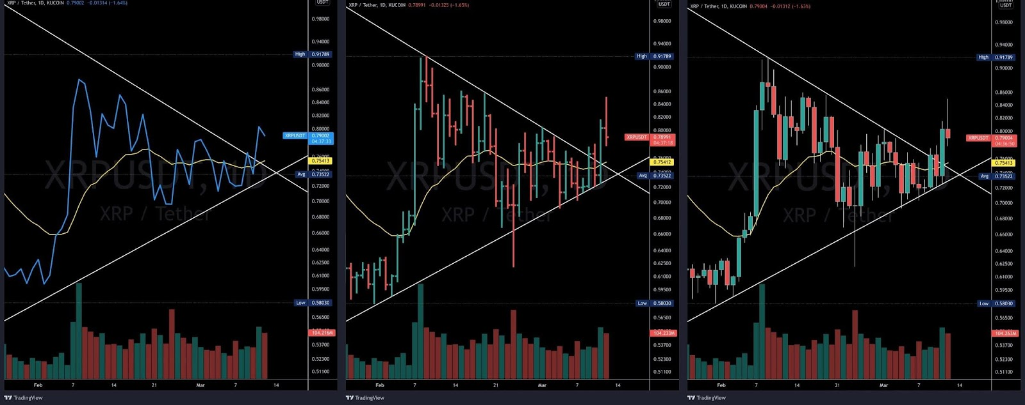](https://www.trsryxrpl.com/quiz/lesson-6-effects-on-trading/)

[**Lesson 2 – Chart Types Quiz**](https://www.trsryxrpl.com/quiz/lesson-6-effects-on-trading/)

[Congratulations! You have passed this quiz achieving 100%](https://www.trsryxrpl.com/quiz/lesson-6-effects-on-trading/)[**NEXT LESSON**](https://www.trsryxrpl.com/lesson/lesson-3-trend-lines/)

1. [**Which chart type below is the candlestick chart?**](https://www.trsryxrpl.com/quiz/lesson-6-effects-on-trading/)

[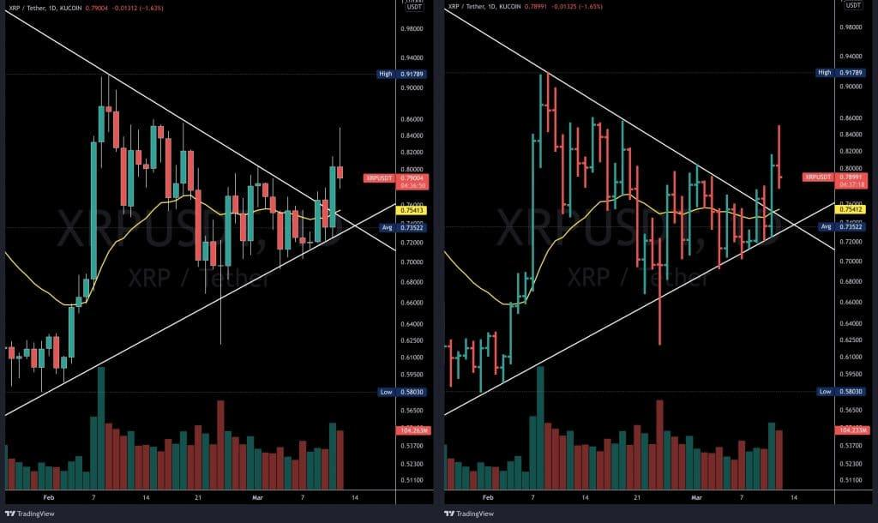](https://www.trsryxrpl.com/quiz/lesson-6-effects-on-trading/)

* [https://lh6.googleusercontent.com/nqnbeE1cUSJOY2gbCYYNOU-K4aZtEGdquQln2u199gUv6LzvY0AdprUvO7r5iU_ckMGl_IJfmDOMe6H5ITs78GjRGvxAui_QmZUFwZYxZWtUW9AAytP4IijvJAweIOI6dYyb8tKFvh4YzwBD5Q The one on the right](https://www.trsryxrpl.com/quiz/lesson-6-effects-on-trading/)
* [https://lh4.googleusercontent.com/cWje2kaNyzsGDAWCrIbeL1XjYZPAMWBaum5iZn1IlsPk2gNZ1gbNIln6efaCHcj_pQKVhwBRl8HWOzbm3AcvyK3lZtxVUKffo5RYsITixsDjVljGNS-xPdhlhEtQMR3wbB-hbg9Gf2lLBB468g The one of the left](https://www.trsryxrpl.com/quiz/lesson-6-effects-on-trading/)
* [https://lh6.googleusercontent.com/nqnbeE1cUSJOY2gbCYYNOU-K4aZtEGdquQln2u199gUv6LzvY0AdprUvO7r5iU_ckMGl_IJfmDOMe6H5ITs78GjRGvxAui_QmZUFwZYxZWtUW9AAytP4IijvJAweIOI6dYyb8tKFvh4YzwBD5Q Neither](https://www.trsryxrpl.com/quiz/lesson-6-effects-on-trading/)

[Correct**4/4 $TRSRY**](https://www.trsryxrpl.com/quiz/lesson-6-effects-on-trading/)

1. [**When I draw support and resistance lines it’s easier to draw them using which chart type?**](https://www.trsryxrpl.com/quiz/lesson-6-effects-on-trading/)
   * [https://lh6.googleusercontent.com/nqnbeE1cUSJOY2gbCYYNOU-K4aZtEGdquQln2u199gUv6LzvY0AdprUvO7r5iU_ckMGl_IJfmDOMe6H5ITs78GjRGvxAui_QmZUFwZYxZWtUW9AAytP4IijvJAweIOI6dYyb8tKFvh4YzwBD5Q Candlestick chart](https://www.trsryxrpl.com/quiz/lesson-6-effects-on-trading/)
   * [https://lh6.googleusercontent.com/nqnbeE1cUSJOY2gbCYYNOU-K4aZtEGdquQln2u199gUv6LzvY0AdprUvO7r5iU_ckMGl_IJfmDOMe6H5ITs78GjRGvxAui_QmZUFwZYxZWtUW9AAytP4IijvJAweIOI6dYyb8tKFvh4YzwBD5Q Crayon chart](https://www.trsryxrpl.com/quiz/lesson-6-effects-on-trading/)
   * [https://lh4.googleusercontent.com/cWje2kaNyzsGDAWCrIbeL1XjYZPAMWBaum5iZn1IlsPk2gNZ1gbNIln6efaCHcj_pQKVhwBRl8HWOzbm3AcvyK3lZtxVUKffo5RYsITixsDjVljGNS-xPdhlhEtQMR3wbB-hbg9Gf2lLBB468g Line chart](https://www.trsryxrpl.com/quiz/lesson-6-effects-on-trading/)
   * [https://lh6.googleusercontent.com/nqnbeE1cUSJOY2gbCYYNOU-K4aZtEGdquQln2u199gUv6LzvY0AdprUvO7r5iU_ckMGl_IJfmDOMe6H5ITs78GjRGvxAui_QmZUFwZYxZWtUW9AAytP4IijvJAweIOI6dYyb8tKFvh4YzwBD5Q Bar chart](https://www.trsryxrpl.com/quiz/lesson-6-effects-on-trading/)

[Correct**4/4 $TRSRY**](https://www.trsryxrpl.com/quiz/lesson-6-effects-on-trading/)

**Lesson 3 – Trend Lines**

Congratulations! You have passed this lesson's quiz achieving 100%

*Length: 10 minutes*

When drawing trend lines it is easier to start with a line chart and try to connect as many endpoints as you can, the more the better. As soon as you connect them change the chart over to candlesticks. You may have to make minor adjustments, but do what makes sense. The trend line can touch the top or bottom of the body and the high and low of the wicks if needed.

As price action flows between the trend lines you may have to make adjustments to them, and to make the chart cleaner, delete trend lines that aren’t needed anymore.

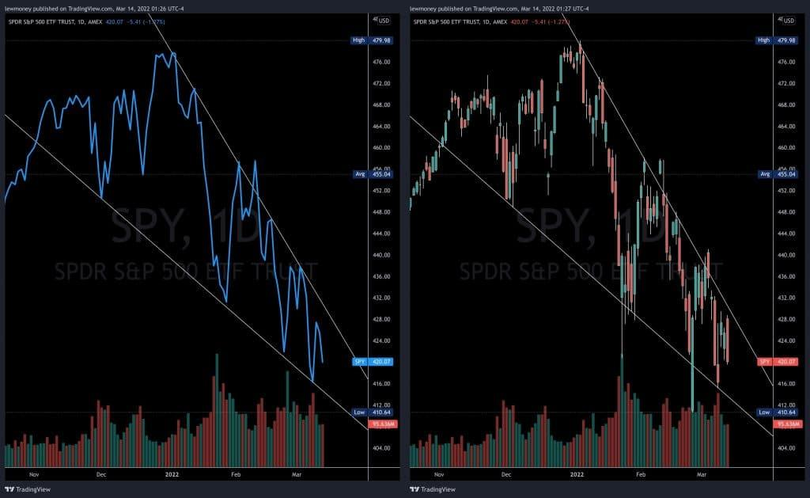  
You normally want to draw trend lines using a longer time frame if you are a swing trader, like the daily or weekly, to get a bigger picture of the general trend. Day traders most likely will use one minute or five minute charts to draw trend lines, as they are looking for short term trades.

**Lesson 3 – Trend Lines Quiz**

Congratulations! You have passed this quiz achieving 100%[**NEXT LESSON**](https://www.trsryxrpl.com/lesson/lesson-4-support-resistance/)

1. **What chart type is the easiest to use when drawing trend lines?**
   * https://lh6.googleusercontent.com/nqnbeE1cUSJOY2gbCYYNOU-K4aZtEGdquQln2u199gUv6LzvY0AdprUvO7r5iU_ckMGl_IJfmDOMe6H5ITs78GjRGvxAui_QmZUFwZYxZWtUW9AAytP4IijvJAweIOI6dYyb8tKFvh4YzwBD5Q Candlestick chart
   * https://lh6.googleusercontent.com/nqnbeE1cUSJOY2gbCYYNOU-K4aZtEGdquQln2u199gUv6LzvY0AdprUvO7r5iU_ckMGl_IJfmDOMe6H5ITs78GjRGvxAui_QmZUFwZYxZWtUW9AAytP4IijvJAweIOI6dYyb8tKFvh4YzwBD5Q Bar chart
   * https://lh4.googleusercontent.com/cWje2kaNyzsGDAWCrIbeL1XjYZPAMWBaum5iZn1IlsPk2gNZ1gbNIln6efaCHcj_pQKVhwBRl8HWOzbm3AcvyK3lZtxVUKffo5RYsITixsDjVljGNS-xPdhlhEtQMR3wbB-hbg9Gf2lLBB468g Line chart

Correct**4/4 $TRSRY**

1. **Swing traders should draw trend lines using a 5 minute chart?**
   * https://lh6.googleusercontent.com/nqnbeE1cUSJOY2gbCYYNOU-K4aZtEGdquQln2u199gUv6LzvY0AdprUvO7r5iU_ckMGl_IJfmDOMe6H5ITs78GjRGvxAui_QmZUFwZYxZWtUW9AAytP4IijvJAweIOI6dYyb8tKFvh4YzwBD5Q True
   * https://lh4.googleusercontent.com/cWje2kaNyzsGDAWCrIbeL1XjYZPAMWBaum5iZn1IlsPk2gNZ1gbNIln6efaCHcj_pQKVhwBRl8HWOzbm3AcvyK3lZtxVUKffo5RYsITixsDjVljGNS-xPdhlhEtQMR3wbB-hbg9Gf2lLBB468g False

Correct**4/4 $TRSRY**

**Lesson 4 – Support & Resistance**

Congratulations! You have passed this lesson's quiz achieving 100%

*Length: 10 minutes*

* Support  
  Concentration of demand in a downtrend
* Resistance   
  Concentration of supply in an uptrend

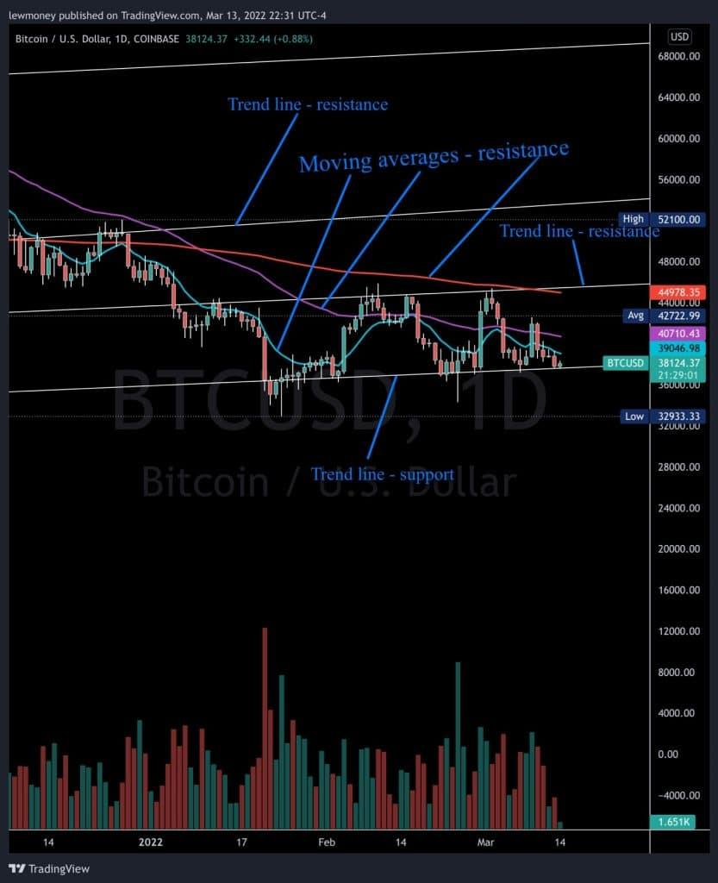Support and resistance can be identified on a chart by the use of trend lines and moving averages.

In the picture above, the trend line below the price action acts as a support, while the trend lines above will act as resistance. Also, the moving averages will act as support and resistance depending on if they are above or below the price action.

As soon as price breaks through a resistance it will then turn into a support. The support area on a chart normally attracts more buyers than sellers, and vice versa, the resistance usually attracts more sellers than buyers.

**Lesson 4 – Support & Resistance Quiz**

Congratulations! You have passed this quiz achieving 100%[**NEXT LESSON**](https://www.trsryxrpl.com/lesson/lesson-5-timeframes/)

1. **When the price breaks through a moving average to the upside, and drops down to test it… the moving average is then considered?**
   * https://lh6.googleusercontent.com/nqnbeE1cUSJOY2gbCYYNOU-K4aZtEGdquQln2u199gUv6LzvY0AdprUvO7r5iU_ckMGl_IJfmDOMe6H5ITs78GjRGvxAui_QmZUFwZYxZWtUW9AAytP4IijvJAweIOI6dYyb8tKFvh4YzwBD5Q Resistance
   * https://lh4.googleusercontent.com/cWje2kaNyzsGDAWCrIbeL1XjYZPAMWBaum5iZn1IlsPk2gNZ1gbNIln6efaCHcj_pQKVhwBRl8HWOzbm3AcvyK3lZtxVUKffo5RYsITixsDjVljGNS-xPdhlhEtQMR3wbB-hbg9Gf2lLBB468g Support

Correct**4/4 $TRSRY**

1. **When trading and you are looking to buy into a project…after drawing the trend lines and finding areas of support and resistance, what is a good spot to set buy orders?**
   * https://lh6.googleusercontent.com/nqnbeE1cUSJOY2gbCYYNOU-K4aZtEGdquQln2u199gUv6LzvY0AdprUvO7r5iU_ckMGl_IJfmDOMe6H5ITs78GjRGvxAui_QmZUFwZYxZWtUW9AAytP4IijvJAweIOI6dYyb8tKFvh4YzwBD5Q At resistance
   * https://lh4.googleusercontent.com/cWje2kaNyzsGDAWCrIbeL1XjYZPAMWBaum5iZn1IlsPk2gNZ1gbNIln6efaCHcj_pQKVhwBRl8HWOzbm3AcvyK3lZtxVUKffo5RYsITixsDjVljGNS-xPdhlhEtQMR3wbB-hbg9Gf2lLBB468g At support
   * https://lh6.googleusercontent.com/nqnbeE1cUSJOY2gbCYYNOU-K4aZtEGdquQln2u199gUv6LzvY0AdprUvO7r5iU_ckMGl_IJfmDOMe6H5ITs78GjRGvxAui_QmZUFwZYxZWtUW9AAytP4IijvJAweIOI6dYyb8tKFvh4YzwBD5Q Neither

Correct**4/4 $TRSRY**

**Lesson 5 – Timeframes**

Congratulations! You have passed this lesson's quiz achieving 100%

*Length: 10 minutes*

Time frames are important because you are looking at the overall trend. It depends on the type of trader you are as to which time frame you look at most often.  
Day traders will look at the shorter time frames, like the hour chart to determine the trend, and trade off the 15 minute or 5 minute charts.  
Swing traders on the other hand will look at the daily and weekly charts to determine the trend.  
They may narrow it down to the hour chart to trade off of.  
Position traders, or long term traders will focus on the weekly and monthly charts to determine the trend, and trade off of the daily chart.  
Here are some examples below of different time frames.

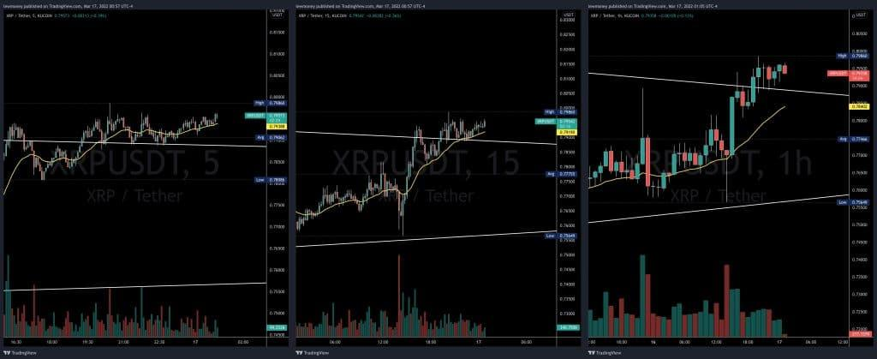5min / 15min / 1Hr

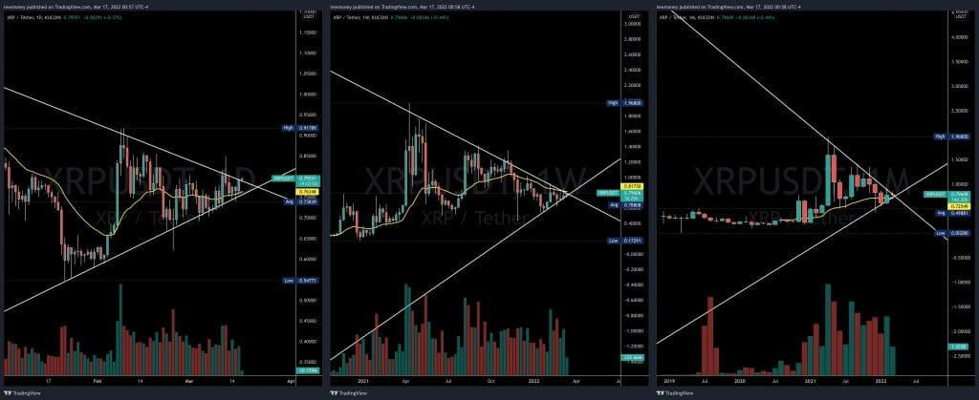1 day / 1 week / 1 month

# **Lesson 5 – Timeframes Quiz**

Congratulations! You have passed this quiz achieving 100%[**NEXT LESSON**](https://www.trsryxrpl.com/lesson/lesson-6-popular-indicators/)

Top of Form

1. **Which time frame(s) would you choose to find the overall trend if you were a swing trader?**
   * https://lh6.googleusercontent.com/nqnbeE1cUSJOY2gbCYYNOU-K4aZtEGdquQln2u199gUv6LzvY0AdprUvO7r5iU_ckMGl_IJfmDOMe6H5ITs78GjRGvxAui_QmZUFwZYxZWtUW9AAytP4IijvJAweIOI6dYyb8tKFvh4YzwBD5Q 5 min
   * https://lh6.googleusercontent.com/nqnbeE1cUSJOY2gbCYYNOU-K4aZtEGdquQln2u199gUv6LzvY0AdprUvO7r5iU_ckMGl_IJfmDOMe6H5ITs78GjRGvxAui_QmZUFwZYxZWtUW9AAytP4IijvJAweIOI6dYyb8tKFvh4YzwBD5Q 1 hour
   * https://lh6.googleusercontent.com/nqnbeE1cUSJOY2gbCYYNOU-K4aZtEGdquQln2u199gUv6LzvY0AdprUvO7r5iU_ckMGl_IJfmDOMe6H5ITs78GjRGvxAui_QmZUFwZYxZWtUW9AAytP4IijvJAweIOI6dYyb8tKFvh4YzwBD5Q 15 min
   * https://lh4.googleusercontent.com/cWje2kaNyzsGDAWCrIbeL1XjYZPAMWBaum5iZn1IlsPk2gNZ1gbNIln6efaCHcj_pQKVhwBRl8HWOzbm3AcvyK3lZtxVUKffo5RYsITixsDjVljGNS-xPdhlhEtQMR3wbB-hbg9Gf2lLBB468g Daily and weekly

Correct**4/4 $TRSRY**

1. **True or false: if you were day trading you would look at the monthly chart to find the overall trend?**
   * https://lh6.googleusercontent.com/nqnbeE1cUSJOY2gbCYYNOU-K4aZtEGdquQln2u199gUv6LzvY0AdprUvO7r5iU_ckMGl_IJfmDOMe6H5ITs78GjRGvxAui_QmZUFwZYxZWtUW9AAytP4IijvJAweIOI6dYyb8tKFvh4YzwBD5Q True
   * https://lh4.googleusercontent.com/cWje2kaNyzsGDAWCrIbeL1XjYZPAMWBaum5iZn1IlsPk2gNZ1gbNIln6efaCHcj_pQKVhwBRl8HWOzbm3AcvyK3lZtxVUKffo5RYsITixsDjVljGNS-xPdhlhEtQMR3wbB-hbg9Gf2lLBB468g False

Correct**4/4 $TRSRY**

# **Lesson 6: Popular Indicators**

You require 50% to pass this lesson's quiz. Your grade is 0%

*Length: 10 minutes*

There are thousands of different indicators to choose from, and many different strategies out there. The question is which combo is right for you?  
Some of the most popular indicators that traders use are moving averages, relative strength index, on-balance volume, and moving average convergence divergence.

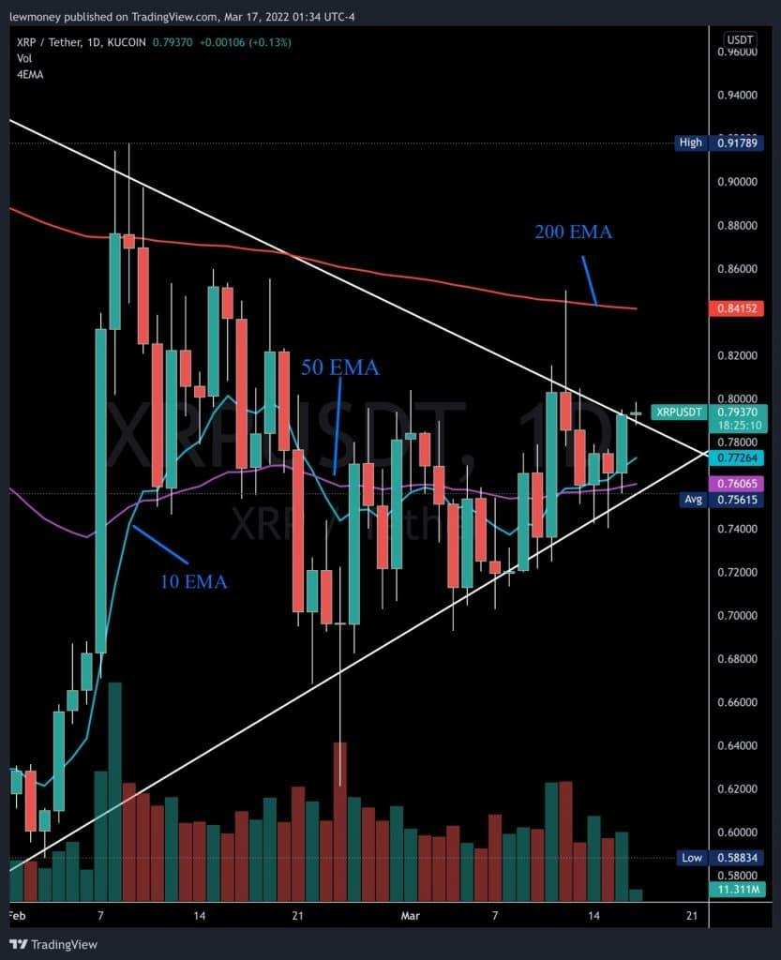

Moving averages are trend following indicators that define the current direction, but they do not predict price direction. Since they are based off of past prices they do lag, but they help filter out the noise of choppy price action. They are also used as support and resistance as traders will use moving averages as buy and sell signals.  
In relation to the above example, exponentially weighted moving averages (EMA’s) are an average price calculation over a specific time period, and they put more weight on the most recent price data. The difference between the 10 EMA, 50 EMA and 200 EMA above is the  
average of the last 10, 50, 200 periods… the 10 EMA will be faster and follow the price closer, while the longer periods will move slower.

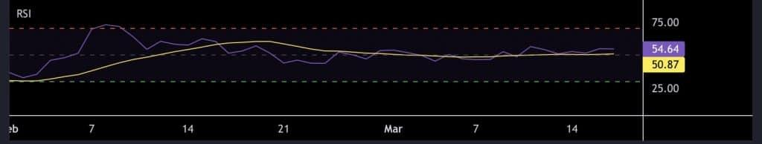The relative strength index is a popular momentum indicator that gauges the speed and change of price movements. The RSI fluctuates between 0 and 100. When the RSI rises above 70, it is considered overbought, and when it falls below 30, it is deemed oversold. Divergences, failure swings, and centerline crossovers can also be used to generate signals.

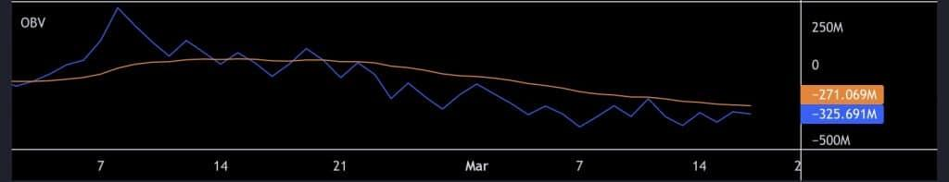On Balance Volume (OBV) is a cumulative indicator that measures buying and selling pressure by adding volume on up days and subtracting volume on down days. Chartists can use OBV to confirm price trends or look for divergences between OBV and price to predict price movements. This is one of our favourites to use in predicting where price may be heading by looking for divergences.

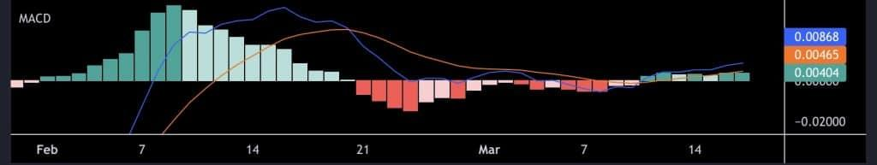The Moving Average Convergence/Divergence (MACD) oscillator is one of the most basic and effective momentum indicators available. The MACD is used for trend following and momentum trading.  
As the moving averages converge, cross, and diverge, the MACD fluctuates above and below the zero line. To generate signals, traders can look for signal line crossovers, centerline crossovers, and divergences. Because the MACD is unbounded, it is ineffective at identifying overbought and oversold levels.

**Lesson 6: Popular Indicators Quiz**

You require 50% to pass this quiz. Your grade is 0%

1. **Which of the below indicators can’t be used to find divergences?**
   * https://lh6.googleusercontent.com/nqnbeE1cUSJOY2gbCYYNOU-K4aZtEGdquQln2u199gUv6LzvY0AdprUvO7r5iU_ckMGl_IJfmDOMe6H5ITs78GjRGvxAui_QmZUFwZYxZWtUW9AAytP4IijvJAweIOI6dYyb8tKFvh4YzwBD5Q Moving averages (EMA)
   * https://lh6.googleusercontent.com/nqnbeE1cUSJOY2gbCYYNOU-K4aZtEGdquQln2u199gUv6LzvY0AdprUvO7r5iU_ckMGl_IJfmDOMe6H5ITs78GjRGvxAui_QmZUFwZYxZWtUW9AAytP4IijvJAweIOI6dYyb8tKFvh4YzwBD5Q On balance volume (OBV)
   * https://lh4.googleusercontent.com/cWje2kaNyzsGDAWCrIbeL1XjYZPAMWBaum5iZn1IlsPk2gNZ1gbNIln6efaCHcj_pQKVhwBRl8HWOzbm3AcvyK3lZtxVUKffo5RYsITixsDjVljGNS-xPdhlhEtQMR3wbB-hbg9Gf2lLBB468g Relative strength index (RSI)
   * https://lh6.googleusercontent.com/nqnbeE1cUSJOY2gbCYYNOU-K4aZtEGdquQln2u199gUv6LzvY0AdprUvO7r5iU_ckMGl_IJfmDOMe6H5ITs78GjRGvxAui_QmZUFwZYxZWtUW9AAytP4IijvJAweIOI6dYyb8tKFvh4YzwBD5Q Moving average convergence/divergence (MACD)

Incorrect**0/4 $TRSRY**

Right Answer: **Moving averages (EMA)**

1. **If the 200 EMA is below the price action it would be considered resistance?**
   * https://lh4.googleusercontent.com/cWje2kaNyzsGDAWCrIbeL1XjYZPAMWBaum5iZn1IlsPk2gNZ1gbNIln6efaCHcj_pQKVhwBRl8HWOzbm3AcvyK3lZtxVUKffo5RYsITixsDjVljGNS-xPdhlhEtQMR3wbB-hbg9Gf2lLBB468g True
   * https://lh6.googleusercontent.com/nqnbeE1cUSJOY2gbCYYNOU-K4aZtEGdquQln2u199gUv6LzvY0AdprUvO7r5iU_ckMGl_IJfmDOMe6H5ITs78GjRGvxAui_QmZUFwZYxZWtUW9AAytP4IijvJAweIOI6dYyb8tKFvh4YzwBD5Q False

Incorrect**0/4 $TRSRY**

Right Answer: **False**

**Lesson 7: Understanding Wicks**

Congratulations! You have passed this lesson's quiz achieving 50%

*Length: 10 minutes*

By definition, a wick is a line on a candlestick chart used to show where an asset’s price is fluctuating relative to its opening and closing prices. Wicks can also be referred to as whiskers, shadows, or tails. In financial market terms, a wick is simply a vertical line that helps you  
visualize the high and low areas of price action. This means that when reading a typical candlestick chart, traders will focus on three key points, among others: the open price, the close price, and the candle wicks. The wicks themselves indicate price extremes, allowing traders to better understand market sentiment and dynamics. This means when the price moves relative to the open and close price, wicks form as a visual record of that movement.  
The candlestick pattern is created based on the open, high, low and close of a market. The “box” portion of the candlestick is known as the body, while the lines at each end are the wicks (representing the highs and their lows). The length of the wick is also relevant. For example, if there is a long wick at the bottom of the candle, this indicates that the price went all the way down and then rose again before the candle ended. This suggests an uptake in buying immediately after a period of selling pressure. For this reason, some technical analysts believe that a long wick often signals a price reversal and moves the market in the opposite direction of that wick. Below is an example of long wick candles at the bottom and top of a trend, showing the pressure pushing the price in the opposite direction.

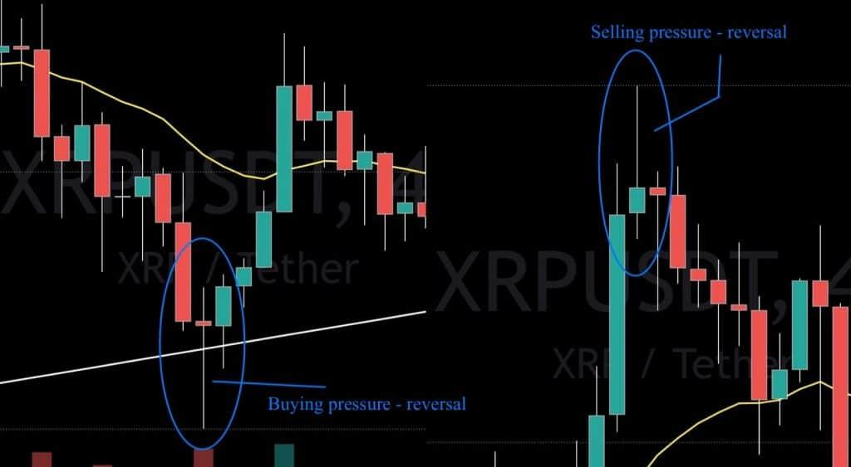

Alternatively, there is also the option of a wickless candle. These candles look like a square or rectangle as the open and close prices coincide with the high and low marks of that particular candle.

**Lesson 7: Understanding Wicks Quiz**

Congratulations! You have passed this quiz achieving 50%[**NEXT LESSON**](https://www.trsryxrpl.com/lesson/lesson-8-order-types/)

1. **A wick shows the _________ of price action?**
   * https://lh6.googleusercontent.com/nqnbeE1cUSJOY2gbCYYNOU-K4aZtEGdquQln2u199gUv6LzvY0AdprUvO7r5iU_ckMGl_IJfmDOMe6H5ITs78GjRGvxAui_QmZUFwZYxZWtUW9AAytP4IijvJAweIOI6dYyb8tKFvh4YzwBD5Q Open and close
   * https://lh4.googleusercontent.com/cWje2kaNyzsGDAWCrIbeL1XjYZPAMWBaum5iZn1IlsPk2gNZ1gbNIln6efaCHcj_pQKVhwBRl8HWOzbm3AcvyK3lZtxVUKffo5RYsITixsDjVljGNS-xPdhlhEtQMR3wbB-hbg9Gf2lLBB468g High and low
   * https://lh6.googleusercontent.com/nqnbeE1cUSJOY2gbCYYNOU-K4aZtEGdquQln2u199gUv6LzvY0AdprUvO7r5iU_ckMGl_IJfmDOMe6H5ITs78GjRGvxAui_QmZUFwZYxZWtUW9AAytP4IijvJAweIOI6dYyb8tKFvh4YzwBD5Q Start and finish
   * https://lh6.googleusercontent.com/nqnbeE1cUSJOY2gbCYYNOU-K4aZtEGdquQln2u199gUv6LzvY0AdprUvO7r5iU_ckMGl_IJfmDOMe6H5ITs78GjRGvxAui_QmZUFwZYxZWtUW9AAytP4IijvJAweIOI6dYyb8tKFvh4YzwBD5Q None of the above

Correct**4/4 $TRSRY**

1. **A long wick at the bottom of a candle means?**
   * https://lh4.googleusercontent.com/cWje2kaNyzsGDAWCrIbeL1XjYZPAMWBaum5iZn1IlsPk2gNZ1gbNIln6efaCHcj_pQKVhwBRl8HWOzbm3AcvyK3lZtxVUKffo5RYsITixsDjVljGNS-xPdhlhEtQMR3wbB-hbg9Gf2lLBB468g There is a lot of selling pressure
   * https://lh6.googleusercontent.com/nqnbeE1cUSJOY2gbCYYNOU-K4aZtEGdquQln2u199gUv6LzvY0AdprUvO7r5iU_ckMGl_IJfmDOMe6H5ITs78GjRGvxAui_QmZUFwZYxZWtUW9AAytP4IijvJAweIOI6dYyb8tKFvh4YzwBD5Q There is a lot of buying pressure
   * https://lh6.googleusercontent.com/nqnbeE1cUSJOY2gbCYYNOU-K4aZtEGdquQln2u199gUv6LzvY0AdprUvO7r5iU_ckMGl_IJfmDOMe6H5ITs78GjRGvxAui_QmZUFwZYxZWtUW9AAytP4IijvJAweIOI6dYyb8tKFvh4YzwBD5Q None of the above

Incorrect**0/4 $TRSRY**

Right Answer: **There is a lot of buying pressure**

**Lesson 8: Order Types**

Congratulations! You have passed this lesson's quiz achieving 100%

*Length: 10 minutes*

**The Market Order**

The most basic type of trade is a market order. It is a buy or sell order for the current price. If you want to place a market buy, you will usually pay a price that is close to or equal to the posted ask. If you place a market sell, you will be paid a price that is equal to or close to the posted bid.

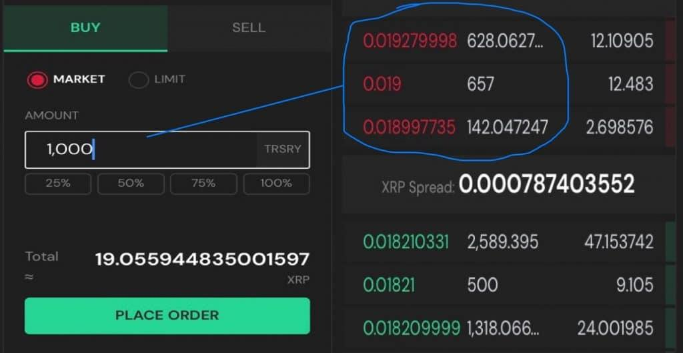

Using a market buy order (see above) or market sell order (see below) is not recommended unless the spread is small. Be careful of large spreads when placing market orders. If you are not sure, only use limit orders.

**The Limit Order**

A limit order, also known as a pending order, allows investors to purchase and sell on the market at a predetermined price in the future. This type of order is used to execute a trade if the price reaches a pre-defined level; the order will not be filled if the price does not reach the pre-defined level. A limit order, in essence, specifies the highest or lowest price at which you are willing to buy or sell.

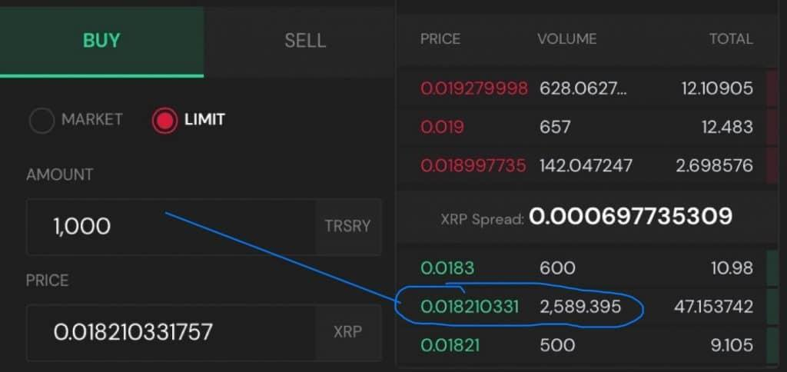

A limit buy order (see above) and limit sell order (see below) are recommended in trading, if at all possible. This way you get the best price you are wiling to pay.

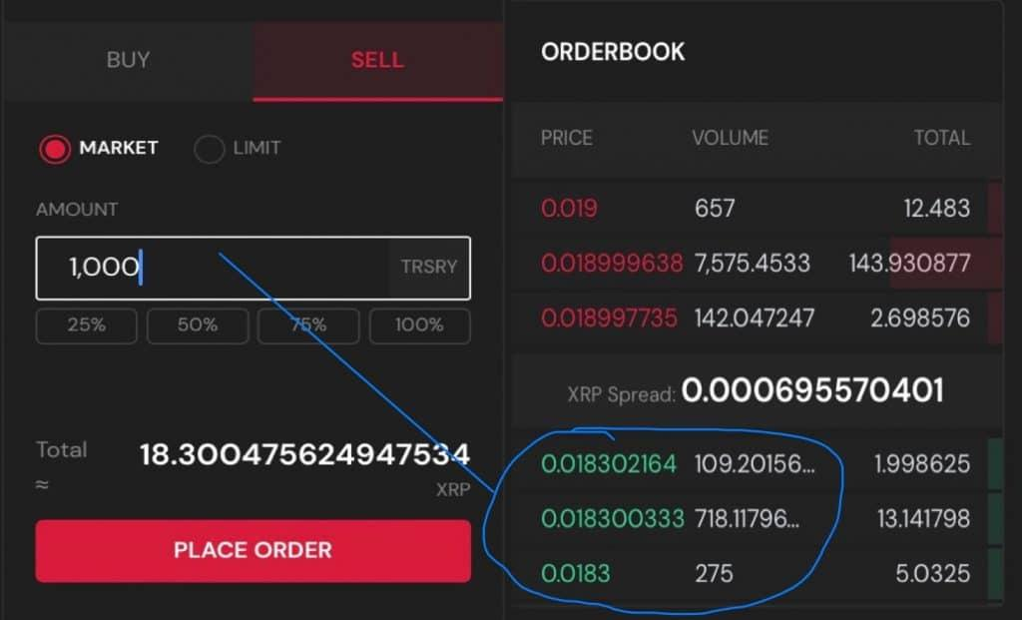

**Lesson 8: Order Types Quiz**

Congratulations! You have passed this quiz achieving 100%[**NEXT LESSON**](https://www.trsryxrpl.com/lesson/lesson-9-the-buy-sell-spread/)

1. **True or False: a limit order allows investors to purchase or sell at a predetermined price in the future.**
   * https://lh4.googleusercontent.com/cWje2kaNyzsGDAWCrIbeL1XjYZPAMWBaum5iZn1IlsPk2gNZ1gbNIln6efaCHcj_pQKVhwBRl8HWOzbm3AcvyK3lZtxVUKffo5RYsITixsDjVljGNS-xPdhlhEtQMR3wbB-hbg9Gf2lLBB468g True
   * https://lh6.googleusercontent.com/nqnbeE1cUSJOY2gbCYYNOU-K4aZtEGdquQln2u199gUv6LzvY0AdprUvO7r5iU_ckMGl_IJfmDOMe6H5ITs78GjRGvxAui_QmZUFwZYxZWtUW9AAytP4IijvJAweIOI6dYyb8tKFvh4YzwBD5Q False

Correct**4/4 $TRSRY**

1. **What type of order is recommended when buying?**
   * https://lh6.googleusercontent.com/nqnbeE1cUSJOY2gbCYYNOU-K4aZtEGdquQln2u199gUv6LzvY0AdprUvO7r5iU_ckMGl_IJfmDOMe6H5ITs78GjRGvxAui_QmZUFwZYxZWtUW9AAytP4IijvJAweIOI6dYyb8tKFvh4YzwBD5Q Market order
   * https://lh6.googleusercontent.com/nqnbeE1cUSJOY2gbCYYNOU-K4aZtEGdquQln2u199gUv6LzvY0AdprUvO7r5iU_ckMGl_IJfmDOMe6H5ITs78GjRGvxAui_QmZUFwZYxZWtUW9AAytP4IijvJAweIOI6dYyb8tKFvh4YzwBD5Q Spread order
   * https://lh4.googleusercontent.com/cWje2kaNyzsGDAWCrIbeL1XjYZPAMWBaum5iZn1IlsPk2gNZ1gbNIln6efaCHcj_pQKVhwBRl8HWOzbm3AcvyK3lZtxVUKffo5RYsITixsDjVljGNS-xPdhlhEtQMR3wbB-hbg9Gf2lLBB468g Limit order
   * https://lh6.googleusercontent.com/nqnbeE1cUSJOY2gbCYYNOU-K4aZtEGdquQln2u199gUv6LzvY0AdprUvO7r5iU_ckMGl_IJfmDOMe6H5ITs78GjRGvxAui_QmZUFwZYxZWtUW9AAytP4IijvJAweIOI6dYyb8tKFvh4YzwBD5Q None of the above

Correct**4/4 $TRSRY**

**Lesson 9: The Buy / Sell Spread**

Congratulations! You have passed this lesson's quiz achieving 50%

*Length: 10 minutes*

The amount by which the ask price for an asset in the market exceeds the bid price is known as the bid-ask spread. The bid-ask spread is the difference between the highest price that a buyer is willing to pay and the lowest price that a seller is willing to accept for an asset. A seller will be paid the bid price, while a buyer will pay the ask price.  
Because of their higher liquidity, high volume markets typically have a lower spread (more competition among buyers and sellers). Markets with insufficient liquidity and low trading volume, on the other hand, tend to have a wider spread.

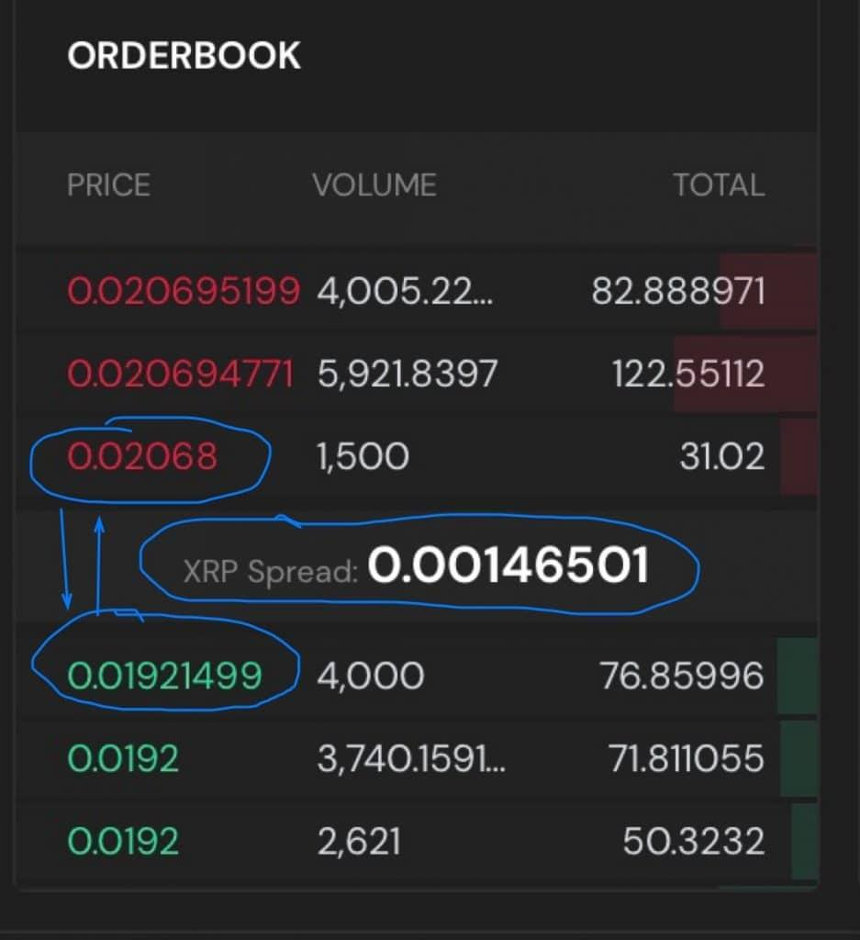Above you have a coin with a lower spread, so if you market buy an order there won’t be much of a difference versus putting a limit order on the bid price. You will notice it more in a larger orders however.

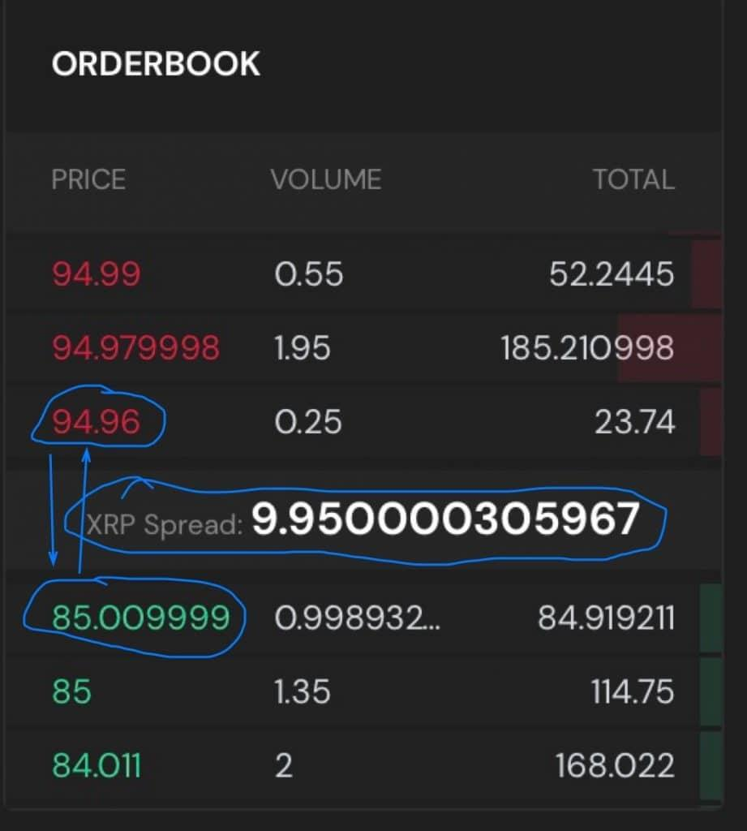Here above you have a token with a wider spread, so if you market buy this, you will be paying 10 XRP higher than if you set a limit order at the bid price and waited.

So keep this in mind when trading, especially the lower supply tokens and coins with less liquidity, the spread may be wider.

**Course 4.3: DEX Vs CEX**If you are weighing up whether to use a Centralized or Decentralized exchanges to trade in crypto, this module will talk you through the merits of each.

**Lesson 1: What is a DEX?**

Congratulations! You have passed this lesson's quiz achieving 100%

*Length: 10 minutes*

Decentralised Exchanges (DEX) are essentially peer-to-peer marketplaces for cryptocurrencies where tokens/coins are traded directly from user to user without the use of an intermediary. DEXs conduct these peer-to-peer trades through the use of smart contracts – essentially self-executing agreements that are built into the DEX code. This allows users to trade their cryptocurrency safely and efficiently between users without requiring to share private keys, personal information (even their name!) or allow exchanges to charge large fees for the service.

DEXs generally offer a very large number of tradable cryptocurrencies, this works both works for and against the average investor. It allows investors to access many thousands of different cryptocurrencies that cannot be found elsewhere meaning there is a huge amount of potential, however the currencies listed within DEXs are generally not vetted or verified with limited amount of information. Unfortunately, these circumstances align perfectly for those who are planning a rug pull which can leave many investors out of pocket.

There are multiple types of DEXs that all serve differing purposes within the cryptocurrency space – Automatic Market Maker, Order Book DEX, DEX Aggregators – Find out more in the next lesson!

**Lesson 1: What is a DEX? Quiz**

Congratulations! You have passed this quiz achieving 100%[**NEXT LESSON**](https://www.trsryxrpl.com/lesson/dex_cex_different-types-of-dexs/)

1. **What is the agreement/code that allows DEXs to operate?**
   * https://lh6.googleusercontent.com/nqnbeE1cUSJOY2gbCYYNOU-K4aZtEGdquQln2u199gUv6LzvY0AdprUvO7r5iU_ckMGl_IJfmDOMe6H5ITs78GjRGvxAui_QmZUFwZYxZWtUW9AAytP4IijvJAweIOI6dYyb8tKFvh4YzwBD5Q HTML
   * https://lh4.googleusercontent.com/cWje2kaNyzsGDAWCrIbeL1XjYZPAMWBaum5iZn1IlsPk2gNZ1gbNIln6efaCHcj_pQKVhwBRl8HWOzbm3AcvyK3lZtxVUKffo5RYsITixsDjVljGNS-xPdhlhEtQMR3wbB-hbg9Gf2lLBB468g Smart Contract
   * https://lh6.googleusercontent.com/nqnbeE1cUSJOY2gbCYYNOU-K4aZtEGdquQln2u199gUv6LzvY0AdprUvO7r5iU_ckMGl_IJfmDOMe6H5ITs78GjRGvxAui_QmZUFwZYxZWtUW9AAytP4IijvJAweIOI6dYyb8tKFvh4YzwBD5Q Blockchain
   * https://lh6.googleusercontent.com/nqnbeE1cUSJOY2gbCYYNOU-K4aZtEGdquQln2u199gUv6LzvY0AdprUvO7r5iU_ckMGl_IJfmDOMe6H5ITs78GjRGvxAui_QmZUFwZYxZWtUW9AAytP4IijvJAweIOI6dYyb8tKFvh4YzwBD5Q XRP Ledger

Correct**4/4 $TRSRY**

1. **What is meant by peer-to-peer?**
   * https://lh6.googleusercontent.com/nqnbeE1cUSJOY2gbCYYNOU-K4aZtEGdquQln2u199gUv6LzvY0AdprUvO7r5iU_ckMGl_IJfmDOMe6H5ITs78GjRGvxAui_QmZUFwZYxZWtUW9AAytP4IijvJAweIOI6dYyb8tKFvh4YzwBD5Q Users sell crypto directly to each other through written agreement
   * https://lh6.googleusercontent.com/nqnbeE1cUSJOY2gbCYYNOU-K4aZtEGdquQln2u199gUv6LzvY0AdprUvO7r5iU_ckMGl_IJfmDOMe6H5ITs78GjRGvxAui_QmZUFwZYxZWtUW9AAytP4IijvJAweIOI6dYyb8tKFvh4YzwBD5Q Crypto is sold from one person to another
   * https://lh4.googleusercontent.com/cWje2kaNyzsGDAWCrIbeL1XjYZPAMWBaum5iZn1IlsPk2gNZ1gbNIln6efaCHcj_pQKVhwBRl8HWOzbm3AcvyK3lZtxVUKffo5RYsITixsDjVljGNS-xPdhlhEtQMR3wbB-hbg9Gf2lLBB468g Smart Contracts allow for offers to be created and accepted instantly allowing for users to trade directly with each other without the need of an intermediary
   * https://lh6.googleusercontent.com/nqnbeE1cUSJOY2gbCYYNOU-K4aZtEGdquQln2u199gUv6LzvY0AdprUvO7r5iU_ckMGl_IJfmDOMe6H5ITs78GjRGvxAui_QmZUFwZYxZWtUW9AAytP4IijvJAweIOI6dYyb8tKFvh4YzwBD5Q Trading crypto with your friends in person

Correct**4/4 $TRSRY**

**Lesson 2: What are the different types of DEX’s?**

Congratulations! You have passed this lesson's quiz achieving 100%

*Length: 10 minutes*

**Order Book DEX**

The XRPL’s in-built DEX is a great example of an orderbook DEX. An orderbook DEX simply lists all orders created for a certain pair of assets, they are compiled of both buy and sell orders. The order book DEX arranges the prices and allows users to swap directly peer-to-peer at the agreed order prices. You can set a buy or sell order at at any price, however if there is no one willing to pay the price it will not go through. The order book DEX relies on the supply and demand of the asset pairs.

**Automatic Market Maker DEX (AMM)**

AMM DEXs use liquidity pools to allow peers to exchange tokens, however the price is calculated via a constant mathematical formula instead of specific user placed orders. Liquidity pools are essentially large amounts of an asset that are managed by the AMM, the liquidity is supplied by the users of the platform and they are rewarded for every buy/sell within their selected pool. Contributors to the pool are rewarded with profits from any fees charged by the pool for anyone who interacts with it. Simply the most common mathematical formula used and suggested by Vitalik (creator of ETH) is x * y = k   
x = value of token A within the pool   
y = value of token B within the pool   
k = a constant value (one that doesn’t change)

Every time token A is bought (subsequently removing that amount of token A from the pool), the value of token A must increase to keep ‘k’ constant, the same would occur for token B if it was bought instead. If a sell occurs the process is reverted and the price decreases. AMMs also benefit from non-AMM exchanges to keep the prices balanced. For example, an ETH/BTC pair on an AMM may be 0.079, however on a CEX it might be 0.075, investors will quickly realise the price difference and bring it inline immediately. Nowadays these arbitrage opportunities are usually managed by bots and exchanges.

This is the basic working of an AMM however more complex models exist such as Curve and Balancer. The most popular however is the Uniswap model, broadly and simply explained above.

**DEX Aggregator**

A DEX aggregator can be most likened to a search engine, there are thousands of DEXs that exist and more and more iterations are being created daily. This leads to massive differences between prices and liquidity between different exchanges and tokens. DEX aggregators are relatively new, only really coming to life in 2019 as part of a hackathon competition. Essentially DEX aggregators track down the best prices and fees across thousands of DEXs and present the user with trades that are the cheapest and most efficient. They even go as far as executing split trades, where there is an intermediary swap to ensure you get the cheapest price. Aggregators use both AMM and Orderbook DEXs and are rising greatly in popularity, especially as the technology improves. Many believe the DEX aggregator is the way of the future and it’s easy to see why they really may be one day!

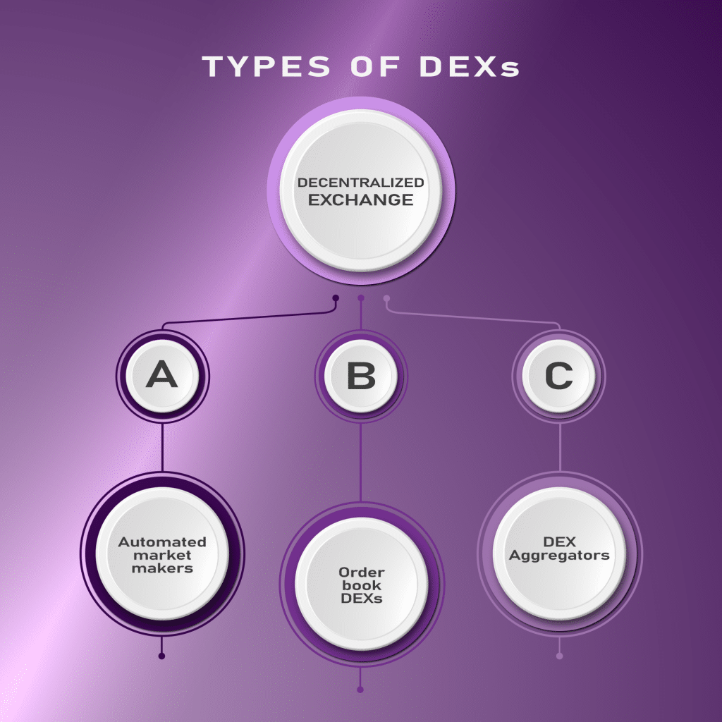

Popular Aggregators include 1inch, SushiSwap, Trader Joe, MDEX

**Lesson 2: What are the different types of DEX’s? Quiz**

Congratulations! You have passed this quiz achieving 100%[**NEXT LESSON**](https://www.trsryxrpl.com/lesson/dex_cex_what-is-a-cex/)

1. **The XRPL DEX is an example of a?**
   * https://lh4.googleusercontent.com/cWje2kaNyzsGDAWCrIbeL1XjYZPAMWBaum5iZn1IlsPk2gNZ1gbNIln6efaCHcj_pQKVhwBRl8HWOzbm3AcvyK3lZtxVUKffo5RYsITixsDjVljGNS-xPdhlhEtQMR3wbB-hbg9Gf2lLBB468g Order book DEX
   * https://lh6.googleusercontent.com/nqnbeE1cUSJOY2gbCYYNOU-K4aZtEGdquQln2u199gUv6LzvY0AdprUvO7r5iU_ckMGl_IJfmDOMe6H5ITs78GjRGvxAui_QmZUFwZYxZWtUW9AAytP4IijvJAweIOI6dYyb8tKFvh4YzwBD5Q Normal DEX
   * https://lh6.googleusercontent.com/nqnbeE1cUSJOY2gbCYYNOU-K4aZtEGdquQln2u199gUv6LzvY0AdprUvO7r5iU_ckMGl_IJfmDOMe6H5ITs78GjRGvxAui_QmZUFwZYxZWtUW9AAytP4IijvJAweIOI6dYyb8tKFvh4YzwBD5Q Centralised DEX
   * https://lh6.googleusercontent.com/nqnbeE1cUSJOY2gbCYYNOU-K4aZtEGdquQln2u199gUv6LzvY0AdprUvO7r5iU_ckMGl_IJfmDOMe6H5ITs78GjRGvxAui_QmZUFwZYxZWtUW9AAytP4IijvJAweIOI6dYyb8tKFvh4YzwBD5Q AMM DEX

Correct**4/4 $TRSRY**

1. **True or False: The first DEX Aggregator was created in 2018**
   * https://lh6.googleusercontent.com/nqnbeE1cUSJOY2gbCYYNOU-K4aZtEGdquQln2u199gUv6LzvY0AdprUvO7r5iU_ckMGl_IJfmDOMe6H5ITs78GjRGvxAui_QmZUFwZYxZWtUW9AAytP4IijvJAweIOI6dYyb8tKFvh4YzwBD5Q True
   * https://lh4.googleusercontent.com/cWje2kaNyzsGDAWCrIbeL1XjYZPAMWBaum5iZn1IlsPk2gNZ1gbNIln6efaCHcj_pQKVhwBRl8HWOzbm3AcvyK3lZtxVUKffo5RYsITixsDjVljGNS-xPdhlhEtQMR3wbB-hbg9Gf2lLBB468g False

Correct**4/4 $TRSRY**

1. **What is a liquidity pool?**
   * https://lh4.googleusercontent.com/cWje2kaNyzsGDAWCrIbeL1XjYZPAMWBaum5iZn1IlsPk2gNZ1gbNIln6efaCHcj_pQKVhwBRl8HWOzbm3AcvyK3lZtxVUKffo5RYsITixsDjVljGNS-xPdhlhEtQMR3wbB-hbg9Gf2lLBB468g A collection of tokens that are locked in a smart contract to be used within DeFi
   * https://lh6.googleusercontent.com/nqnbeE1cUSJOY2gbCYYNOU-K4aZtEGdquQln2u199gUv6LzvY0AdprUvO7r5iU_ckMGl_IJfmDOMe6H5ITs78GjRGvxAui_QmZUFwZYxZWtUW9AAytP4IijvJAweIOI6dYyb8tKFvh4YzwBD5Q Staked cryptocurrencies
   * https://lh6.googleusercontent.com/nqnbeE1cUSJOY2gbCYYNOU-K4aZtEGdquQln2u199gUv6LzvY0AdprUvO7r5iU_ckMGl_IJfmDOMe6H5ITs78GjRGvxAui_QmZUFwZYxZWtUW9AAytP4IijvJAweIOI6dYyb8tKFvh4YzwBD5Q The tokens that are held by a wallet to help them conduct trades
   * https://lh6.googleusercontent.com/nqnbeE1cUSJOY2gbCYYNOU-K4aZtEGdquQln2u199gUv6LzvY0AdprUvO7r5iU_ckMGl_IJfmDOMe6H5ITs78GjRGvxAui_QmZUFwZYxZWtUW9AAytP4IijvJAweIOI6dYyb8tKFvh4YzwBD5Q Tokens that have lots of excess liquidity

Correct**4/4 $TRSRY**

**Lesson 3: What is a CEX?**

Congratulations! You have passed this lesson's quiz achieving 100%

*Length: 10 minutes*

CEX stands for Centralised Exchange. A CEX is basically the cryptocurrency equivalent of a stock exchange. CEXs are designed to handle large scale trading and are usually more ‘beginner friendly’, most allow users to onboard their funds via fiat and also withdraw it for fiat. They essentially serve as a ‘middle man’ to allow users to transact easily and securely, due to this they however generally charge much greater fees than their DEX counterparts.

What makes a CEX centralised is this ‘middle man’ concept – essentially the exchange provider acts as a safeguard to your crypto meaning errors such as forgetting your private key, or entering the wrong token address when executing trades/swaps are essentially completely removed or greatly mitigated. Most CEXs use the order book market concept to organise traders buy and sell orders as well as listing the tokens last sold price.

CEXs are still the dominant crypto exchange, they account for approximately 95% of all cryptocurrency trades and have shown little signs of slowing down. For example, Binance is the CEX with the greatest daily volume of approximately USD$40 billion, whereas the DEX with the greatest volume is Uniswap with approximately USD$2 Billion .

**Lesson 3: What is a CEX? Quiz**

Congratulations! You have passed this quiz achieving 100%[**NEXT LESSON**](https://www.trsryxrpl.com/lesson/dex_cex-pros-and-cons/)

1. **True or False: CEXs generally use an orderbook to organise buy and sell orders?**
   * https://lh4.googleusercontent.com/cWje2kaNyzsGDAWCrIbeL1XjYZPAMWBaum5iZn1IlsPk2gNZ1gbNIln6efaCHcj_pQKVhwBRl8HWOzbm3AcvyK3lZtxVUKffo5RYsITixsDjVljGNS-xPdhlhEtQMR3wbB-hbg9Gf2lLBB468g True
   * https://lh6.googleusercontent.com/nqnbeE1cUSJOY2gbCYYNOU-K4aZtEGdquQln2u199gUv6LzvY0AdprUvO7r5iU_ckMGl_IJfmDOMe6H5ITs78GjRGvxAui_QmZUFwZYxZWtUW9AAytP4IijvJAweIOI6dYyb8tKFvh4YzwBD5Q False

Correct**4/4 $TRSRY**

1. **True or False: CEXs trading fees are usually cheaper than DEX trading fees**
   * https://lh6.googleusercontent.com/nqnbeE1cUSJOY2gbCYYNOU-K4aZtEGdquQln2u199gUv6LzvY0AdprUvO7r5iU_ckMGl_IJfmDOMe6H5ITs78GjRGvxAui_QmZUFwZYxZWtUW9AAytP4IijvJAweIOI6dYyb8tKFvh4YzwBD5Q True
   * https://lh4.googleusercontent.com/cWje2kaNyzsGDAWCrIbeL1XjYZPAMWBaum5iZn1IlsPk2gNZ1gbNIln6efaCHcj_pQKVhwBRl8HWOzbm3AcvyK3lZtxVUKffo5RYsITixsDjVljGNS-xPdhlhEtQMR3wbB-hbg9Gf2lLBB468g False

Correct**4/4 $TRSRY**

1. **True or False: CEXs are generally not beginner friendly exchanges?**
   * https://lh6.googleusercontent.com/nqnbeE1cUSJOY2gbCYYNOU-K4aZtEGdquQln2u199gUv6LzvY0AdprUvO7r5iU_ckMGl_IJfmDOMe6H5ITs78GjRGvxAui_QmZUFwZYxZWtUW9AAytP4IijvJAweIOI6dYyb8tKFvh4YzwBD5Q True
   * https://lh4.googleusercontent.com/cWje2kaNyzsGDAWCrIbeL1XjYZPAMWBaum5iZn1IlsPk2gNZ1gbNIln6efaCHcj_pQKVhwBRl8HWOzbm3AcvyK3lZtxVUKffo5RYsITixsDjVljGNS-xPdhlhEtQMR3wbB-hbg9Gf2lLBB468g False

Correct**4/4 $TRSRY**

**Lesson 4: Let’s compare: pros and cons**

Congratulations! You have passed this lesson's quiz achieving 66.67%

*Length: 10 minutes*

From prior lessons it is evident that DEXs and CEXs excel in their own unique ways, depending on the user and their intended investments it is common to use a mixture of both as required. Knowing when and how to use a DEX/CEX effectively ensures that you maximise profits and keep fees to a minimum.

**DEX**

Pros – Generally lower exchange fees, larger array of tokens and coins to invest in, many De-Fi features are often integrated, stronger security (DEXs are much harder to hack due to a lack of a custodian, it is generally the users job to keep their keys and recovery phrases secure), greater anonymity, most DEXs do not require KYC, full control over your own assets – nearly impossible to freeze or lock funds.

Cons – Lack of liquidity in obscure pairs/tokens, slower transaction speeds depending on which blockchain is used, lack of charts and trading tools, smart contract vulnerabilities and that not all DEXs have good intentions – some exist purely to make the creators money.

**CEX**

Pros – Great amounts of liquidity, huge amounts of daily volume, trades are extremely fast, large array of trading charts and tools for users, much simpler and more intuiative, FIAT deposits and withdrawals are common features, reliability for users, KYC for all users (can also be seen as a con)

Cons – Fees are charged for nearly all actions (deposit, withdrawal, trading etc.), risks for hacks are much greater as exchanges have custody of huge amounts of cryptocurrency, some exchanges have been found to manipulate prices and market volume, KYC is required for all users (can also be seen as a pro), lack of control – not your keys, not your crypto; at the end of the day the exchange has custody of your crypto until its withdrawn to your own off exchange wallet.

Hopefully with the set of information above you have a greater understanding of each exchanges role within the space, always DYOR and explore your options before committing to a DEX or CEX to use.

**Lesson 4: Let’s compare: pros and cons Quiz**

Congratulations! You have passed this quiz achieving 66.67%

1. **In regards to cryptocurrency, what is a Custodian?**
   * https://lh6.googleusercontent.com/nqnbeE1cUSJOY2gbCYYNOU-K4aZtEGdquQln2u199gUv6LzvY0AdprUvO7r5iU_ckMGl_IJfmDOMe6H5ITs78GjRGvxAui_QmZUFwZYxZWtUW9AAytP4IijvJAweIOI6dYyb8tKFvh4YzwBD5Q Someone who is able to put you in custody
   * https://lh4.googleusercontent.com/cWje2kaNyzsGDAWCrIbeL1XjYZPAMWBaum5iZn1IlsPk2gNZ1gbNIln6efaCHcj_pQKVhwBRl8HWOzbm3AcvyK3lZtxVUKffo5RYsITixsDjVljGNS-xPdhlhEtQMR3wbB-hbg9Gf2lLBB468g A financial institution that hold customers securities safely
   * https://lh6.googleusercontent.com/nqnbeE1cUSJOY2gbCYYNOU-K4aZtEGdquQln2u199gUv6LzvY0AdprUvO7r5iU_ckMGl_IJfmDOMe6H5ITs78GjRGvxAui_QmZUFwZYxZWtUW9AAytP4IijvJAweIOI6dYyb8tKFvh4YzwBD5Q Strictly banks
   * https://lh6.googleusercontent.com/nqnbeE1cUSJOY2gbCYYNOU-K4aZtEGdquQln2u199gUv6LzvY0AdprUvO7r5iU_ckMGl_IJfmDOMe6H5ITs78GjRGvxAui_QmZUFwZYxZWtUW9AAytP4IijvJAweIOI6dYyb8tKFvh4YzwBD5Q A trading company

Correct**4/4 $TRSRY**

1. **For traders that wish to use charting tools, leverage and create multiple trades within short periods of time on a single platform – which exchange type would be more suited?**
   * https://lh6.googleusercontent.com/nqnbeE1cUSJOY2gbCYYNOU-K4aZtEGdquQln2u199gUv6LzvY0AdprUvO7r5iU_ckMGl_IJfmDOMe6H5ITs78GjRGvxAui_QmZUFwZYxZWtUW9AAytP4IijvJAweIOI6dYyb8tKFvh4YzwBD5Q DEX
   * https://lh4.googleusercontent.com/cWje2kaNyzsGDAWCrIbeL1XjYZPAMWBaum5iZn1IlsPk2gNZ1gbNIln6efaCHcj_pQKVhwBRl8HWOzbm3AcvyK3lZtxVUKffo5RYsITixsDjVljGNS-xPdhlhEtQMR3wbB-hbg9Gf2lLBB468g CEX

Correct**4/4 $TRSRY**

1. **You wish to purchase a new BSC token that is nearing its launch date, what exchange would more than likely be used?**
   * https://lh6.googleusercontent.com/nqnbeE1cUSJOY2gbCYYNOU-K4aZtEGdquQln2u199gUv6LzvY0AdprUvO7r5iU_ckMGl_IJfmDOMe6H5ITs78GjRGvxAui_QmZUFwZYxZWtUW9AAytP4IijvJAweIOI6dYyb8tKFvh4YzwBD5Q DEX
   * https://lh4.googleusercontent.com/cWje2kaNyzsGDAWCrIbeL1XjYZPAMWBaum5iZn1IlsPk2gNZ1gbNIln6efaCHcj_pQKVhwBRl8HWOzbm3AcvyK3lZtxVUKffo5RYsITixsDjVljGNS-xPdhlhEtQMR3wbB-hbg9Gf2lLBB468g CEX

Incorrect**0/4 $TRSRY**

Right Answer: **DEX**

## **Course 5: The Blockchain and NFTs**

   If you are unfamiliar with Non Fungible Tokens (NFTs), then perhaps this course will equip you with the necessary knowledge to get started.

**Lesson 1: What Is Cryptography?**  
A gentle introduction to what cyrptography and cryptocurrencies are and what the blockchain is.  
  
Congratulations! You have passed this lesson's quiz achieving 100%

*Length: 10 minutes*

Cryptography is defined as the study or practice of conducting secure communication techniques that only allow the sender and the intended recipient to view its content. Its name is derived from the Greek words kryptos (hidden) and graph (writing). Cryptography is heavily reliant on the use of ciphers – essentially a program that is used to scramble data into a code, the only way to solve the code is to have a ‘key’. The key can be thought of as the ‘cheat sheet’ that tells the cipher how to solve the code for the hidden message.

There are 3 basic types of cryptography – secret key cryptography, public key cryptography and hash functions. All of these have their different use cases with the blockchain.

Secret Key

Is the simplest form of cryptography. Essentially a message is scrambled through a cipher using a certain ‘secret key’, and the same ‘secret key’ is used to unscramble the code.

Public Key

Uses two separate keys to encrypt and decrypt the data. The data is encrypted using the public key, and the only way to decrypt it is to use the secret key. This means that the key used to encrypt and decrypt the message is different allowing you to share the public key if desired.

Hash Functions

Hashing is essentially used as a validation and integrity tool to check data. Hash functions are one-way encryptions, meaning you cannot decode a hash as it uses complex mathematical functions that would essentially require you to guess until correct. Outside of the blockchain, it is commonly used to store password data – instead of a website holding your password as a text file, it simply converts your data to a hash and crosschecks it when you sign in.

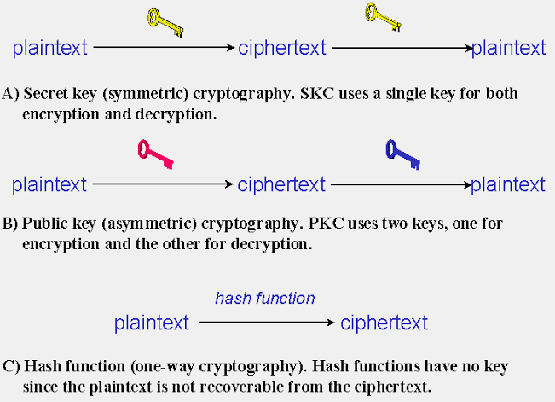  
 **If you want to read more about this before you do the quiz this is a very good website for a more in-depth dive ->**[**Click here**](https://www.garykessler.net/library/crypto.html#:~:text=Three%20types%20of%20cryptography%3A%20secret,public%20key%2C%20and%20hash%20function)

**Lesson 1: What Is Cryptography? Quiz**

**Congratulations! You have passed this quiz achieving 100%**[**NEXT LESSON**](https://www.trsryxrpl.com/lesson/lesson-2-blockchains-explained/)

1. **What is a cipher?**
   * **https://lh6.googleusercontent.com/nqnbeE1cUSJOY2gbCYYNOU-K4aZtEGdquQln2u199gUv6LzvY0AdprUvO7r5iU_ckMGl_IJfmDOMe6H5ITs78GjRGvxAui_QmZUFwZYxZWtUW9AAytP4IijvJAweIOI6dYyb8tKFvh4YzwBD5Q Something used to funnel data**
   * **https://lh4.googleusercontent.com/cWje2kaNyzsGDAWCrIbeL1XjYZPAMWBaum5iZn1IlsPk2gNZ1gbNIln6efaCHcj_pQKVhwBRl8HWOzbm3AcvyK3lZtxVUKffo5RYsITixsDjVljGNS-xPdhlhEtQMR3wbB-hbg9Gf2lLBB468g An algorithm that scrambles data into code**
   * **https://lh6.googleusercontent.com/nqnbeE1cUSJOY2gbCYYNOU-K4aZtEGdquQln2u199gUv6LzvY0AdprUvO7r5iU_ckMGl_IJfmDOMe6H5ITs78GjRGvxAui_QmZUFwZYxZWtUW9AAytP4IijvJAweIOI6dYyb8tKFvh4YzwBD5Q A hacking tool**
   * **https://lh6.googleusercontent.com/nqnbeE1cUSJOY2gbCYYNOU-K4aZtEGdquQln2u199gUv6LzvY0AdprUvO7r5iU_ckMGl_IJfmDOMe6H5ITs78GjRGvxAui_QmZUFwZYxZWtUW9AAytP4IijvJAweIOI6dYyb8tKFvh4YzwBD5Q A programme that is used in crypto**

**Correct4/4 $TRSRY**

1. **Which key is safe for you to share with other users if desired?**
   * **https://lh4.googleusercontent.com/cWje2kaNyzsGDAWCrIbeL1XjYZPAMWBaum5iZn1IlsPk2gNZ1gbNIln6efaCHcj_pQKVhwBRl8HWOzbm3AcvyK3lZtxVUKffo5RYsITixsDjVljGNS-xPdhlhEtQMR3wbB-hbg9Gf2lLBB468g Public key**
   * **https://lh6.googleusercontent.com/nqnbeE1cUSJOY2gbCYYNOU-K4aZtEGdquQln2u199gUv6LzvY0AdprUvO7r5iU_ckMGl_IJfmDOMe6H5ITs78GjRGvxAui_QmZUFwZYxZWtUW9AAytP4IijvJAweIOI6dYyb8tKFvh4YzwBD5Q Private key**
   * **https://lh6.googleusercontent.com/nqnbeE1cUSJOY2gbCYYNOU-K4aZtEGdquQln2u199gUv6LzvY0AdprUvO7r5iU_ckMGl_IJfmDOMe6H5ITs78GjRGvxAui_QmZUFwZYxZWtUW9AAytP4IijvJAweIOI6dYyb8tKFvh4YzwBD5Q Hash function**
   * **https://lh6.googleusercontent.com/nqnbeE1cUSJOY2gbCYYNOU-K4aZtEGdquQln2u199gUv6LzvY0AdprUvO7r5iU_ckMGl_IJfmDOMe6H5ITs78GjRGvxAui_QmZUFwZYxZWtUW9AAytP4IijvJAweIOI6dYyb8tKFvh4YzwBD5Q Cipher**

Correct4/4 $TRSRY

**Lesson 2: Blockchains explained**

Congratulations! You have passed this lesson's quiz achieving 100%

*Length: 10 minutes*

Lets start by breaking ‘blockchain’ down… Block = a set of ordered information, and chain = a continuous link. This essentially summarises the basic innerworkings of a blockchain.

Information sets are recorded into a block; however, each block’s storage capacity is limited. Once the block has been filled, a new block is instantly created and continues recording data. However, each and every block is linked to each other through cryptography, specifically hash functions. This means that each block is one-way encrypted meaning the contents and records of each block cannot be changed, without changing every single subsequent block. The blockchain is said to be *immutable*.

Blockchains can be used for multiple purposes such as – payment processing, money transfer, supply chain monitoring, data sharing and copywriting to name a few.

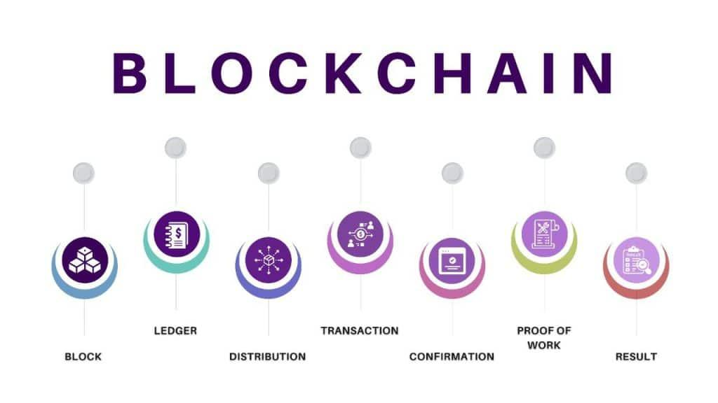  
To summarise, the blockchain is a long chain of encrypted data blocks that relates to one another ensuring that changes to the ‘blockchain’ are impossible once an event has been recorded.

Below are a list of popular blockchains used across a range of cryptocurrencies and other applications, feel free to skim over each link below to find a few key differences:

Bitcoin – [**https://bitcoin.org/en/**](https://bitcoin.org/en/)Ethereum – [**https://ethereum.org/en/**](https://ethereum.org/en/)Ripple – [**https://ripple.com/**](https://ripple.com/)Cardano – [**https://cardano.org/**](https://cardano.org/)Polkadot – [**https://polkadot.network/**](https://polkadot.network/)   
Stellar –[**https://www.stellar.org/lumens?locale=en**](https://www.stellar.org/lumens?locale=en)

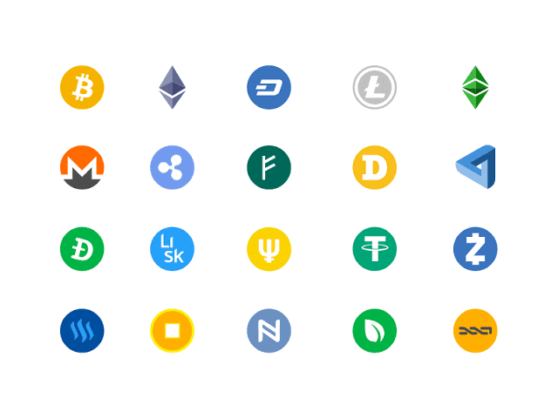

**Lesson 2: Blockchains explained Quiz**

Congratulations! You have passed this quiz achieving 100%[**NEXT LESSON**](https://www.trsryxrpl.com/lesson/lesson-3-what-is-a-cryptocurrency/)

1. **True or false: blockchains are only used for crypto**
   * https://lh6.googleusercontent.com/nqnbeE1cUSJOY2gbCYYNOU-K4aZtEGdquQln2u199gUv6LzvY0AdprUvO7r5iU_ckMGl_IJfmDOMe6H5ITs78GjRGvxAui_QmZUFwZYxZWtUW9AAytP4IijvJAweIOI6dYyb8tKFvh4YzwBD5Q True
   * https://lh4.googleusercontent.com/cWje2kaNyzsGDAWCrIbeL1XjYZPAMWBaum5iZn1IlsPk2gNZ1gbNIln6efaCHcj_pQKVhwBRl8HWOzbm3AcvyK3lZtxVUKffo5RYsITixsDjVljGNS-xPdhlhEtQMR3wbB-hbg9Gf2lLBB468g False

Correct**4/4 $TRSRY**

1. **Can a block’s data be changed?**
   * https://lh6.googleusercontent.com/nqnbeE1cUSJOY2gbCYYNOU-K4aZtEGdquQln2u199gUv6LzvY0AdprUvO7r5iU_ckMGl_IJfmDOMe6H5ITs78GjRGvxAui_QmZUFwZYxZWtUW9AAytP4IijvJAweIOI6dYyb8tKFvh4YzwBD5Q No, it takes too long to hack
   * https://lh6.googleusercontent.com/nqnbeE1cUSJOY2gbCYYNOU-K4aZtEGdquQln2u199gUv6LzvY0AdprUvO7r5iU_ckMGl_IJfmDOMe6H5ITs78GjRGvxAui_QmZUFwZYxZWtUW9AAytP4IijvJAweIOI6dYyb8tKFvh4YzwBD5Q Yes it's not easy however
   * https://lh4.googleusercontent.com/cWje2kaNyzsGDAWCrIbeL1XjYZPAMWBaum5iZn1IlsPk2gNZ1gbNIln6efaCHcj_pQKVhwBRl8HWOzbm3AcvyK3lZtxVUKffo5RYsITixsDjVljGNS-xPdhlhEtQMR3wbB-hbg9Gf2lLBB468g No. For an individual block to be changed every single future block will also need to be changed
   * https://lh6.googleusercontent.com/nqnbeE1cUSJOY2gbCYYNOU-K4aZtEGdquQln2u199gUv6LzvY0AdprUvO7r5iU_ckMGl_IJfmDOMe6H5ITs78GjRGvxAui_QmZUFwZYxZWtUW9AAytP4IijvJAweIOI6dYyb8tKFvh4YzwBD5Q Yes, but only by professionals

Correct**4/4 $TRSRY**

**Lesson 3: What Is A Cryptocurrency?**

Congratulations! You have passed this lesson's quiz achieving 100%

*Length: 10 minutes*

Cryptocurrency is defined as a digital or virtual currency that is secured through the use of cryptography to address issues such as counterfeiting or double spending. Most cryptocurrencies are run from a blockchain allowing decentralised access to users, while keeping governments and authorities from manipulating them in any way.

Decentralisation is a key selling point for most cryptocurrencies, it essentially means that no single person controls, changes or effects the currency in anyway. There is no requirement for an institute to control or manage transactions as they are all completed directly between two parties and instantly recorded on the blockchain. Due to this in general most cryptocurrencies boast lightning-fast transactions for low fees – take XRP for example!

Cryptocurrencies also offer some protection in regards to making anonymous transactions, however transactions can generally be linked back to a centralised or KYC exchange wallet and therefore your identity if law enforcement is inclined to do so, depending on the level of verification you as a user may have supplied when registering with an exchange prior to starting trading.

**Lesson 3: What Is A Cryptocurrency? Quiz**

Congratulations! You have passed this quiz achieving 100%[**NEXT LESSON**](https://www.trsryxrpl.com/lesson/lesson-4-wallets-explained/)

1. **Cryptocurrency transactions occur directly between two parties (generally)**
   * https://lh4.googleusercontent.com/cWje2kaNyzsGDAWCrIbeL1XjYZPAMWBaum5iZn1IlsPk2gNZ1gbNIln6efaCHcj_pQKVhwBRl8HWOzbm3AcvyK3lZtxVUKffo5RYsITixsDjVljGNS-xPdhlhEtQMR3wbB-hbg9Gf2lLBB468g True
   * https://lh6.googleusercontent.com/nqnbeE1cUSJOY2gbCYYNOU-K4aZtEGdquQln2u199gUv6LzvY0AdprUvO7r5iU_ckMGl_IJfmDOMe6H5ITs78GjRGvxAui_QmZUFwZYxZWtUW9AAytP4IijvJAweIOI6dYyb8tKFvh4YzwBD5Q False

Correct**4/4 $TRSRY**

1. **True or false: most cryptocurrencies don’t use blockchains**
   * https://lh6.googleusercontent.com/nqnbeE1cUSJOY2gbCYYNOU-K4aZtEGdquQln2u199gUv6LzvY0AdprUvO7r5iU_ckMGl_IJfmDOMe6H5ITs78GjRGvxAui_QmZUFwZYxZWtUW9AAytP4IijvJAweIOI6dYyb8tKFvh4YzwBD5Q True
   * https://lh4.googleusercontent.com/cWje2kaNyzsGDAWCrIbeL1XjYZPAMWBaum5iZn1IlsPk2gNZ1gbNIln6efaCHcj_pQKVhwBRl8HWOzbm3AcvyK3lZtxVUKffo5RYsITixsDjVljGNS-xPdhlhEtQMR3wbB-hbg9Gf2lLBB468g False

Correct**4/4 $TRSRY**

1. **True or false: cryptocurrency transactions are untraceable**
   * https://lh6.googleusercontent.com/nqnbeE1cUSJOY2gbCYYNOU-K4aZtEGdquQln2u199gUv6LzvY0AdprUvO7r5iU_ckMGl_IJfmDOMe6H5ITs78GjRGvxAui_QmZUFwZYxZWtUW9AAytP4IijvJAweIOI6dYyb8tKFvh4YzwBD5Q True
   * https://lh4.googleusercontent.com/cWje2kaNyzsGDAWCrIbeL1XjYZPAMWBaum5iZn1IlsPk2gNZ1gbNIln6efaCHcj_pQKVhwBRl8HWOzbm3AcvyK3lZtxVUKffo5RYsITixsDjVljGNS-xPdhlhEtQMR3wbB-hbg9Gf2lLBB468g False

Correct**4/4 $TRSRY**

**Lesson 4: Wallets Explained**

Congratulations! You have passed this lesson's quiz achieving 100%

*Length: 10 minutes*

Many people who dabble in cryptocurrency actually understand how a wallet works but if you are just starting out then read on. Your crypto is NOT stored on or within your wallet, it is stored directly on the blockchain. Your crypto wallet simply allows you to ‘interact’ and view your balance of the crypto that is recorded in the blockchain.

The way the balances are interacted with is through ‘signing’ transactions with your private key – think back to the initial lesson on cryptography.

Put simply, crypto wallets store your private keys and have inbuilt programs and design interfaces to make interacting with your cryptocurrency as simple as possible – meanwhile all your crypto is stored safely and securely within the blockchain.

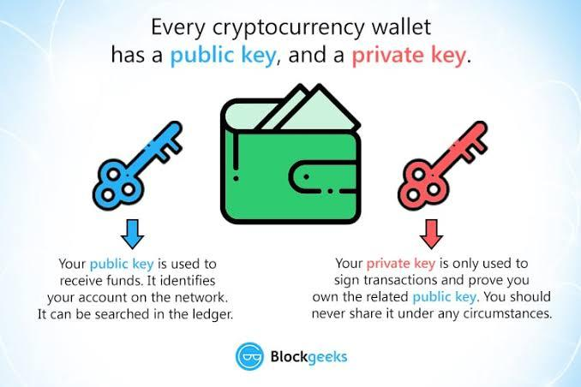**Image courtesy of**[**blockgeeks.com**](https://blockgeeks.com/)**If you are keen to get trading and would like to set up your wallet, check out this video courtesy of XUMM Trustlines Facebook Group.**[**https://youtu.be/9Hyq_sn16qg**](https://youtu.be/9Hyq_sn16qg)**Lesson 4: Wallets Explained Quiz**

**Congratulations! You have passed this quiz achieving 100%**[**NEXT LESSON**](https://www.trsryxrpl.com/modules/nfts/?course_id=4093)

1. **What is the purpose of a cryptocurrency wallet?**
   * **https://lh6.googleusercontent.com/nqnbeE1cUSJOY2gbCYYNOU-K4aZtEGdquQln2u199gUv6LzvY0AdprUvO7r5iU_ckMGl_IJfmDOMe6H5ITs78GjRGvxAui_QmZUFwZYxZWtUW9AAytP4IijvJAweIOI6dYyb8tKFvh4YzwBD5Q To store all your crypto within it safely**
   * **https://lh6.googleusercontent.com/nqnbeE1cUSJOY2gbCYYNOU-K4aZtEGdquQln2u199gUv6LzvY0AdprUvO7r5iU_ckMGl_IJfmDOMe6H5ITs78GjRGvxAui_QmZUFwZYxZWtUW9AAytP4IijvJAweIOI6dYyb8tKFvh4YzwBD5Q To ensure it can be used at the shops in the future**
   * **https://lh4.googleusercontent.com/cWje2kaNyzsGDAWCrIbeL1XjYZPAMWBaum5iZn1IlsPk2gNZ1gbNIln6efaCHcj_pQKVhwBRl8HWOzbm3AcvyK3lZtxVUKffo5RYsITixsDjVljGNS-xPdhlhEtQMR3wbB-hbg9Gf2lLBB468g To allow users to store their private keys safely and ‘sign’ transactions in the simplest possible way**
   * **https://lh6.googleusercontent.com/nqnbeE1cUSJOY2gbCYYNOU-K4aZtEGdquQln2u199gUv6LzvY0AdprUvO7r5iU_ckMGl_IJfmDOMe6H5ITs78GjRGvxAui_QmZUFwZYxZWtUW9AAytP4IijvJAweIOI6dYyb8tKFvh4YzwBD5Q To show everyone how much TRSRY you hold**

**Correct4/4 $TRSRY**

1. **Where is crypto stored?**
   * **https://lh4.googleusercontent.com/cWje2kaNyzsGDAWCrIbeL1XjYZPAMWBaum5iZn1IlsPk2gNZ1gbNIln6efaCHcj_pQKVhwBRl8HWOzbm3AcvyK3lZtxVUKffo5RYsITixsDjVljGNS-xPdhlhEtQMR3wbB-hbg9Gf2lLBB468g On the blockchain**
   * **https://lh6.googleusercontent.com/nqnbeE1cUSJOY2gbCYYNOU-K4aZtEGdquQln2u199gUv6LzvY0AdprUvO7r5iU_ckMGl_IJfmDOMe6H5ITs78GjRGvxAui_QmZUFwZYxZWtUW9AAytP4IijvJAweIOI6dYyb8tKFvh4YzwBD5Q In your wallet**
   * **https://lh6.googleusercontent.com/nqnbeE1cUSJOY2gbCYYNOU-K4aZtEGdquQln2u199gUv6LzvY0AdprUvO7r5iU_ckMGl_IJfmDOMe6H5ITs78GjRGvxAui_QmZUFwZYxZWtUW9AAytP4IijvJAweIOI6dYyb8tKFvh4YzwBD5Q With an exchange**
   * **https://lh6.googleusercontent.com/nqnbeE1cUSJOY2gbCYYNOU-K4aZtEGdquQln2u199gUv6LzvY0AdprUvO7r5iU_ckMGl_IJfmDOMe6H5ITs78GjRGvxAui_QmZUFwZYxZWtUW9AAytP4IijvJAweIOI6dYyb8tKFvh4YzwBD5Q In your bank**

Correct4/4 $TRSRY

**Course 5.1: NFT's**If like many you are intrigued by the current trend in NFT's, this module offers a gentle introduction to this space.  
 **Lesson 1: What Are NFT’s?**

Congratulations! You have passed this lesson's quiz achieving 50%

*Length: 10 minutes*

An NFT is a non-fungible token, with non-fungible meaning they’re unique and therefore unable to be exchanged for another NFT as they are not equal. Whereas 1 BTC will always equal 1 BTC, (they are fungible), 1 NFT won’t equal any other 1 NFT. NFTs are unique sets of data that are stored within the blockchain that can be sold or traded. NFTs most often are attributed to photos, however can include videos and audio also, as well as utility. Each and every NFT created is uniquely identifiable meaning copies are able to be recognised easily, and true owners can undisputedly prove they own a certain NFT.

However, as much as the blockchain shows proof of ownership – NFTs do not restrict anyone from ‘stealing’ or copying the digital files within the NFT, or creating another NFT with the exact same underlying files. Essentially there are no laws around the legality and rights of owning an NFT, and at this current state in time NFTs are likened to status symbols. 

To summarise, NFTs are uniquely identifiable tokens created on the blockchain that store sets of data such as images, audio and video.

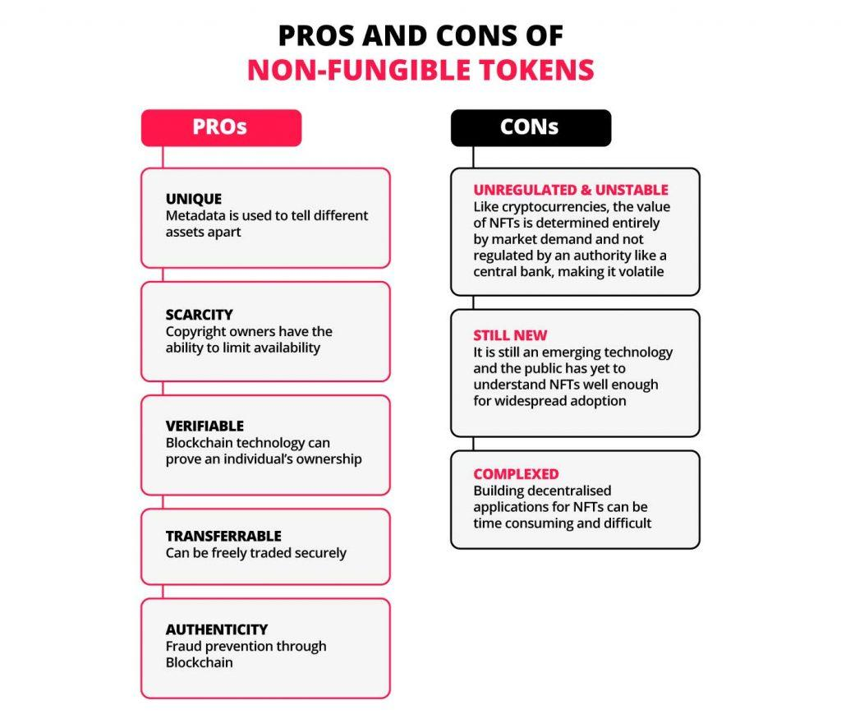 **Lesson 1: What Are NFT’s? Quiz**

**Congratulations! You have passed this quiz achieving 50%**[**NEXT LESSON**](https://www.trsryxrpl.com/lesson/real-world-use-cases-for-nfts/)

1. **Does buying an NFT give you rights to ownership of the digital art?**
   * **https://lh4.googleusercontent.com/cWje2kaNyzsGDAWCrIbeL1XjYZPAMWBaum5iZn1IlsPk2gNZ1gbNIln6efaCHcj_pQKVhwBRl8HWOzbm3AcvyK3lZtxVUKffo5RYsITixsDjVljGNS-xPdhlhEtQMR3wbB-hbg9Gf2lLBB468g Yes, owning the NFT means you own the original artwork**
   * **https://lh6.googleusercontent.com/nqnbeE1cUSJOY2gbCYYNOU-K4aZtEGdquQln2u199gUv6LzvY0AdprUvO7r5iU_ckMGl_IJfmDOMe6H5ITs78GjRGvxAui_QmZUFwZYxZWtUW9AAytP4IijvJAweIOI6dYyb8tKFvh4YzwBD5Q Not necessarily, it is worth checking the license terms or speaking to the creator of the NFT**

**Incorrect0/4 $TRSRY**

**Right Answer: Not necessarily, it is worth checking the license terms or speaking to the creator of the NFT**

1. **Is the data within an NFTs legally owned by the person holding them?**
   * **https://lh6.googleusercontent.com/nqnbeE1cUSJOY2gbCYYNOU-K4aZtEGdquQln2u199gUv6LzvY0AdprUvO7r5iU_ckMGl_IJfmDOMe6H5ITs78GjRGvxAui_QmZUFwZYxZWtUW9AAytP4IijvJAweIOI6dYyb8tKFvh4YzwBD5Q Yes**
   * **https://lh4.googleusercontent.com/cWje2kaNyzsGDAWCrIbeL1XjYZPAMWBaum5iZn1IlsPk2gNZ1gbNIln6efaCHcj_pQKVhwBRl8HWOzbm3AcvyK3lZtxVUKffo5RYsITixsDjVljGNS-xPdhlhEtQMR3wbB-hbg9Gf2lLBB468g No**

Correct4/4 $TRSRY

**Lesson 2: Real World Use Cases for NFTs**

Congratulations! You have passed this lesson's quiz achieving 100%

*Length: 10 minutes*

Real world use cases of NFTs?

As much as some NFTs are seen as no more than a gimmick, there are many uses case for NFTs within the real world, and only time will tell how prevalent they will become. A common theme behind many of the concepts of real use cases comes down to the speed, transparency and security of the blockchain.

Authenticity of products – ensuring real world products are authentic e.g. imagine purchasing medicine with an NFT QR code that when scanned would reveal the products journey from Manufacturing to purchase date, as well as verifying its contents.

Real Estate – NFT land deeds and proof of ownership, as well as the ability to track the prices of homes over time via the NFT values.  Transactions between buyers and sellers could be sped up immensely all while ensuring the process is kept as simple as possible.

Birth Certificates/Medical Records – Imagine your own NFT birth certificate. Marked into the blockchain with your information, creating an easily accessible lifelong ID. Same goes for medical records, however allowing doctors and medical professionals to access and add data as required.

Supply Chain – Supply chains and consumers would greatly benefit from NFT tracking, suppliers will be able to uniquely identify each product with an NFT ensuring that tampering is not possible, all while allowing consumers to have consistent access to the whereabouts of the product.

Ticketing – In some shape or form NFTs will change the world of ticketing. NFT tickets can be easily sold in case of the inability to attend an event, they can be kept safe digitally within the blockchain.(no losing paper tickets or accidentally deleting them from your email). Secure parking passes for example can be replaced with NFTs, allowing only those verified from the blockchain to pass through.

NFTs and cryptocurrency will absolutely change the way we live in some degree, there is a huge amount of potential regarding NFTs – however the new technology and education required for these changes will take time to implement and develop into the commercial world.

[Lesson 2: Real World Use Cases for NFTs Quiz](https://www.trsryxrpl.com/quiz/real-world-use-cases-for-nfts/)

[Congratulations! You have passed this quiz achieving 100%](https://www.trsryxrpl.com/quiz/real-world-use-cases-for-nfts/)[NEXT LESSON](https://www.trsryxrpl.com/lesson/how-to-create-your-own-nft-on-xrpl/)

1. [What are the problems stopping NFT adoption today?](https://www.trsryxrpl.com/quiz/real-world-use-cases-for-nfts/)
   * [https://lh6.googleusercontent.com/nqnbeE1cUSJOY2gbCYYNOU-K4aZtEGdquQln2u199gUv6LzvY0AdprUvO7r5iU_ckMGl_IJfmDOMe6H5ITs78GjRGvxAui_QmZUFwZYxZWtUW9AAytP4IijvJAweIOI6dYyb8tKFvh4YzwBD5Q We need more people who know how to design and be creative](https://www.trsryxrpl.com/quiz/real-world-use-cases-for-nfts/)
   * [https://lh4.googleusercontent.com/cWje2kaNyzsGDAWCrIbeL1XjYZPAMWBaum5iZn1IlsPk2gNZ1gbNIln6efaCHcj_pQKVhwBRl8HWOzbm3AcvyK3lZtxVUKffo5RYsITixsDjVljGNS-xPdhlhEtQMR3wbB-hbg9Gf2lLBB468g Education and existing technology](https://www.trsryxrpl.com/quiz/real-world-use-cases-for-nfts/)
   * [https://lh6.googleusercontent.com/nqnbeE1cUSJOY2gbCYYNOU-K4aZtEGdquQln2u199gUv6LzvY0AdprUvO7r5iU_ckMGl_IJfmDOMe6H5ITs78GjRGvxAui_QmZUFwZYxZWtUW9AAytP4IijvJAweIOI6dYyb8tKFvh4YzwBD5Q They are too expensive to produce](https://www.trsryxrpl.com/quiz/real-world-use-cases-for-nfts/)

[Correct4/4 $TRSRY](https://www.trsryxrpl.com/quiz/real-world-use-cases-for-nfts/)

1. [What is NOT one of the 3 main benefits of NFTs within the real world?](https://www.trsryxrpl.com/quiz/real-world-use-cases-for-nfts/)
   * [https://lh6.googleusercontent.com/nqnbeE1cUSJOY2gbCYYNOU-K4aZtEGdquQln2u199gUv6LzvY0AdprUvO7r5iU_ckMGl_IJfmDOMe6H5ITs78GjRGvxAui_QmZUFwZYxZWtUW9AAytP4IijvJAweIOI6dYyb8tKFvh4YzwBD5Q Security](https://www.trsryxrpl.com/quiz/real-world-use-cases-for-nfts/)
   * [https://lh6.googleusercontent.com/nqnbeE1cUSJOY2gbCYYNOU-K4aZtEGdquQln2u199gUv6LzvY0AdprUvO7r5iU_ckMGl_IJfmDOMe6H5ITs78GjRGvxAui_QmZUFwZYxZWtUW9AAytP4IijvJAweIOI6dYyb8tKFvh4YzwBD5Q Speed](https://www.trsryxrpl.com/quiz/real-world-use-cases-for-nfts/)
   * [https://lh4.googleusercontent.com/cWje2kaNyzsGDAWCrIbeL1XjYZPAMWBaum5iZn1IlsPk2gNZ1gbNIln6efaCHcj_pQKVhwBRl8HWOzbm3AcvyK3lZtxVUKffo5RYsITixsDjVljGNS-xPdhlhEtQMR3wbB-hbg9Gf2lLBB468g Untraceability](https://www.trsryxrpl.com/quiz/real-world-use-cases-for-nfts/)
   * [https://lh6.googleusercontent.com/nqnbeE1cUSJOY2gbCYYNOU-K4aZtEGdquQln2u199gUv6LzvY0AdprUvO7r5iU_ckMGl_IJfmDOMe6H5ITs78GjRGvxAui_QmZUFwZYxZWtUW9AAytP4IijvJAweIOI6dYyb8tKFvh4YzwBD5Q Transparency](https://www.trsryxrpl.com/quiz/real-world-use-cases-for-nfts/)

[Correct4/4 $TRSRY](https://www.trsryxrpl.com/quiz/real-world-use-cases-for-nfts/)

1. [True or False: in the future NFTs have the technology to assist postage/shipping companies?](https://www.trsryxrpl.com/quiz/real-world-use-cases-for-nfts/)
   * [https://lh4.googleusercontent.com/cWje2kaNyzsGDAWCrIbeL1XjYZPAMWBaum5iZn1IlsPk2gNZ1gbNIln6efaCHcj_pQKVhwBRl8HWOzbm3AcvyK3lZtxVUKffo5RYsITixsDjVljGNS-xPdhlhEtQMR3wbB-hbg9Gf2lLBB468g True](https://www.trsryxrpl.com/quiz/real-world-use-cases-for-nfts/)
   * [https://lh6.googleusercontent.com/nqnbeE1cUSJOY2gbCYYNOU-K4aZtEGdquQln2u199gUv6LzvY0AdprUvO7r5iU_ckMGl_IJfmDOMe6H5ITs78GjRGvxAui_QmZUFwZYxZWtUW9AAytP4IijvJAweIOI6dYyb8tKFvh4YzwBD5Q False](https://www.trsryxrpl.com/quiz/real-world-use-cases-for-nfts/)

[Correct4/4 $TRSRY](https://www.trsryxrpl.com/quiz/real-world-use-cases-for-nfts/)

**Lesson 3: How To Create Your Own NFT on XRPL**

Congratulations! You have passed this lesson's quiz achieving 100%

*Length: 10 minutes*

Currently the easiest way to create an NFT on the XRPL is to use the Sologenic Marketplace. To follow along feel free to follow this link to get started! <https://sologenic.org/nfts/marketplace> – The tutorial will have screenshots from a mobile device; however, the steps will be identical on a PC. Current Sologenic NFTs are XLS-14D, however they will be ported to XLS-20D when complete.

Step 1 – Ensure you have at least 3 SOLO and 10XRP to create your NFT.

Step 2 – Connect your wallet by finding the “Connect Wallet” button wallet within the menu, choose the option that applies to you. For this example we will use XUMM Wallet, however if using another option just follow the instructions.

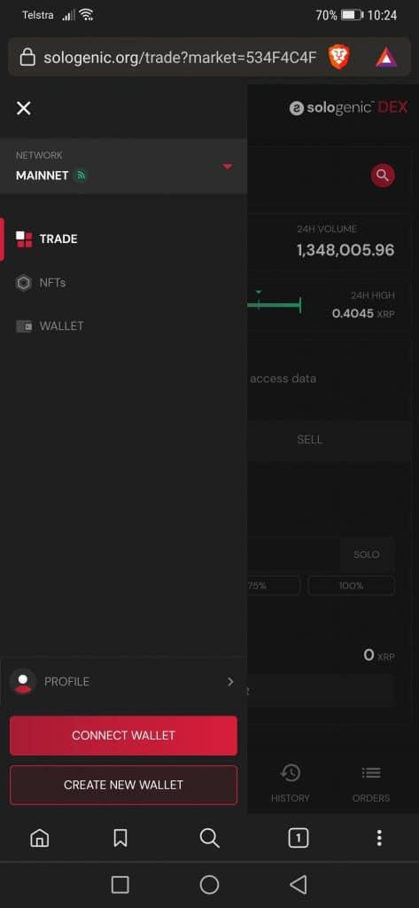  
Step 3 – When the QR code shows up, click the blue link that says (Xumm Wallet >), or if on PC scan the QR code from within the XUMM app. Once in XUMM sign the transaction and your wallet will be linked!

Step 4 – Click the red “MINT” button in the top right corner, click on the “Verify” button and head to your XUMM app to sign the requested transaction. Once that is complete fill out the images you are choosing for your collection banner (these are NOT your NFTs, simply artwork to promote the folder where your NFTs are stored).

Step 5 – Once complete the next page will ask for you to add an NFT, it will require you to pay/burn 3 SOLO to Mint your NFT. Sign this transaction and proceed with uploading your file as the NFT. Within the add an NFT page you can select categories and properties to help your NFT gain reach as well as create descriptions and add external links.

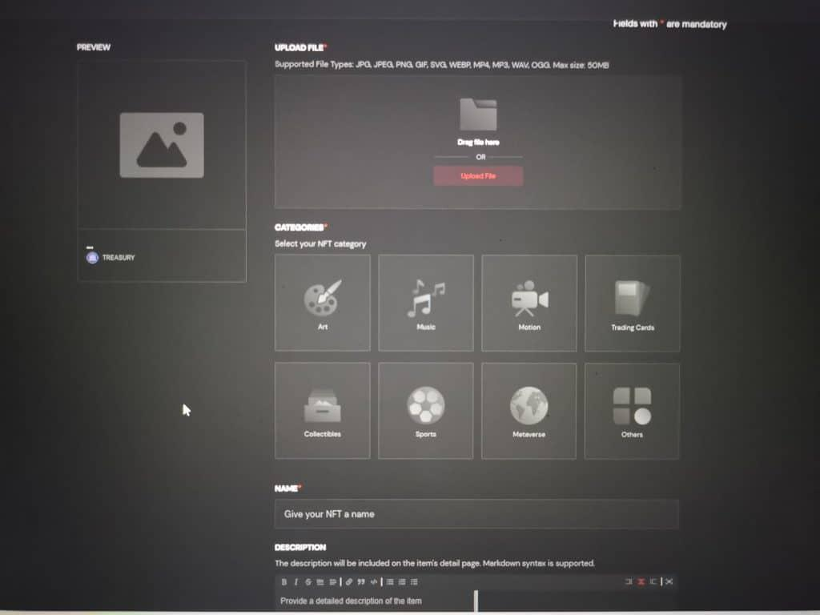  
Step 6 – Once your NFT is created, click “Confirm” and then on the next page click finish. The final transaction will be to ‘seal’ the NFT which costs 10 XRP. Once that is complete congratulations you have created your first NFT!

From here you are free to trade or hold your NFT as you wish! Feel free to explore the Sologenic marketplace and try put your brand new NFT for sale, you can choose between XRP or Solo.

NFTs you own can be viewed on the XUMM wallet: Tap the small XUMM logo in the centre of the home panel, tap on “View more xApps”, tap on Peerkat NFT Viewer (light blue meerkats) and wait for it to load.

**Lesson 3: How To Create Your Own NFT on XRPL Quiz**

**Congratulations! You have passed this quiz achieving 100%**[**NEXT LESSON**](https://www.trsryxrpl.com/modules/mining/?course_id=4093)

1. **True or False: NFTs can be sold for both XRP and Solo?**
   * **https://lh4.googleusercontent.com/cWje2kaNyzsGDAWCrIbeL1XjYZPAMWBaum5iZn1IlsPk2gNZ1gbNIln6efaCHcj_pQKVhwBRl8HWOzbm3AcvyK3lZtxVUKffo5RYsITixsDjVljGNS-xPdhlhEtQMR3wbB-hbg9Gf2lLBB468g True**
   * **https://lh6.googleusercontent.com/nqnbeE1cUSJOY2gbCYYNOU-K4aZtEGdquQln2u199gUv6LzvY0AdprUvO7r5iU_ckMGl_IJfmDOMe6H5ITs78GjRGvxAui_QmZUFwZYxZWtUW9AAytP4IijvJAweIOI6dYyb8tKFvh4YzwBD5Q False**

**Correct4/4 $TRSRY**

1. **NFTs minted on Sologenic are only able to be viewed within the Sologenic Marketplace?**
   * **https://lh6.googleusercontent.com/nqnbeE1cUSJOY2gbCYYNOU-K4aZtEGdquQln2u199gUv6LzvY0AdprUvO7r5iU_ckMGl_IJfmDOMe6H5ITs78GjRGvxAui_QmZUFwZYxZWtUW9AAytP4IijvJAweIOI6dYyb8tKFvh4YzwBD5Q True**
   * **https://lh4.googleusercontent.com/cWje2kaNyzsGDAWCrIbeL1XjYZPAMWBaum5iZn1IlsPk2gNZ1gbNIln6efaCHcj_pQKVhwBRl8HWOzbm3AcvyK3lZtxVUKffo5RYsITixsDjVljGNS-xPdhlhEtQMR3wbB-hbg9Gf2lLBB468g False**

**Correct4/4 $TRSRY**

1. **What is the minting fee for each Sologenic NFT?**
   * **https://lh6.googleusercontent.com/nqnbeE1cUSJOY2gbCYYNOU-K4aZtEGdquQln2u199gUv6LzvY0AdprUvO7r5iU_ckMGl_IJfmDOMe6H5ITs78GjRGvxAui_QmZUFwZYxZWtUW9AAytP4IijvJAweIOI6dYyb8tKFvh4YzwBD5Q 1 Solo**
   * **https://lh6.googleusercontent.com/nqnbeE1cUSJOY2gbCYYNOU-K4aZtEGdquQln2u199gUv6LzvY0AdprUvO7r5iU_ckMGl_IJfmDOMe6H5ITs78GjRGvxAui_QmZUFwZYxZWtUW9AAytP4IijvJAweIOI6dYyb8tKFvh4YzwBD5Q 2 Solo**
   * **https://lh4.googleusercontent.com/cWje2kaNyzsGDAWCrIbeL1XjYZPAMWBaum5iZn1IlsPk2gNZ1gbNIln6efaCHcj_pQKVhwBRl8HWOzbm3AcvyK3lZtxVUKffo5RYsITixsDjVljGNS-xPdhlhEtQMR3wbB-hbg9Gf2lLBB468g 3 Solo**
   * **https://lh6.googleusercontent.com/nqnbeE1cUSJOY2gbCYYNOU-K4aZtEGdquQln2u199gUv6LzvY0AdprUvO7r5iU_ckMGl_IJfmDOMe6H5ITs78GjRGvxAui_QmZUFwZYxZWtUW9AAytP4IijvJAweIOI6dYyb8tKFvh4YzwBD5Q 10 Solo**

Correct4/4 $TRSRY

**Course 5.2: Mining**If you are interested in Mining and want to know more then this is the module for you.

**Lesson 1: What is Crypto Mining**

Congratulations! You have passed this lesson's quiz achieving 100%

*Length: 10 minutes*

Crypto mining is the competitive process that verifies and adds new transactions to the blockchain for a cryptocurrency. The miners with the most computing power are rewarded with some amount of the currency or in some cases transaction fees from users of the network. Generally each user receives a reward that is dictated by their addition of computing power to the network. Below are a few examples of the different takes on mining:

Individual Miners

Nowadays anyone can purchase specialized mining hardware but it will hurt the wallet when compared to the early 2010s prices of mining rigs. As new crypto assets that use proof-of-work (PoW) get up and running sometimes a regular computer or cell phone may be sufficient for mining, however more established chains such as BTC are nearly impossible to mine alone.

Mining Pools

Organizations combine their resources to obtain a larger amount of mining hardware / computing power. Mining pools are open to the public and anyone can add their computers / computing power to the network. Rewards within mining pools are generally split between all users depending on their computing power, this allows users with insignificant mining machines to at least earn ‘something’.

Cloud Mining

Simply put, cloud mining is the easiest way to buy computing power but the rewards can be dramatically different. Through cloud mining people can rent time/computing power at a set price or at a sliding scale price depending on the service you use. Cloud mining allows you to minimise start up costs and doesn’t require any extra equipment or create extra heat or electricity. However you have to think why a company would choose to rent you their machine, when they could make a larger profit from running it for themselves.

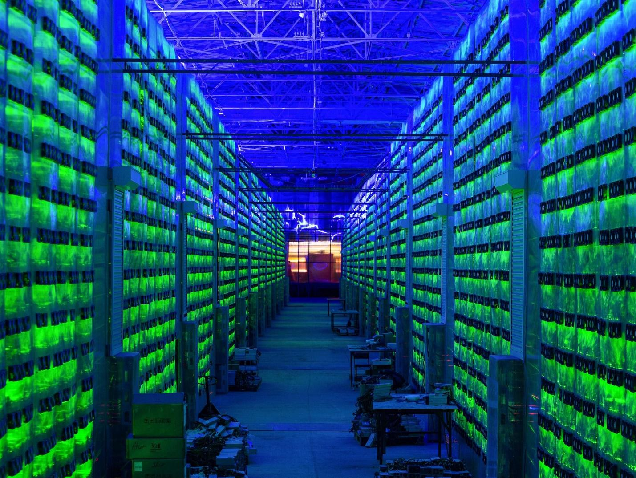 **Lesson 1: What is Crypto Mining Quiz**

**Congratulations! You have passed this quiz achieving 100%**[**NEXT LESSON**](https://www.trsryxrpl.com/lesson/lesson-2-proof-of-work/)

1. **What is a way to buy computing power for a set amount of time?**
   * **https://lh6.googleusercontent.com/nqnbeE1cUSJOY2gbCYYNOU-K4aZtEGdquQln2u199gUv6LzvY0AdprUvO7r5iU_ckMGl_IJfmDOMe6H5ITs78GjRGvxAui_QmZUFwZYxZWtUW9AAytP4IijvJAweIOI6dYyb8tKFvh4YzwBD5Q Mining pool**
   * **https://lh4.googleusercontent.com/cWje2kaNyzsGDAWCrIbeL1XjYZPAMWBaum5iZn1IlsPk2gNZ1gbNIln6efaCHcj_pQKVhwBRl8HWOzbm3AcvyK3lZtxVUKffo5RYsITixsDjVljGNS-xPdhlhEtQMR3wbB-hbg9Gf2lLBB468g Cloud mining**
   * **https://lh6.googleusercontent.com/nqnbeE1cUSJOY2gbCYYNOU-K4aZtEGdquQln2u199gUv6LzvY0AdprUvO7r5iU_ckMGl_IJfmDOMe6H5ITs78GjRGvxAui_QmZUFwZYxZWtUW9AAytP4IijvJAweIOI6dYyb8tKFvh4YzwBD5Q Individual mining**
   * **https://lh6.googleusercontent.com/nqnbeE1cUSJOY2gbCYYNOU-K4aZtEGdquQln2u199gUv6LzvY0AdprUvO7r5iU_ckMGl_IJfmDOMe6H5ITs78GjRGvxAui_QmZUFwZYxZWtUW9AAytP4IijvJAweIOI6dYyb8tKFvh4YzwBD5Q SPAC mining**

**Correct4/4 $TRSRY**

1. **What is a competitive process?**
   * **https://lh6.googleusercontent.com/nqnbeE1cUSJOY2gbCYYNOU-K4aZtEGdquQln2u199gUv6LzvY0AdprUvO7r5iU_ckMGl_IJfmDOMe6H5ITs78GjRGvxAui_QmZUFwZYxZWtUW9AAytP4IijvJAweIOI6dYyb8tKFvh4YzwBD5Q Break Dancing**
   * **https://lh6.googleusercontent.com/nqnbeE1cUSJOY2gbCYYNOU-K4aZtEGdquQln2u199gUv6LzvY0AdprUvO7r5iU_ckMGl_IJfmDOMe6H5ITs78GjRGvxAui_QmZUFwZYxZWtUW9AAytP4IijvJAweIOI6dYyb8tKFvh4YzwBD5Q GPU's**
   * **https://lh6.googleusercontent.com/nqnbeE1cUSJOY2gbCYYNOU-K4aZtEGdquQln2u199gUv6LzvY0AdprUvO7r5iU_ckMGl_IJfmDOMe6H5ITs78GjRGvxAui_QmZUFwZYxZWtUW9AAytP4IijvJAweIOI6dYyb8tKFvh4YzwBD5Q POW**
   * **https://lh4.googleusercontent.com/cWje2kaNyzsGDAWCrIbeL1XjYZPAMWBaum5iZn1IlsPk2gNZ1gbNIln6efaCHcj_pQKVhwBRl8HWOzbm3AcvyK3lZtxVUKffo5RYsITixsDjVljGNS-xPdhlhEtQMR3wbB-hbg9Gf2lLBB468g Mining**

**Correct4/4 $TRSRY**

**Lesson 2: Proof of Work**

Congratulations! You have passed this lesson's quiz achieving 100%

*Length: 10 minutes*

Anonymity and decentralization are the key parts in the original cryptocurrencies. But there needed to be a way to confirm transactions without involving financial institutions. The solution that was found is called proof of work.

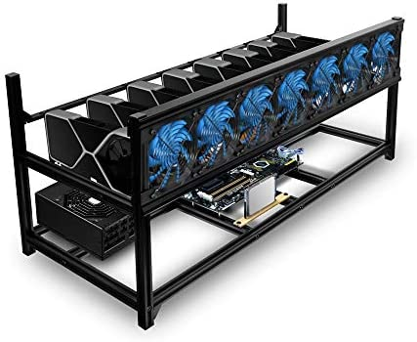Here’s an example,

A PoW Crypto projects use a variety of different hashing algorithms to create different types of hash code. When a POW coin transaction occurs, they go through a security verification and are grouped into a block to be mined. For an example, Bitcoin’s proof-of-work algorithm then generates a hash for the block. A hash refers to a fixed-length of alphanumeric code. This code is used to represent letters, words and data of any length.

Hash-rate refers, to the total combined computational power that is being used to mine and process transactions on a Proof-of-Work blockchain. The algorithm called SHA-256 is what Bitcoin uses and always generates hashes with 64 characters.

PoW is a way to add new blocks of transactions to that desired crypto’s blockchain. The work, in this case, is generating a hash that matches the targeted hash for the current block. This takes a huge amount of guesses and processing power, the miners machines race to be the first to generate the hash first for that block. The winner gets to add the latest block of transactions to the blockchain. So, the more computational power the miner has the more hash they can solve which equals to more chances of the hash created to be correct.

Here is where the benefit of mining pools become evident – lets say you are mining by yourself on a 5 year old laptop, there is a tiny tiny chance (basically impossible) that you solve the block and earn the 6.25 BTC block reward all for yourself, but generally you will earn nothing even if you mined for your entire life… But if you join a pool of tens of thousands of machines and add your laptop’s power to the pool, you will earn tiny regular rewards as your pool solves the blocks together!  
  
**Lesson 2: Proof of Work Quiz**

Congratulations! You have passed this quiz achieving 100%[**NEXT LESSON**](https://www.trsryxrpl.com/lesson/minting_what-is-proof-of-stake/)

1. **What is a hash?**
   * https://lh6.googleusercontent.com/nqnbeE1cUSJOY2gbCYYNOU-K4aZtEGdquQln2u199gUv6LzvY0AdprUvO7r5iU_ckMGl_IJfmDOMe6H5ITs78GjRGvxAui_QmZUFwZYxZWtUW9AAytP4IijvJAweIOI6dYyb8tKFvh4YzwBD5Q Sha-256
   * https://lh6.googleusercontent.com/nqnbeE1cUSJOY2gbCYYNOU-K4aZtEGdquQln2u199gUv6LzvY0AdprUvO7r5iU_ckMGl_IJfmDOMe6H5ITs78GjRGvxAui_QmZUFwZYxZWtUW9AAytP4IijvJAweIOI6dYyb8tKFvh4YzwBD5Q Code that refers to the token
   * https://lh6.googleusercontent.com/nqnbeE1cUSJOY2gbCYYNOU-K4aZtEGdquQln2u199gUv6LzvY0AdprUvO7r5iU_ckMGl_IJfmDOMe6H5ITs78GjRGvxAui_QmZUFwZYxZWtUW9AAytP4IijvJAweIOI6dYyb8tKFvh4YzwBD5Q Bitcoin
   * https://lh4.googleusercontent.com/cWje2kaNyzsGDAWCrIbeL1XjYZPAMWBaum5iZn1IlsPk2gNZ1gbNIln6efaCHcj_pQKVhwBRl8HWOzbm3AcvyK3lZtxVUKffo5RYsITixsDjVljGNS-xPdhlhEtQMR3wbB-hbg9Gf2lLBB468g A fixed-length of alphanumeric code

Correct**4/4 $TRSRY**

1. **What does POW stand for?**
   * https://lh6.googleusercontent.com/nqnbeE1cUSJOY2gbCYYNOU-K4aZtEGdquQln2u199gUv6LzvY0AdprUvO7r5iU_ckMGl_IJfmDOMe6H5ITs78GjRGvxAui_QmZUFwZYxZWtUW9AAytP4IijvJAweIOI6dYyb8tKFvh4YzwBD5Q Power Of Work
   * https://lh6.googleusercontent.com/nqnbeE1cUSJOY2gbCYYNOU-K4aZtEGdquQln2u199gUv6LzvY0AdprUvO7r5iU_ckMGl_IJfmDOMe6H5ITs78GjRGvxAui_QmZUFwZYxZWtUW9AAytP4IijvJAweIOI6dYyb8tKFvh4YzwBD5Q Proof Of Wealth
   * https://lh6.googleusercontent.com/nqnbeE1cUSJOY2gbCYYNOU-K4aZtEGdquQln2u199gUv6LzvY0AdprUvO7r5iU_ckMGl_IJfmDOMe6H5ITs78GjRGvxAui_QmZUFwZYxZWtUW9AAytP4IijvJAweIOI6dYyb8tKFvh4YzwBD5Q Power Of Wellness
   * https://lh4.googleusercontent.com/cWje2kaNyzsGDAWCrIbeL1XjYZPAMWBaum5iZn1IlsPk2gNZ1gbNIln6efaCHcj_pQKVhwBRl8HWOzbm3AcvyK3lZtxVUKffo5RYsITixsDjVljGNS-xPdhlhEtQMR3wbB-hbg9Gf2lLBB468g Proof Of Work

Correct**4/4 $TRSRY**

**Lesson 3: What Is Proof-of-Stake?**

Congratulations! You have passed this lesson's quiz achieving 100%

*Length: 10 minutes*

Proof-of-stake (PoS) was created as an alternative to Proof-of-work (PoW), the original consensus mechanism used to validate a blockchain and add new blocks. PoS is a cryptocurrency consensus mechanism that is used for processing transactions and creating new blocks within that specific blockchain. Thereby keeping the blockchain secure and transactions within order.

Using PoS to validate comes with many benefits such as energy efficiency, security and scalability. PoS requires users to keep the blockchain secure through validators – essentially a process in which the transactions of the block are checked for their accuracy and validity, the block is then signed by the validator and then a reward of transaction fees is paid (some chains may also include an extra coin reward). The great thing is that PoS doesn’t require extra equipment or vast technical knowledge, as long as you hold a PoS coin and wish to ‘stake’ it you are able to earn!

PoS works in a similar way to mining pools, if you wish to stake your coins they will be allocated to a node. Nodes that are chosen to validate a block are essentially random, however those with a larger stake have increased chances. This is due to the fact that they have more of their coins at stake and any fraudulent blocks will result in greater penalties.

[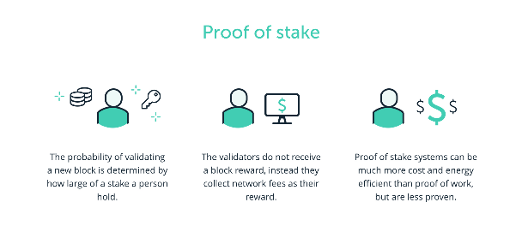This is generally a very basic rundown on the PoS system and many of these steps can be greatly expanded on within your own research!](https://www.trsryxrpl.com/quiz/lesson-2-proof-of-work/)

**Lesson 3: What Is Proof-of-Stake? Quiz**

**Congratulations! You have passed this quiz achieving 100%**[**NEXT LESSON**](https://www.trsryxrpl.com/lesson/lesson-5-which-is-better/)

1. **Some benefits of PoS are?**
   * **https://lh6.googleusercontent.com/mjVX-Tnb_wRg4bHXse0JwhnqK7ALUrctZQRnGN5NesIuFukZtPcOsfaK9vM4zx5MsYLylaGz8zHEPYNg7m_wd5rSW6FfZp_Hteial0t-4iu4zwIKt8JQ8g4X-EBfWgPnb--RWLeIu527nfHynQ Energy efficiency**
   * **https://lh4.googleusercontent.com/ty8Kk-u9837S72Iz3TdtTjOa1tg4Gf2hnUv2-WI-kLq-R_y0mcqw0LMalPYCJN6NpC2-fU5ZKFzLOOg9Lv06fJP5LnuC-ugaDbz0ICg6og4y9mfzcB3dAe6sPFVexbTaitRb5ZskmyWlt7Sb9A Computing problems**
   * **https://lh6.googleusercontent.com/mjVX-Tnb_wRg4bHXse0JwhnqK7ALUrctZQRnGN5NesIuFukZtPcOsfaK9vM4zx5MsYLylaGz8zHEPYNg7m_wd5rSW6FfZp_Hteial0t-4iu4zwIKt8JQ8g4X-EBfWgPnb--RWLeIu527nfHynQ Security**
   * **https://lh4.googleusercontent.com/ty8Kk-u9837S72Iz3TdtTjOa1tg4Gf2hnUv2-WI-kLq-R_y0mcqw0LMalPYCJN6NpC2-fU5ZKFzLOOg9Lv06fJP5LnuC-ugaDbz0ICg6og4y9mfzcB3dAe6sPFVexbTaitRb5ZskmyWlt7Sb9A Coin developers make more money**
   * **https://lh6.googleusercontent.com/mjVX-Tnb_wRg4bHXse0JwhnqK7ALUrctZQRnGN5NesIuFukZtPcOsfaK9vM4zx5MsYLylaGz8zHEPYNg7m_wd5rSW6FfZp_Hteial0t-4iu4zwIKt8JQ8g4X-EBfWgPnb--RWLeIu527nfHynQ Scalability**

**Correct4/4 $TRSRY**

1. **True or False: Bitcoin operates using PoS?**
   * **https://lh6.googleusercontent.com/nqnbeE1cUSJOY2gbCYYNOU-K4aZtEGdquQln2u199gUv6LzvY0AdprUvO7r5iU_ckMGl_IJfmDOMe6H5ITs78GjRGvxAui_QmZUFwZYxZWtUW9AAytP4IijvJAweIOI6dYyb8tKFvh4YzwBD5Q True**
   * **https://lh4.googleusercontent.com/cWje2kaNyzsGDAWCrIbeL1XjYZPAMWBaum5iZn1IlsPk2gNZ1gbNIln6efaCHcj_pQKVhwBRl8HWOzbm3AcvyK3lZtxVUKffo5RYsITixsDjVljGNS-xPdhlhEtQMR3wbB-hbg9Gf2lLBB468g False**

**Correct4/4 $TRSRY**

**Lesson 4: Which is Better?**

Congratulations! You have passed this lesson's quiz achieving 66.67%

*Length: 10 minutes*

Which is better really depends on what the user and the project developers believe, as well as future targets.

Proof of work is still considered to be king where there is a focus on decentralization and security. However, the proof of stake consensus mechanism with validators and its energy efficiency means that for some institutions and developments it is an ideal solution. It’s important to keep in mind however that proof of stake and its validation powers are consistently given to large stakeholders, which over many many years could slowly result in a form of centralisation.

This could be perceived as a problem but not for proof of work because it relies on solving complex mathematical puzzles using computing power to decipher the hash. The proof of work method may be the best method for some businesses to use, and for financial transactions requiring the highest security, proof of stake and its speed may-be the best method for them. Overall, each method has its own unique niche and inherent benefit’s but as of now, both are needed until another product comes out that has even greater advantages and mechanism than these two methods.

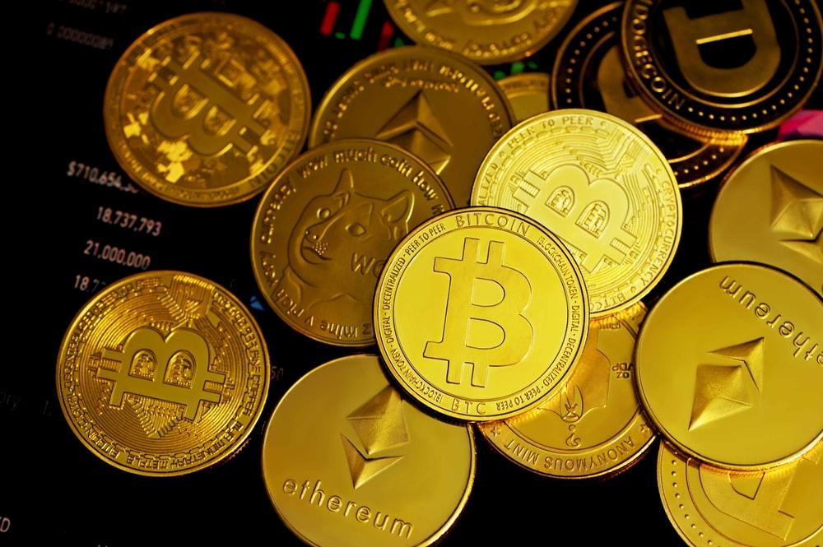

**Lesson 4: Which is Better? Quiz**

Congratulations! You have passed this quiz achieving 66.67%[**NEXT LESSON**](https://www.trsryxrpl.com/lesson/lesson-5-other-types-of-mining/)

1. **Which is considered more secure?**
   * https://lh6.googleusercontent.com/nqnbeE1cUSJOY2gbCYYNOU-K4aZtEGdquQln2u199gUv6LzvY0AdprUvO7r5iU_ckMGl_IJfmDOMe6H5ITs78GjRGvxAui_QmZUFwZYxZWtUW9AAytP4IijvJAweIOI6dYyb8tKFvh4YzwBD5Q PoW
   * https://lh4.googleusercontent.com/cWje2kaNyzsGDAWCrIbeL1XjYZPAMWBaum5iZn1IlsPk2gNZ1gbNIln6efaCHcj_pQKVhwBRl8HWOzbm3AcvyK3lZtxVUKffo5RYsITixsDjVljGNS-xPdhlhEtQMR3wbB-hbg9Gf2lLBB468g PoS

Incorrect**0/4 $TRSRY**

Right Answer: **PoW**

1. **Which is considered faster and more scalable?**
   * https://lh6.googleusercontent.com/nqnbeE1cUSJOY2gbCYYNOU-K4aZtEGdquQln2u199gUv6LzvY0AdprUvO7r5iU_ckMGl_IJfmDOMe6H5ITs78GjRGvxAui_QmZUFwZYxZWtUW9AAytP4IijvJAweIOI6dYyb8tKFvh4YzwBD5Q PoW
   * https://lh4.googleusercontent.com/cWje2kaNyzsGDAWCrIbeL1XjYZPAMWBaum5iZn1IlsPk2gNZ1gbNIln6efaCHcj_pQKVhwBRl8HWOzbm3AcvyK3lZtxVUKffo5RYsITixsDjVljGNS-xPdhlhEtQMR3wbB-hbg9Gf2lLBB468g PoS

Correct**4/4 $TRSRY**

1. **Which is considered more energy efficient?**
   * https://lh6.googleusercontent.com/nqnbeE1cUSJOY2gbCYYNOU-K4aZtEGdquQln2u199gUv6LzvY0AdprUvO7r5iU_ckMGl_IJfmDOMe6H5ITs78GjRGvxAui_QmZUFwZYxZWtUW9AAytP4IijvJAweIOI6dYyb8tKFvh4YzwBD5Q PoW
   * https://lh4.googleusercontent.com/cWje2kaNyzsGDAWCrIbeL1XjYZPAMWBaum5iZn1IlsPk2gNZ1gbNIln6efaCHcj_pQKVhwBRl8HWOzbm3AcvyK3lZtxVUKffo5RYsITixsDjVljGNS-xPdhlhEtQMR3wbB-hbg9Gf2lLBB468g PoS

Correct**4/4 $TRSRY**

**Lesson 5: Other Types of Mining?**

Congratulations! You have passed this lesson's quiz achieving 50%

*Length: 10 minutes*

Beyond Proof of Work and Proof of Stake there a countless numbers of different mining protocols being rolled out for different blockchains and cryptocurrencies. They are generally a modified outlook on the PoS and PoW models, with an attempt to reduce their inefficiencies.

The entire reason cryptocurrencies are mined is to ensure that transactions are verified and validated to the blockchain, as well as preventing double spending by malicious users. Double spending is where a digital token/coin is spent more than once, for example by reclaiming the coins. An example of double spending would be if a user holds 1 BTC, but is able to send 1 BTC to two separate addresses. Using a mining protocol this type of double spend transaction is not possible, and the distributed ledger can prove no coin was spent twice.

The link below highlights 14 examples of other examples of mining, as well as what benefits they bring and issues they aim to fix.

[**https://medium.com/hackernoon/pos-pow-and-12-other-blockchain-protocols-you-didnt-know-about-3634b089d119**](https://medium.com/hackernoon/pos-pow-and-12-other-blockchain-protocols-you-didnt-know-about-3634b089d119)

**Lesson 5: Other Types of Mining? Quiz**

Congratulations! You have passed this quiz achieving 50%

1. **Nearly all mining protocols aim to improve the PoS or PoW model?**
   * https://lh4.googleusercontent.com/cWje2kaNyzsGDAWCrIbeL1XjYZPAMWBaum5iZn1IlsPk2gNZ1gbNIln6efaCHcj_pQKVhwBRl8HWOzbm3AcvyK3lZtxVUKffo5RYsITixsDjVljGNS-xPdhlhEtQMR3wbB-hbg9Gf2lLBB468g True
   * https://lh6.googleusercontent.com/nqnbeE1cUSJOY2gbCYYNOU-K4aZtEGdquQln2u199gUv6LzvY0AdprUvO7r5iU_ckMGl_IJfmDOMe6H5ITs78GjRGvxAui_QmZUFwZYxZWtUW9AAytP4IijvJAweIOI6dYyb8tKFvh4YzwBD5Q False

Correct**4/4 $TRSRY**

1. **What is double spending?**
   * https://lh4.googleusercontent.com/cWje2kaNyzsGDAWCrIbeL1XjYZPAMWBaum5iZn1IlsPk2gNZ1gbNIln6efaCHcj_pQKVhwBRl8HWOzbm3AcvyK3lZtxVUKffo5RYsITixsDjVljGNS-xPdhlhEtQMR3wbB-hbg9Gf2lLBB468g Where a user spends double the amount of a token they expected to.
   * https://lh6.googleusercontent.com/nqnbeE1cUSJOY2gbCYYNOU-K4aZtEGdquQln2u199gUv6LzvY0AdprUvO7r5iU_ckMGl_IJfmDOMe6H5ITs78GjRGvxAui_QmZUFwZYxZWtUW9AAytP4IijvJAweIOI6dYyb8tKFvh4YzwBD5Q An error within a digital currency that allows someone to use an amount of coin more than once
   * https://lh6.googleusercontent.com/nqnbeE1cUSJOY2gbCYYNOU-K4aZtEGdquQln2u199gUv6LzvY0AdprUvO7r5iU_ckMGl_IJfmDOMe6H5ITs78GjRGvxAui_QmZUFwZYxZWtUW9AAytP4IijvJAweIOI6dYyb8tKFvh4YzwBD5Q Where a transaction fee is charged twice
   * https://lh6.googleusercontent.com/nqnbeE1cUSJOY2gbCYYNOU-K4aZtEGdquQln2u199gUv6LzvY0AdprUvO7r5iU_ckMGl_IJfmDOMe6H5ITs78GjRGvxAui_QmZUFwZYxZWtUW9AAytP4IijvJAweIOI6dYyb8tKFvh4YzwBD5Q A hack that can compromise you wallet

Incorrect**0/4 $TRSRY**

Right Answer: **An error within a digital currency that allows someone to use an amount of coin more than once**